





ESA EO Framework - Bureau d’Etudes

STAC ICD for LTA
Reference: CAP-TN-037-BE - Version 1.0-rc2
September 2025

Table des matières
Table des matières 2
1 Introduction 5
1.1 List of abbreviations 5
1.2 Definitions 5
1.3 Purpose and scope 6
1.4 Applicable Documents 6
1.5 Reference Documents and Resources 7
2 Context and scope 10
2.1 LTA description 10
2.2 STAC description 10
2.3 OGC API – Processes description 11
2.4 Scope of the document 12
3 LTA Interface description 14
3.1 Architecture overview 14
3.2 Query Products Catalogue 15
3.2.1 LTA Data Model 18
3.2.2 STAC Catalogue requirements 19
3.2.3 STAC Collection requirements 21
3.2.4 STAC Item and Assets requirements 24
3.2.5 STAC Extensions 31
3.3 Search and download product API 32
3.3.1 AIP instance requirements 32
3.3.2 LTA Client requirements 35
3.3.3 Use case examples 36
3.4 OGC API – Processes conformance 44
3.5 Product Retrieval 49
3.5.1 ProductOrder process 49
3.5.2 BulkCreate process 54
3.5.3 BatchOrder process 60
3.5.4 Use case examples 64
3.6 Product Subscription 67
3.6.1 Subscription creation 67
3.6.2 Subscription cancelation 72
3.6.3 Notification sending 74
3.6.4 Use case examples 76
3.7 Catalogue Export 77
Annex A - Conformance test suite 78
Annex B - list of schemas for OGC API Processes conformance classes 79

CHANGE LOG
Reason for change | Issue | Date
First Issue | 1.0-rc1 | 28/05/2025
Corrections to address comments | 1.0-rc2 | 22/09/2025
CHANGE RECORD
Reason for change | page(s) | Paragraph(s)
Document creation | All | All
1.0-rc2 | 4 | 1.2: Definition of product updated
 | 13 | 3.1: Architecture diagram updated
 | 24 | 3.2.4: Table updated with new properties and a note on platform
 | 28 | 3.2.4:  - new requirement STAC-LTA-ITEM-REQ-0055  - STAC-LTA-ITEM-REQ-0060 updated  - STAC-LTA-ITEM-REQ-0065 updated
 | 29 | Add file:size and file:checksum in assets properties
 | 30 | Update STAC-LTA-ITEM-REQ-0101
 | 33 | 3.3.1.3: Update of STAC-LTA-API-REQ-0305
 | 34 | 3.3.1.3: new recommendation STAC-AIP-API-REC-0335
 | 51 & 60 | Updated definition of output parameter(s) “productLink(s)”  Update OGC-AIP-PRO-REQ-110
 | 54 | OGC-AIP-PRO-REQ-070 updated with additional inputs (collections, ids)
 | several | 3.5: sequence diagrams updated
 | General | “LTA instance” replaced by “AIP instance”  Process ID, inputs and outputs use camelCase formalism
 | Appendices | Annex B added

APPROVALS
Role | Name | Signature
Written by: | Bureau d’Etudes Team

Introduction

List of abbreviations
Name | Definition
AIP | Archive Interface delivery Point
AMQP | Advanced Message Queuing Protocol
API | Application Programming Interface
CDSE | Copernicus Data Space Ecosystem
CSC | Copernicus Space Component
EOF | ESA Earth Observations Framework
EOPF | EO Processor Framework. The new EOPF format is based on Zarr standard.
ICD | Interface Control Document
JSON | JavaScript Object Notation
JWT | Java Web Token
LTA | Long Term Archive
OGC | Open Geospatial Consortium
PRIP | Production Interface delivery Point
STAC | Spatio Temporal Asset Catalog: The STAC specification is a common language to describe geospatial information, so it can more easily be worked with, indexed, and discovered.

Definitions
AIP – Archive Interface delivery Point – the interface delivery point for products requested from the LTA
Product – Packaged set of data files corresponding to EO or auxiliary product format specification. Within the meaning of the STAC standard, a product represents a STAC item with all associated assets.
Order – A client request for a data product to be retrieved by the LTA and staged on the AIP, thereby making it available for download by the requesting user.
Bulk Request – A client request to trigger the creation of a Bulk, defined by a list of products or query filter parameters and a Batch size. The LTA breaks the Bulk into Batches, based on the Batch size provided and the most efficient ordering of products.
Batch Order – A client request to trigger the delivery of products making up a particular Batch (resulting from a Bulk) from the LTA to the AIP, from where they can subsequently be downloaded.
Priority – The LTA manages a priority scheme for all retrievals. Priority is defined as an integer e.g. 1-100 (with 100 being the highest priority) and product retrievals from the archive are managed in the order of priority.
A user is assigned a default priority and a maximum priority.
Subscription – A client request for notification of future products entering the LTA which fulfil particular query filter parameters. A Subscription can optionally request for such products to be automatically Ordered by the LTA, thus staged on the AIP and made available for download.

Purpose and scope
The purpose of this document is to specify an https RESTful API of the LTA, so called AIP, through which Copernicus Sentinel data products may be queried and downloaded by authorised users.
This document extends the specifications contained [STAC_EOF_ICD] and defines a set of requirements to be made applicable in the frame of STAC adoption for the definition and operations of the “Query endpoint” of AIP. However, STAC is not suitable for some operations, like Retrieve, Bulk and Subscription operations. Those endpoints will then be defined through a more suitable standard, “OGC API – Processes”.
The document is structured as follows:
Introduction, the current introduction and the list of applicable and reference documents and resources,
Objectives and needs, an explanation of the objectives and how they are achieved,
Interface description for Query, Retrieve and Subscription endpoints,
  - a detailed description and related requirements for the AIP Query endpoint, based on STAC standard
  - a detailed description and related requirements for the AIP Retrieve and Bulk Retrieve endpoints, based on OGC API – Processes standard
  - a detailed description and related requirements for the AIP Subscription endpoints, based on OGC API – Processes standard and AMQP
Annex A provides explanations and links to the conformance test suite
Annex B provides a list of all JSON schemas for OGC API Processes conformance
This specification relies on the STAC specification version 1.1.0 and the OGC API – Processes specification version 1.0. The Query API is intended to be compliant with the STAC specification, and the Order and Subscription APIs are intended to be compliant with the OGC API – Processes specification.
Compliance to the ICD can be considered as
- an API contract with a set of STAC API style calls, which must be supported, that shall follow STAC API query conventions such as URL syntax, filter syntax, content accessing conventions, etc.
- an API contract with a set of OGC API style calls, which must be supported.

Applicable Documents
ID | Description
STAC_EOF_ICD | STAC Requirements and Recommendation for EOF Services  CAP-TN-030-BE_STAC Version 1.0
STAC_ITEM_SPEC | STAC Item Specification v1.1.0  https://github.com/radiantearth/stac-spec/tree/v1.1.0/item-spec
STAC_COLLECTION_SPEC | STAC Collection Specification v1.1.0  https://github.com/radiantearth/stac-spec/tree/v1.1.0/collection-spec
STAC_CATALOG_SPEC | STAC Catalog Specification V1.1.0  https://github.com/radiantearth/stac-spec/tree/v1.1.0/catalog-spec
STAC_API_CORE_SPEC | STAC API – Core Specification V1.0.0  https://github.com/radiantearth/stac-api-spec/tree/release/v1.0.0/core
STAC_API_FEATURE_SPEC | STAC API – Collections and Features Specification v1.0.0  https://github.com/radiantearth/stac-api-spec/tree/release/v1.0.0/ogcapi-features#stac-api---features
STAC_API_ITEM_SEARCH_SPEC | STAC API – Item Search v1.0.0  https://github.com/radiantearth/stac-api-spec/tree/release/v1.0.0/item-search
STAC_API_FILTER_EXTENSION | STAC API – Filter Extension Specification  https://github.com/stac-api-extensions/filter
STAC_API_SORT_EXTENSION | STAC API – Sort Extension Specification  https://github.com/stac-api-extensions/sort
STAC_API_FIELDS_EXTENSION | STAC API – Fields Extension Specification  https://github.com/stac-api-extensions/fields
GEOJSON_SPEC | The GeoJSON Format – RFC7946  https://datatracker.ietf.org/doc/html/rfc7946
GEOFOOTPRINT_RECOM | Recommendations for GeoJSON Footprints  Ref: CAP-TN-027-ESA-BE  Version 1.0
JSON_SCHEMA | JSON Schema Specification  JSON Schema - Specification [#section] (json-schema.org)
AUTHENTICATION_SERVICE_ICD | Central Authentication Service ICD  TBD

Reference Documents and Resources
ID |  | Description
RD-ARC | ESA EO Operations Framework (EOF) - CSC - Ground Segment Architecture  Ref: ESA-EOPG-EOPGC-TN-7  Version 1.5
EOPF_SPECIFICATION | Earth Observation Product Format  https://eopf.copernicus.eu/eopf-products-and-adfs/eopf-adf-format-def-product-tutorials/
CEOS_STAC_RECOM |  | CEOS EO collection and granule discovery best practices with STAC  https://github.com/ceos-org/stac-collection-and-granule-discovery-best-practices
STAC_BEST_PRACTICES |  | STAC Best Practices  https://github.com/radiantearth/stac-spec/blob/master/best-practices.md
STAC_EXTENSIONS |  | STAC extensions  https://stac-extensions.github.io/
STAC_API_EXTENSIONS |  | STAC API Extensions  https://stac-api-extensions.github.io/
STAC_ALTERNATE_ASSET_EXTENSION |  | Alternate Assets Extension Specification  https://github.com/stac-extensions/alternate-assets
STAC_TIMESTAMP_EXTENSION |  | Timestamps Extension Specification  https://github.com/stac-extensions/timestamps
STAC_EOPF_EXTENSION |  | EOPF STAC Extension  https://github.com/CS-SI/eopf-stac-extension
STAC_STORAGE_EXTENSION | Storage Extension Specification  https://github.com/stac-extensions/storage
STAC_PRODUCT_EXTENSION | Product Extension Specification  https://github.com/stac-extensions/product
STAC_PROCESSING_EXTENSION | Processing Extension Specification  https://github.com/stac-extensions/processing
STAC_FILE_INFO_EXTENSION | File Info Extension Specification  https://github.com/stac-extensions/file
STAC_AUTHENTICATION_EXTENSION | Authentication Extension Specification  https://github.com/stac-extensions/authentication
STAC_EO_EXTENSION | Electro Optical Extension Specification  https://github.com/stac-extensions/eo
STAC_SATELLITE_EXTENSION | Satellite Extension Specification  https://github.com/stac-extensions/sat
STAC_SCIENTIFIC_EXTENSION | Scientific Extension Specification  https://github.com/stac-extensions/scientific
STAC_GRID_EXTENSION | Grid Extension Specification  https://github.com/stac-extensions/grid
STAC_SAR_EXTENSION | SAR Extension Specification  https://github.com/stac-extensions/sar
STAC_VIEW_EXTENSION | View Geometry Specification  https://github.com/stac-extensions/view
S3_API | S3 API Reference  https://docs.aws.amazon.com/AmazonS3/latest/API/Type_API_Reference.html
OPENID_CONNECT_SPEC | OpenID Connect Core 1.0 incorporating errata set 2  https://openid.net/specs/openid-connect-core-1_0.html
CQL2_SPEC | Common Query Language (CQL2)  https://docs.ogc.org/is/21-065r2/21-065r2.html#cql2-json
FILTER_CLASS | Filter Conformance Class URI  https://portal.ogc.org/files/96288#_requirements_class_filter
FEATURE_FILTER_CLASS | Feature Filter Conformance Class URI  https://portal.ogc.org/files/96288#_requirements_class_features_filter
BASIC_CQL2_CLASS | Simple CQL Conformance Class URI  http://www.opengis.net/spec/cql2/1.0/conf/basic-cql2
ITEM_SEARCH_FILTER_CLASS | Item Search Filter Conformance Class URI  https://api.stacspec.org/v1.0.0-rc.3/item-search#filter
CQL2_JSON_CLASS | CQL2 JSON Conformance Class URI  http://www.opengis.net/spec/cql2/1.0/conf/cql2-json
LTA_ODATA_ICD | Long Term Archive Interface Control Document  Ref: ESA-EOPG-EOPGC-IF-2  Version 1.9
OGC_API_PROCESSES_STANDARD | OGC API - Processes - Part 1: Core  Ref: 18-062r2  Version: 1.0.0  https://docs.ogc.org/is/18-062r2/18-062r2.html
AMQP_1_0_STANDARD | AMQP 1.0 OASIS Standard  http://docs.oasis-open.org/amqp/core/v1.0/os/amqp-core-complete-v1.0-os.pdf

Context and scope

LTA description
The data preservation function ensures the storage of the essential mission data. It is fulfilled by the
Long Term Archive element in the form of operational service provision.
The LTA service is defined to cover the following main functions:
- Data Ingestion and safe storage: LTA retrieve Sentinel products from PRIPs endpoints.
- Data Query, Retrieval and delivery on an AIP: LTA clients query AIP endpoints for those operations.
- Data curation and archive Integrity
- Performance Monitoring and Reporting
- Implementation and operations of the AIP, ensuring its availability for consumers and handling of cache policy
The LTA interface includes all the features necessary to support the above LTA functionalities.
In particular, all the features to query the stored data, query performance information for monitoring purposes and to retrieve the selected data.
As a provider of data, the LTA interfaces with multiple clients:
- the Data Access and On-Demand Production elements, through the Archive Interface delivery Point
- the E2E Operations Performance Monitoring element, to provide the reporting information required for the E2E operations monitoring
- potentially the other LTA instances, and other clients such as Cal/Val users requiring data not otherwise available through the Data Access
The interface to these clients for the access to the API and delivery of Products is the so called AIP, governed by this ICD.

STAC description
STAC is an open specification that defines a common structure and an API for describing and cataloguing
spatio-temporal assets.
The following figure highlights the main concepts of the STAC specification:

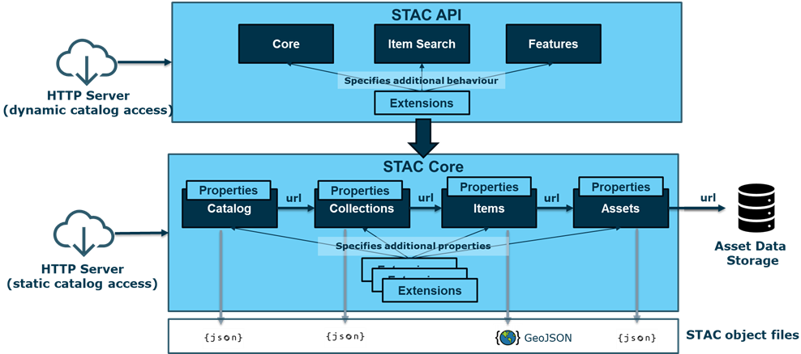

The STAC specification is composed of two main sub-parts:
- The STAC Core that specifies the STAC Objects that constitutes the STAC Data Model, and
- The STAC API that specifies the set of operations that can be performed on the STAC Objects leveraging an HTTP API.
This document establishes requirements and recommendations for the implementation of STAC in EOF AIP instances. An AIP instance manages products for all Sentinel Mission.
Therefore, it is expected that any AIP instance complies with:
- The requirements and recommendations defined in [STAC_EOF_ICD],
- The requirements and recommendations contained in the present document

OGC API – Processes description
The OGC API - Processes Standard supports the wrapping of computational tasks into executable processes that can be offered by a server through a Web API and be invoked by a client application. The standard specifies a processing interface to communicate over a RESTful protocol using JSON encodings. A process can be executed in a synchronous or asynchronous mode. In the latter, a new job is created for each process execution request.
The standard offers the following HTTP operations:
RESOURCE | PATH | HTTP METHOD | INFORMATION DELIVERED
Landing page | / | GET | General information about the service, links to API endpoints
Conformance classes | /conformance | GET | List of conformance classes, including extensions
Process list | /processes | GET | Process identifiers, links to process descriptions
Process description | /processes/{processID} | GET | all necessary information needed to execute a process. This information can be used to send a JSON execute request to the API that will pass initial sanity checks, for example to check correct input/output identifiers.
Job status info | /jobs/{jobID} | GET | The job status info contains not only status information, but for finished processes also links to results / exceptions
Job results | /jobs/{jobID}/results | GET | Job results for job with jobID identifier
Process execution | /processes/{ProcessID}/execution | POST | create new processing jobs (process executions).
Job cancelation | /jobs/{JobID} | DELETE | Cancel a running job

One of the main reference implementations of the OGC API standards is pygeoapi.

Scope of the document
This document is applicable to the following functions that are provided by AIP instances:
- Query LTA Products Catalogue
- Retrieve Product
- Bulk Retrieve Products
- Subscription
- Catalogue Export

Compared to the formal LTA ICD, the current document does not address the following LTA functions:
- Traceability Interface
- Monitoring and Reporting

This specification is assumed to be applicable in conjunction with the adoption of the new Sentinel product format, EOPF.
Each statement is formulated according to the following example:
<ID> – <Title>
Text of the statement.

The first line includes the following fields:
- <ID> Id of the requirement or recommendation in the form STAC-AIP-<CAT>-REQ-<XXXX> / OGC-[AIP|LTA]-<CAT>-REQ-<XXXX> (for a requirement) or STAC-AIP-<CAT>-REC-<XXXX> / OGC-[AIP|LTA]-<CAT>-REC-<XXXX> (for a recommendation)
- For STAC-AIP, <CAT> is the related STAC category:
- CORE: General requirement related to STAC Core
- API : AIP API
- CAT: Catalog
- COL: Collection
- ITEM: Item
- ASSET: Asset
- For OGC-AIP, <CAT> is one of those values:
- API: OGC standard API
- PRO: OGC process definition
- <XXXX> is the four-digit ID of the statement.
- <Title> The title of the statement
The following lines are the body of the requirement or recommendation. For a requirement, we use the modal “shall” whereas a “recommendation” is expressed with the modal “should”.

LTA Interface description

Architecture overview
The following diagram describes the high-level architecture that underpins the LTA/AIP interfaces.

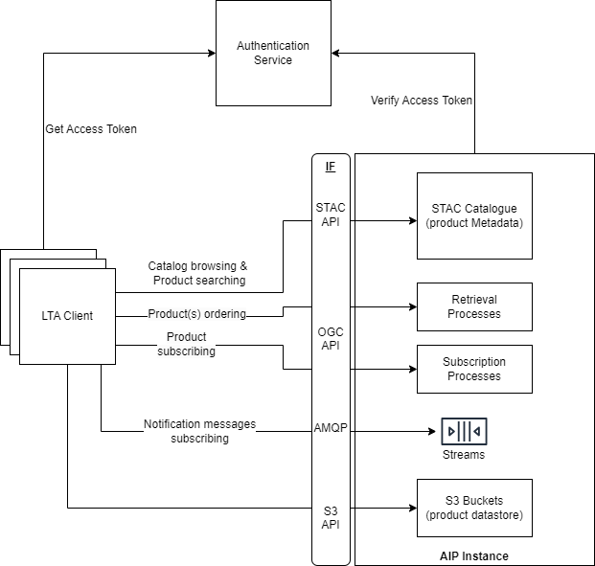
Figure 1: LTA Architecture overview

This architecture highlights the following components:
- The AIP Instance which embeds:
The STAC Catalogue that expose a standard STAC API through AIP for browsing and searching the collections and products managed by the instance and for retrieving their metadata.
A set of processes to make Retrieval operations through AIP’s standard OGC API
- A set of processes to make Subscription operations through AIP’s standard OGC API
- A set of AMQP Streams to publish notification messages to clients with valid subscription ID
A set of S3 Buckets that stores the managed products and expose the S3 API to allow the downloading of those products.
The LTA Clients, that consume several APIs exposed by AIP.
The Authentication Service that supports the centralized authentication service by providing an OIDC interface so that:
LTA Clients retrieve an access token that shall be included in any request sent to the AIP
AIP Instance validate the access tokens found in the incoming requests to ensure they are valid.

Query Products Catalogue
The Query function is provided through a STAC API used to identify required products that may be retrieved from the LTA and, via their identifiers, to trigger the product retrieval. The product catalogue can be queried for specific named products or lists of products, or products matching more complex query criteria.
A typical use scenario for query and download of products from a AIP instance is shown in the figure below:

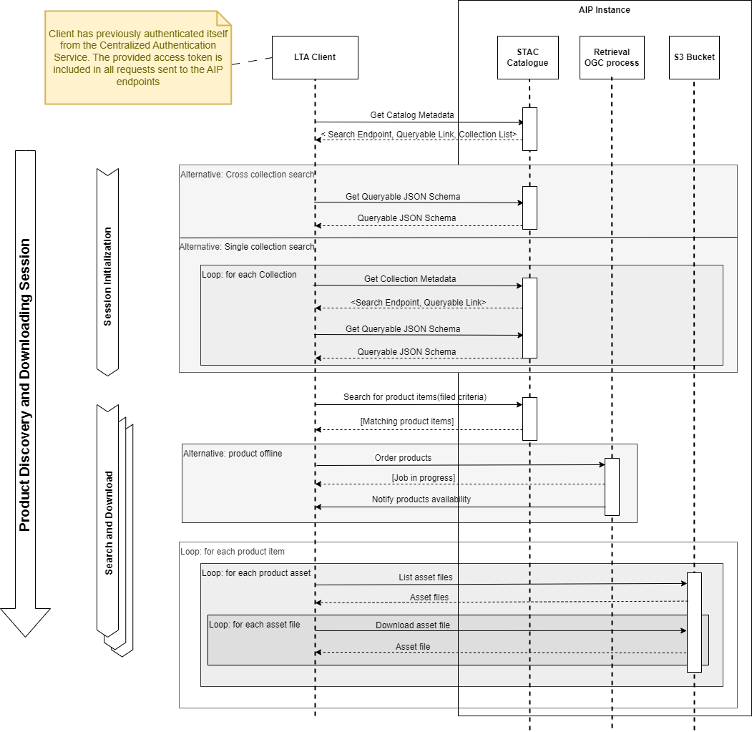
Figure 2: Product query typical scenario

It is mandatory that the LTA Client retrieves from the Centralized Authentication Service an Access Token. This Access Token shall be included in all requests sent to the STAC Catalogue endpoint. The latter is responsible for validating this token and ensuring the client is authorized to access the requested information. For the sake of clarity and concision, these interactions are not shown in the diagram above
First, during the session initialization, the LTA Client shall retrieve from the STAC Catalogue root page the Catalogue metadata, which provides in particular:
- The HTTP endpoint to perform cross collection searching.
- The link to the Queryable JSON Schema that specifies the product metadata fields that can be provided as query parameters for future search requests.
- The list of links to the managed product collections.
- From this point, the LTA Client is able to perform two kinds of queries for searching products:
Cross collection search queries.
Single collection search queries.
For cross collection search queries, the LTA Client shall retrieve the Queryable JSON Schema provided in the STAC Catalogue root page.
For single collection search queries, the LTA Client shall first retrieve the related collection metadata. From those metadata, it shall extract the corresponding Queryable JSON schema and the search endpoint. This shall be performed for any collection that will be requested in the next steps.
Once the LTA Client has retrieved the relevant Queryable JSON schema and search endpoint, it can perform product search queries, ensuring that provided metadata field criteria comply with the Queryable JSON Schema.
As a result of a search query, the LTA Client retrieves a set of STAC Items. Each of them includes properties backed by STAC Core specification or STAC extensions and a list of STAC Assets.
From this point, two scenarios must be envisaged:
- The item is “online” with downloadable assets from S3 buckets (a link for each corresponding file is provided in “assets” section).
- The item is “offline”, meaning that its assets are not immediately available for download. The LTA client must make a “Product order” to retrieve the item “online” and to be able to download assets.
As with STAC Catalog access, all requests sent to the S3 bucket must be authenticated by using the authentication mechanism provided by the object storage provider (not shown in the diagram above).

As part of the EOPF specification, each Product is formatted as a Zarr file structure. Here is a sample of such a structure:

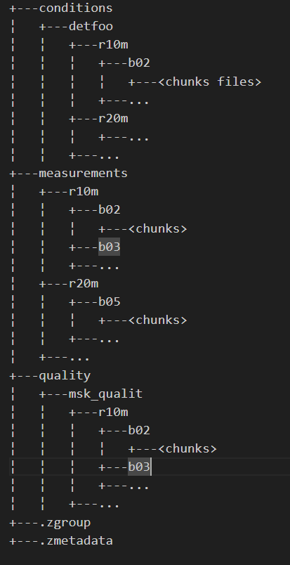

At the root of the file structure, .zmetadata file identifies this folder as a Zarr content. Under the measurements folder, the various band data for each resolution can be found.
The Zarr format allows a client to download and exploit:
- Either the entire Zarr content,
- Or an individual group of measures, for example the data of a given band.

Thus, for the purpose of this ICD, Product Items, returned in response to a Catalogue query, include a STAC Asset for the downloading of the entire Zarr content and an Asset for each individual band or resolution. The detailed list of exposed assets is mission specific and shall be defined in the relevant EOPF product specification.
This implies that the Zarr file structure is stored as is in a S3 bucket, that is each file of the Zarr content is copied as a S3 object keeping the relative path from the root folder as a S3 prefix. From the LTA client point of view, retrieving an asset requires to:
- list all S3 objects sharing the prefix provided by the asset link, leveraging the ListObjectsV2 S3 operation
- download each object whose reference has been returned by the previous operation, leveraging the S3 GetObject operation. The LTA client shall ensure to keep the file structure defined by the full Object key when storing an object on the local file system.

LTA Data Model
The main feature implemented by LTA is to allow remote EOF Services, such on-demand production, to query the LTA Product Catalogue and download products referenced in the responses of those queries.
For this purpose, LTA leverages a Data Model represented by the following figure:

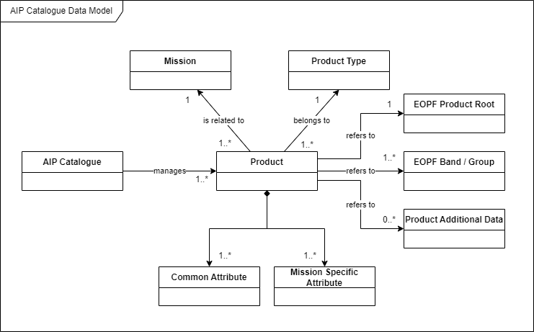
Each AIP Catalogue instance manages a set of Products related to a given mission. Each Product belongs to a Product Type and is described by a set of common attributes and mission specific attributes. Each Product maintains:
- a reference to the full EOPF Product Zarr structure,
- a set of references to the EOPF product assets
- a set of references to production additional data (e.g. auxiliary data document).
Those references allow an LTA client to download the related content.
Based on this high-level data model, the following table provides the relationship between each entity of the LTA data Model and the STAC metamodel:

LTA Data Model entities | Related STAC Metamodel element
AIP Catalogue Instance | STAC Catalogue
Product Type | STAC Collection
Product | STAC Item
Attributes | STAC Item properties
Reference to Product Files | STAC Asset

The following sections state the requirements applicable to any AIP instance to properly map the LTA Data Model to the STAC Core metamodel.

STAC Catalogue requirements
STAC-LTA-CAT-REQ-0010 – Mapping LTA Catalogue instance to STAC Catalogue
The AIP instance shall implement and expose a STAC Catalogue for the purpose of querying the managed by the AIP.

STAC-LTA-CAT-REQ-0011 – Compliance with high level STAC Core requirements
The AIP STAC Catalogue shall comply with the STAC Core requirements stated in [STAC_EOF_ICD].

Here is a sample of the returned JSON response when retrieving the Catalogue landing page.

{
"type": "Catalog",
"id": "s2a-lta",
"title": "Sentinel 2A LTA Catalogue",
"description": "LTA Catalogue for Sentinel 2A",
"stac_version": "1.1.0",
"conformsTo": [
"http://www.opengis.net/spec/cql2/1.0/conf/cql2-json",
"http://www.opengis.net/spec/cql2/1.0/conf/cql2-text",
"https://api.stacspec.org/v1.0.0/item-search",
"https://api.stacspec.org/v1.0.0/ogcapi-features",
"http://www.opengis.net/spec/ogcapi-features-3/1.0/conf/features-filter",
"https://api.stacspec.org/v1.0.0-rc.3/ogcapi-features/extensions/transaction",
"https://api.stacspec.org/v1.0.0/item-search#sort",
"https://api.stacspec.org/v1.0.0/collections",
"https://api.stacspec.org/v1.0.0/item-search#fields",
"https://api.stacspec.org/v1.0.0/item-search#query",
"http://www.opengis.net/spec/ogcapi-features-3/1.0/conf/filter",
"http://www.opengis.net/spec/cql2/1.0/conf/basic-cql2",
"http://www.opengis.net/spec/ogcapi-features-1/1.0/conf/oas30",
"https://api.stacspec.org/v1.0.0-rc.2/item-search#filter",
"https://api.stacspec.org/v1.0.0-rc.2/item-search#context",
"http://www.opengis.net/spec/ogcapi-features-1/1.0/conf/core",
"https://api.stacspec.org/v1.0.0/core",
"http://www.opengis.net/spec/ogcapi-features-1/1.0/conf/geojson"
],
"links": [
{
"rel": "self",
"type": "application/json",
"href": "https://s2a-lta.copernicus.esa.int/"
},
{
"rel": "root",
"type": "application/json",
"href": "https://s2a-lta.copernicus.esa.int/"
},
{
"rel": "data",
"type": "application/json",
"href": "https://s2a-lta.copernicus.esa.int/collections"
},
{
"rel": "conformance",
"type": "application/json",
"title": "STAC/OGC conformance classes implemented by this server",
"href": "https://s2a-lta.copernicus.esa.int/conformance"
},
{
"rel": "search",
"type": "application/geo+json",
"title": "STAC search",
"href": "https://s2a-lta.copernicus.esa.int/search",
"method": "GET"
},
{
"rel": "search",
"type": "application/geo+json",
"title": "STAC search",
"href": "https://s2a-lta.copernicus.esa.int/search",
"method": "POST"
},
{
"rel": "http://www.opengis.net/def/rel/ogc/1.0/queryables",
"type": "application/schema+json",
"title": "Queryables",
"href": "https://s2a-lta.copernicus.esa.int/queryables",
"method": "GET"
},
{
"rel": "child",
"type": "application/json",
"title": "Sentinel-2 Level-0",
"href": "https://https://s2a-lta.copernicus.esa.int/collections/sentinel-2-l0"
},
{
"rel": "child",
"type": "application/json",
"title": "Sentinel-1 Level-0 RAW",
"href": "https://https://s2a-lta.copernicus.esa.int/collections/sentinel-1-l0"
},
{
"rel": "service-desc",
"type": "application/vnd.oai.openapi+json;version=3.0",
"title": "OpenAPI service description",
"href": "https://s2a-lta.copernicus.esa.int/api"
},
{
"rel": "service-doc",
"type": "text/html",
"title": "OpenAPI service documentation",
"href": "https://s2a-lta.copernicus.esa.int/api.html"
}
],
"stac_extensions": []
}

STAC Collection requirements

STAC- LTA-COL-REQ-0020 – Mapping LTA Sentinel Missions to STAC Collections
The AIP instance shall implement and expose a STAC Collection for each Product Type it manages.

STAC- LTA-COL-REQ-0030 – LTA STAC Collection mandatory properties
The AIP instance shall ensure that the following STAC Collection properties are set as specified:
- "id": product type identifier
- "title": display name of the collection
- "description": short description of the collection
- "links": links to related STAC entities, it shall include at least the following relations:
"root": the link to the root page, that is the root URL to reach the LTA Catalogue instance
"parent": same as root
"self": the link to retrieve the current Collection definition
"items": the link to access to the STAC Items belonging to the Collection
"queryables": the link to the JSON Schema that defines all the criteria that are supported by the query function. This schema shall be defined by the mission specific configuration.
- "item_assets": the list of common assets for each STAC Item belonging to this collection,
and their description
- "stac_version": the STAC Core specification version, shall be set to 1.1.0
- "stac_extensions": the list of STAC Core extensions used to define the current Collection.

Here is an example of the expected JSON response when retrieving a STAC Collection managed by the AIP instance:
{
"id": "sentinel-2-l0",
"type": "Collection",
"links": [
{
"rel": "items",
"type": "application/geo+json",
"href": "https://s2a-lta.copernicus.esa.int/collections/sentinel-2-l0/items"
},
{
"rel": "parent",
"type": "application/json",
"href": "https://s2a-lta.copernicus.esa.int/"
},
{
"rel": "root",
"type": "application/json",
"href": "https://s2a-lta.copernicus.esa.int/"
},
{
"rel": "self",
"type": "application/json",
"href": "https://s2a-lta.copernicus.esa.int/collections/sentinel-2-l0"
},
{
"rel": "http://www.opengis.net/def/rel/ogc/1.0/queryables",
"href": "https://s2a-lta.copernicus.esa.int/collections/sentinel-2-l0/queryables",
"type": "application/schema+json",
"title": "Queryables"
}
],
"title": "Sentinel-2 Level-0",
"description": "The purpose of the Sentinel-2 MSI Level-0 processor is to perform the initial processing of raw data received from the Sentinel-2 satellite. The Level-0 processor is the first step in the data processing chain and is responsible for transforming the raw telemetry data into a format suitable for further processing and analysis.",
"item_assets": {
"product": {
"gsd": 10,
"type": "application/vnd+zarr",
"roles": [
"data",
"reflectance"
],
"title": "Full EOPF Product",
"auth:refs": [
"s3"
]
},
"b02": {
"gsd": 10,
"name": "Band 2",
"type": "application/vnd+zarr",
"roles": [
"data",
"reflectance"
],
"title": "Blue (band 2) - 10m",
"auth:refs": [
"s3"
]
}
// ... other asset descriptions
},
"auth:schemes": {
"s3": {
"type": "s3"
},
"oidc": {
"type": "openIdConnect",
"openIdConnectUrl": "https://identity.copernicus.eu/auth/realms/EOF/.well-known/openid-configuration"
}
},
"stac_version": "1.1.0",
"stac_extensions": [
"https://stac-extensions.github.io/item-assets/v1.0.0/schema.json",
"https://stac-extensions.github.io/authentication/v1.1.0/schema.json",
"https://stac-extensions.github.io/projection/v1.1.0/schema.json",
"https://stac-extensions.github.io/product/v0.1.0/schema.json",
]
}

STAC Item and Assets requirements
The following requirements are applicable to any AIP instance whatever the related Sentinel mission.

STAC-LTA-ITEM-REQ-0040 – STAC Items available in each collection
For each STAC collection (corresponding to a product type) it exposes, the AIP instance shall publish and make available each product belonging to this collection. Each product shall be described as a distinct STAC Item.

STAC-LTA-ITEM-REQ-0050 – STAC Items common properties
Any Items delivered by the AIP instance shall at least include the properties listed in following table.
Note : all the properties related to time information shall have a microsecond precision.

Meaning of the table's columns:
- Property Name: Full name of the property
- JSON path in Item: JSON path expression of the property in the STAC Item
- STAC Core or Extension: Set to STAC Core when the property is defined by STAC Core specification or the Full Name of the STAC Extension that defines the related property
- Provider: ‘EOPF’ if the value is retrieved from the EOPF product metadata, LTA when the value is directly provided by the AIP instance, or PRIP if the property comes from PRIP.

Property Name | JSON path in Item | STAC Core or Extension | Provider | Expected value |  | Queryable
Id | $.id | STAC Core | EOPF | Name of the corresponding product without the file extension (generally the name of the EOPF product). | yes
Item Type | $.type | STAC Core | EOPF | Shall be set to "Feature"
Geo Footprint | $.geometry | STAC Core | EOPF | GeoJSON geometry that represents the product geo footprint. The inner "type" and "coordinates" attributes shall be set accordingly. | yes
Bounding Box | $.bbox | STAC Core | EOPF | The bounding box coordinates of the product.
Origin Datetime | $.properties.eopf:origin_datetime | EOPF | PRIP | Timestamp of the availability of the product from the source provider (e.g. publication on PRIP).
Creation Date | $.properties.created | STAC Core | LTA | Creation date and time of the corresponding STAC item into the AIP instance Catalogue.
Update Date | $.properties.updated | STAC Core | LTA | If STAC Item properties have been updated, timestamp of the last update.
Publication Date | $.properties.published | Timestamps | LTA | Timestamp of the availability of the online Item in the AIP instance Catalogue. Can have the same value as $.properties.created when first added. | yes
Expiration Date | $.properties.expires | Timestamps | LTA | Timestamp when the Item will switch to “offline” status (archived on tape) with non-downloadable assets.
Eviction Date | $.properties.unpublished | Timestamps | LTA | Timestamp when the Item is switched from online to offline (e.g. expired).
Datetime | $.properties.datetime | STAC Core | EOPF | Timestamp of the satellite observation related to the product. In case of a time range acquisition, it shall be set to the middle of the start and end time of the acquisition, as per STAC-CORE-ITEM-REQ-0170. | yes
Start Datetime | $.properties.start_datetime | STAC Core | EOPF | Start datetime of the satellite observation related to the product. In case of a single time acquisition, it shall be set to the Datetime property, as per STAC-CORE-ITEM-REQ-0170. | yes
End Datetime | $.properties.end_datetime | STAC Core | EOPF | End datetime of the satellite observation related to the product. In case of a single time acquisition, it shall be set to the Datetime property, as per STAC-CORE-ITEM-REQ-0170. | yes
Availability | $.properties.product:availability | Product | LTA | Online if the product is downloadable right away, or offline if the product has been archived | yes
Product Type | $.properties.product:type | Product | EOPF | See allowed product types in [Erreur ! Source du renvoi introuvable.] | yes
Product Timeliness | $.properties.product:timeliness | Product | EOPF | Timeliness of the product.
Product Timeliness Category | $.properties.product:timeliness_category | Product | EOPF | Timeliness category of the product.
Production Type | $.properties.processing:lineage | Processing | EOPF | Information on the production type.
Mission | $.properties.mission | Stac Core | EOPF | Name of the space program to which the constellation belongs (ex: copernicus)
Constellation | $.properties.constellation | Stac Core | EOPF | Name of the constellation, e.g.: sentinel-1 or sentinel-2.
Platform | $.properties.platform | STAC Core | EOPF | Platform involved in the data acquisition of the product. It shall be set according to STAC-CORE-GEN-REC-0020. It is mission specific and shall be defined in tailored ICDs.  e.g: sentinel-1a | yes
Instruments | $.properties.instruments | Core | EOPF | List of instrument names, e.g.:  "instruments": [  "olci"  ]
Orbit cycle | $.properties.sat:orbit_cycle | Satellite | EOPF | The number of repeat cycle done by the satellite at the time of the acquisition
Absolute Orbit Number | $.properties.sat:absolute_orbit | Satellite | EOPF | Satellite absolute orbit number at the time of observation | yes
Relative Orbit Number | $.properties.sat:relative_orbit | Satellite | EOPF | Satellite relative orbit number at the time of observation | yes
Orbit State | $.properties.sat:orbit_state | Satellite | EOPF | Satellite orbit state at the time observation, may be "ascending" or "descending" | yes
Processing Level | $.properties.processing:level | Processing | EOPF | Depending on the Sentinel missions, possible values are:  - “L0”
Processing Version | $.properties.processing:version | Processing | EOPF | Processing algorithm version, e.g:  "05.10" | yes
Processing Date | $.properties.processing:datetime | Processing | EOPF | Processing date and time of the corresponding product.
Processing Facility | $.properties.processing:facility | Processing | EOPF | The name of the AIP instance that produced the product.
Processing Software | $.properties.processing:software | Processing | EOPF | A dictionary with name/version for key/value describing one or more applications or libraries that were involved during the production of the data for provenance purposes.
STAC Version | $.stac_version | Core | LTA | Shall be set to "1.1.0"
STAC Extensions | $.stac_extensions | Core | LTA | Shall include the list of all the STAC extension schema URL used to describe the Item (see STAC-AIP-CORE-REQ-300).
Links | $.links | Core | LTA | The links related to the current Item. See STAC-CORE-ITEM-REQ-0150 from [STAC_EOF_ICD]
Collection | $.collection | Core | LTA | Name of the parent collection (shall be identical to the Product Type attribute).

STAC-LTA-ITEM-REQ-0055 – STAC Items $.id property’s uniqueness
The $.id property of an item shall be unique across all collections in the STAC catalog hosted by The AIP instance, and implementations must prevent the creation of STAC items with the same ID in multiple collections.

STAC-LTA-ITEM-REQ-0060 – STAC Items lifecycle: Item creation and expiration
When an item if first published in the AIP STAC catalog (when ingested from PRIP), it is considered
as “online” and the following item’s properties shall be set accordingly:
- $.properties.created: set to the current timestamp
- $.properties.published: same as $.properties.created
- $.properties.expires: set to the timestamp when the item will be put offline (archived)
- $.properties.product:availability: set to “online”
When the expiration date is reached, the item will be switched to “offline” and its assets won’t be directly accessible any longer. It’s up to the client to manage the 404 status code if he tries to download the assets. The following item’s properties shall be set accordingly:
- $.properties.product:availability: set to “offline”
- $.properties.unpublished: set to the timestamp when the item is actually offline

Note: all the properties related to time information shall have a microsecond precision.

STAC-LTA-ITEM-REQ-0065 – STAC Items lifecycle: Item ordering
When an item is offline, it can be ordered and then provided “online” again. When an order has been created for an item, its following properties shall be set accordingly:
- $.properties.expires: unset (empty or NULL value)
When an order has been completed, the following item’s properties shall be set accordingly:
- $.properties.product:availability: set to “online”
- $.properties.published: set to the current timestamp
- $.properties.expires: set to the timestamp when the item will be put offline again
The service implementation must manage properly the concurrent ordering of the same product. If an order is placed against a product already being retrieved, the second order query shall be refused with an appropriate message.
Note: all the properties related to time information shall have a microsecond precision.

STAC- LTA-ITEM-REQ-0070 – Expected STAC Assets
Any items delivered by the AIP instance shall include at least the following Assets:
- Asset related to the full EOPF Product
- Asset related to the individual or group of bands of the Product

STAC- LTA-ITEM-REQ-0080 – Name of the STAC Asset related to the EOPF product
The name (JSON key) of the STAC Asset related to the full EOPF product package shall be "product".

STAC- LTA-ITEM-REC-0085 – Thumbnail asset
Each STAC item exposed by the AIP instance should (optionally, to be specified per instance) include an asset representing a thumbnail of the full EOPF product. The AIP instance should ensure the download of the thumbnail file from the corresponding URL.

Note 1: This thumbnail is useful when browsing the AIP instance STAC catalog through the STAC Browser.
Note 2: See STAC-CORE-ASSET-REQ-0300 for proper implementation of this recommendation.

STAC- LTA-ITEM-REQ-0087 – Exposed assets related to sub elements of the EOPF product
Each STAC Item exposed by the AIP instance shall include and allow the download of all the assets identified in the [Erreur ! Source du renvoi introuvable.] for the corresponding STAC collection (a.k.a. product type).

STAC-LTA-ITEM-REQ-0090 – STAC Asset properties
The STAC Assets included in Items published by the AIP instance shall include the properties listed in the following table:

Property Name | JSON path in Item | STAC Core or Extension | Expected value
Download URL | $.assets.<asset_name>.href | STAC Core | S3 URL of the corresponding ZARR folder in the following form:  s3://<bucket>/<path>  The <path> is an S3 prefix allowing to list all the S3 objects matching this prefix.
Title | $.assets.<asset_name>.title | STAC Core | The title of the asset
Type | $.assets.<asset_name>.type | STAC Core | The media type be set to "application/vnd+zarr"
Roles | $.assets.<asset_name>.roles | STAC Core | The role list shall include following items:  - "data"  - "metadata"
Local Folder  Name | $.assets. <asset_name>.file:local_path | File Info | Name of the full folder path, for example : "<product_id>.zarr/measurements/r10m/b02/"
File size | $.assets.<asset_name>.file:  size | File Info | Size of the file: only relevant for asset targeting the full zarr product
File checksum | $.assets.<asset_name>.file:  checksum | File Info | File checksum: only relevant for asset targeting the full zarr product
Authentication scheme | $.assets.<asset_name>.auth:refs | Authentication | Reference to the authentication scheme defined in the auth:schemes of the item properties

STAC-LTA-ITEM-REQ-0100 – STAC Asset href
The STAC Asset href property is a S3 compliant URL. It shall have the following form: s3://<bucket_name>/<product_path>

The <product_path> shall have one of the following forms:
- <product_id>.zarr/ to point to the Full EOPF Product content identified by <product_id>
- <product_id>.zarr/<folder>/<subfolder>/ to point to the ZARR sub-folder with the relative path <folder>/<subfolder> (the number of levels of the subfolder hierarchy is not limited)

STAC-LTA-ITEM-REQ-0101 – Bucket naming convention
The STAC Asset shall be stored within a bucket whose name matches the following form:
lta-<provider>-<productType>
with provider = the name of Service provider

Example, for a Zarr product with ID S02MSIL0__20230216T182840_0001_A123_T000, stored in bucket “lta-<provider>-sentinel-2-l0”. Note that “<provider>” must be replaced by the LTA provider name.

Asset Type | S3 url
Full EOPF Product | s3://lta-<provider>-sentinel-2-l0/S02MSIL0__20230216T182840_0001_A123_T000.zarr/
Band 02 | s3://lta-<provider>-sentinel-2-l0/ S02MSIL0__20230216T182840_0001_A123_T000.zarr/measurements/reflectance/r10m/b02/

STAC Extensions
STAC-LTA-CORE-REQ-0102 – STAC Extensions
The AIP instance shall implement the following STAC extensions and the related minimal version

Extension Name | Minimal version | Reference
Satellite | 1.1.0 | [STAC_SATELLITE_EXTENSION]
Product | 1.0.0 | [STAC_PRODUCT_EXTENSION]
Processing | 1.2.0 | [STAC_PROCESSING_EXTENSIONSTAC_PRODUCT_EXTENSION]
Scientific Citation | 1.0.0 | [STAC_SCIENTIFIC_EXTENSION]
Electro Optical | 2.0.0 | [STAC_EO_EXTENSION]
Grid | 1.1.0 | [STAC_GRID_EXTENSION]
View Geometry | 1.1.0 | [STAC_VIEW_EXTENSION]
SAR | 1.3.0 | [STAC_SAR_EXTENSION]
EOPF | 1.2.0 | [STAC_EOPF_EXTENSION]
Timestamps | 1.1.0 | [STAC_TIMESTAMP_EXTENSION]
Authentication | 1.1.0 | [STAC_AUTHENTICATION_EXTENSION]
File Info | 2.1.0 | [STAC_FILE_INFO_EXTENSION]

Search and download product API
This section formalizes the requirements applicable to AIP Instances and LTA Clients to implement LTA Search and download products based on the principles described in §Erreur ! Source du renvoi introuvable..

AIP instance requirements
This section defines the requirements applicable to any AIP instance for allowing LTA Clients to search and download products leveraging:
- OpenID Connect and JWT standards for authentication and authorization
- STAC API specification for searching capabilities, through the AIP endpoint
- AWS S3 API for downloading products

Search capability requirements
STAC-AIP-API-REQ-0200 – STAC API requirements
The AIP instance shall be compliant with all the requirements specified in section §4 of document [STAC_EOF_ICD]. This includes:
- General Requirements
- Simple search capabilities
- Advanced search capabilities

STAC-AIP-API-REQ-0203 – STAC API limit parameter
The AIP instance shall allow to configure the maximum number of objects (collections or items) returned by a STAC query. This limit shall not be less than 100.

STAC-AIP-API-REQ-0205 – STAC API Extensions
The AIP instance shall implement the following STAC API extensions and the related minimal version

Extension Name | Minimal version | Reference
Filter | 1.0.0-rc4 | [STAC_API_FILTER_EXTENSION]
Sort | 1.0.0 | [STAC_API_SORT_EXTENSION]
Field | 1.0.0 | [STAC_API_FIELDS_EXTENSION]

STAC-AIP-API-REQ-0207 – Queryable fields
The AIP instance shall allow a client to create filters based on the following fields:
- The common properties that are listed in STAC-AIP-ITEM-REQ-0050 and marked as “queryable”
- Mission specific properties that are defined in the [Erreur ! Source du renvoi introuvable.] for the corresponding product type

Note: It implies that the queryable schemas managed by The AIP instance shall be set accordingly.

Authentication and authorization requirements
STAC-AIP-API-REQ-0208 – Compliance to Central Authentication Service
The AIP instance shall comply with [AUTHENTICATION_SERVICE_ICD] to ensure the authentication of the client.

STAC-AIP-API-REQ-0210 – Access control to the STAC Catalogue
The AIP instance shall implement an authorization mechanism that allows to grant (or deny) individual clients at different levels:
- global access to the AIP Catalogue;
- access to each individual AIP Collection.

STAC-AIP-API-REQ-0220 – Global access control semantics
Global access control shall be applied priorly to collection access control.
Global access is required to:
- retrieve the metadata of the Catalogue object
- retrieve the metadata of the underlying Collections, the metadata of the included Items, and to download the related asset files.
If global access is denied for a Client, any STAC API requests it sends shall result in a 403 HTTP Status code response and the corresponding error message. In this case, access to the underlying collections shall be denied too.

STAC-AIP-API-REQ-0230 – Collection access control semantics
Collection access is required to:
- retrieve the metadata of the Collection object;
- retrieve the metadata of the Items included in this Collection and download the related asset files

STAC-AIP-API-REQ-0240 – Role based access control
The authorization mechanism shall rely on the “Client roles” specified through the corresponding JWT claims. This JWT is provided as a Bearer token in the incoming request.

STAC-AIP-API-REQ-0250 – Configurable access control
The authorization mechanism implemented by the AIP instance shall be configurable at collection level and globally.

STAC-AIP-API-REQ-0260 – Zero downtime access control configuration change
It shall be possible to update the access control configuration with no downtime.

Download capability requirements

STAC-LTA-API-REQ-0300 – S3 data storage
The AIP instance shall store products it manages in S3 buckets.

STAC-LTA-API-REQ-0305 – S3 object checksum
The AIP instance shall use the checksum feature of the underlying S3 infrastructure to associate a checksum with each object it stores on S3 buckets. In case the Multipart upload method is used, it shall:
- choose the “full object checksum” type,
- specify a suitable algorithm for checksum calculation (CRC64NVME, CRC32 or CRC32C)
Note: This checksum is used by the LTA client to check the file integrity of the downloaded objects.

STAC-LTA-API-REQ-0310 – Keeping the Zarr file Structure
The AIP instance shall preserve the Zarr file structure when storing a product in a S3 bucket. This implies that:
- Each individual file of the Zarr product is stored as a S3 object;
- The file relative path from the root folder of the Zarr product is the prefix of the corresponding S3 object;
- "/" is the delimiter for any listing operations.

STAC-AIP-API-REQ-0320 – S3 API endpoint for downloading products
The AIP instance shall expose a S3 API endpoint to allow LTA clients to download the products it manages.

STAC-AIP-API-REQ-0330 – S3 API endpoint authentication and authorization
The AIP instance shall authenticate any requests to the S3 API endpoint it manages. It shall authorize download requests consistently with respect to STAC-AIP-API-REQ-210.
Note: as per STAC-LTA-ITEM-REQ-0101, each asset file is backed by a S3 bucket related to the collection/product type.

STAC-AIP-API-REC-0335 – download quotas exceeded
The AIP instance should implement a quota management on downloaded assets by each individual client
In case an LTA client has consumed its allowed quotas, an HTTP status code 429 (“Too Many Requests) is sent in the response with the necessary information, including the datetime when the quotas will be reset.
Note: For each client, it should be possible to configure the size of data per unit of time to download (for example, n Tbytes per month). Those quotas should be described in another document and Quota adjustment should be managed at operations level.

LTA Client requirements

STAC-AIP-API-REQ-0340 – STAC compliance
LTA Clients shall comply with STAC Core 1.1.0 and STAC API 1.0.

STAC-AIP-API-REQ-0350 – LTA Catalogue search
When searching for products managed by the AIP instance, the LTA Client shall apply:
- [STAC_API_FILTER_EXTENSION] for cross-collection search
- [STAC_API_FEATURE_SPEC] for single collection search
- The compliance classes provided in the STAC Catalogue root page in the conformsTo property.

STAC-AIP-API-REQ-0360 – LTA Catalogue search
When searching for products managed by the AIP instance, the LTA Client shall apply:
- [STAC_API_FILTER_EXTENSION] for expressing criteria on the resulting product Items
- [STAC_API_FIELDS_EXTENSION] for defining the fields that shall be included in or excluded from the resulting STAC items
- [STAC_API_SORT_EXTENSION] for defining the sorting logic on the resulting STAC items

STAC-AIP-API-REQ-0365 – Compliance to Queryables schemas
When searching for products managed by the AIP instance, the LTA Client shall verify that the fields provided as search criteria comply with:
- the Queryable JSON schema provided in the STAC Catalogue root page when performing cross-collection search.
- the Queryable JSON schema provided in a Collection page when performing a search within that collection.

STAC-AIP-API-REQ-0370 – LTA Client authentication for STAC browsing
When searching for products managed by the AIP instance, LTA Client shall include in any HTTP request it sends to the AIP an access token previously gathered from the centralized Authentication Service. This token shall be provided in the request an Authorization Bearer token HTTP Header, of the following form:
- Authorization: Bearer <token>

STAC-AIP-API-REQ-0380 – Keeping an access token up to date
The LTA Client is responsible for keeping its access token up to date, by implementing the refresh token OIDC flow.

STAC-AIP-API-REQ-0390 – S3 Compliance
The LTA Client shall comply with [S3_API] when downloading products from a AIP instance S3 API endpoint.

STAC-AIP-API-REQ-0391 – LTA Client authentication for S3 accesses
The LTA Client shall implement the authentication mechanism related to the AIP instance S3 API endpoint.
Note: This mechanism is specific to each LTA instance as it relies on the S3 implementation provided by the Cloud provider hosting the LTA instance. Therefore, it shall be specified in tailored ICDs.

STAC-AIP-API-REQ-0400 – Asset download
The LTA Client shall use the S3 URL provided in any LTA Asset as a prefix. In order to retrieve the content from this prefix, the LTA client shall:
- List all the objects matching this prefix, using the ListObjectsV2 operation.
- Download all the objects from the previous list operation, using the GetObject operation
- Store locally each object as a file, preserving the folder structure materialized by the object key and the "/" delimiter

STAC-AIP-API-REQ-0410 – object checksum verification
The LTA client shall use the checksum feature of the S3 API to verify the integrity of each downloaded object.

Use case examples
This section provides some examples of interactions between a LTA Client and a AIP Instance. For the examples, the following CLI executables are used:
- curl to interact with the AIP STAC Catalogue endpoint
- AWS CLI to interact with the S3 endpoint

In the following examples, it is assumed that:
- The LTA Client has already retrieved from the Centralized Authentication Service an access token whose content is <TOKEN>
- The STAC Catalogue endpoint is https://s2a-lta.copernicus.esa.int/
- aws-cli is configured with the proper S3 endpoint URL, access key and secret key to access the LTA S3 endpoint.

Retrieving the STAC Catalogue root page
The following command allows to retrieve the Catalogue metadata, needed for the next operations:
curl -H "Authorization: Bearer <TOKEN>" -H "Accept: application/json" https://s2a-lta.copernicus.esa.int/

The response has the following form:
{
"type": "Catalog",
"id": "s2a-lta",
"title": "Sentinel 2A LTA Catalogue",
"description": "LTA Catalogue for Sentinel 2A",
"stac_version": "1.1.0",
"conformsTo": [
"http://www.opengis.net/spec/cql2/1.0/conf/cql2-json",
"http://www.opengis.net/spec/cql2/1.0/conf/cql2-text",
"https://api.stacspec.org/v1.0.0/item-search",
"https://api.stacspec.org/v1.0.0/ogcapi-features",
"http://www.opengis.net/spec/ogcapi-features-3/1.0/conf/features-filter",
"https://api.stacspec.org/v1.0.0-rc.3/ogcapi-features/extensions/transaction",
"https://api.stacspec.org/v1.0.0/item-search#sort",
"https://api.stacspec.org/v1.0.0/collections",
"https://api.stacspec.org/v1.0.0/item-search#fields",
"https://api.stacspec.org/v1.0.0/item-search#query",
"http://www.opengis.net/spec/ogcapi-features-3/1.0/conf/filter",
"http://www.opengis.net/spec/cql2/1.0/conf/basic-cql2",
"http://www.opengis.net/spec/ogcapi-features-1/1.0/conf/oas30",
"https://api.stacspec.org/v1.0.0-rc.2/item-search#filter",
"https://api.stacspec.org/v1.0.0-rc.2/item-search#context",
"http://www.opengis.net/spec/ogcapi-features-1/1.0/conf/core",
"https://api.stacspec.org/v1.0.0/core",
"http://www.opengis.net/spec/ogcapi-features-1/1.0/conf/geojson"
],
"links": [
{
"rel": "self",
"type": "application/json",
"href": "https://s2a-lta.copernicus.esa.int/"
},
{
"rel": "root",
"type": "application/json",
"href": "https://s2a-lta.copernicus.esa.int/"
},
{
"rel": "data",
"type": "application/json",
"href": "https://s2a-lta.copernicus.esa.int/collections"
},
{
"rel": "conformance",
"type": "application/json",
"title": "STAC/OGC conformance classes implemented by this server",
"href": "https://s2a-lta.copernicus.esa.int/conformance"
},
{
"rel": "search",
"type": "application/geo+json",
"title": "STAC search",
"href": "https://s2a-lta.copernicus.esa.int/search",
"method": "GET"
},
{
"rel": "search",
"type": "application/geo+json",
"title": "STAC search",
"href": "https://s2a-lta.copernicus.esa.int/search",
"method": "POST"
},
{
"rel": "http://www.opengis.net/def/rel/ogc/1.0/queryables",
"type": "application/schema+json",
"title": "Queryables",
"href": "https://s2a-lta.copernicus.esa.int/queryables",
"method": "GET"
},
{
"rel": "child",
"type": "application/json",
"title": "Sentinel-2 Level-0",
"href": "https://https://s2a-lta.copernicus.esa.int/collections/sentinel-2-l0"
},
{
"rel": "child",
"type": "application/json",
"title": "Sentinel-1 Level-0 RAW",
"href": "https://https://s2a-lta.copernicus.esa.int/collections/sentinel-1-l0"
},
{
"rel": "service-desc",
"type": "application/vnd.oai.openapi+json;version=3.0",
"title": "OpenAPI service description",
"href": "https://s2a-lta.copernicus.esa.int/api"
},
{
"rel": "service-doc",
"type": "text/html",
"title": "OpenAPI service documentation",
"href": "https://s2a-lta.copernicus.esa.int/api.html"
}
],
"stac_extensions": []
}

From this response, the LTA Client can extract:
- The conformance classes found in the "conformsTo" property
- The cross-collection search endpoint URL defined by the "rel": "search" link, that is https://s2a-lta.copernicus.esa.int/search
- The cross-collection Queryable JSON schema URL defined by the "rel": "http://www.opengis.net/def/rel/ogc/1.0/queryables" link, that is https://s2a-lta.copernicus.esa.int/queryables
- The collection endpoint URL defined by the "rel": "data" link, to retrieve the list of collections managed by the AIP Instance, that is https://s2a-lta.copernicus.esa.int/collections

Retrieving the Collections list
The following command retrieves the list of collections managed by the AIP instance and the related metadata needed for the next operations:
curl -H "Authorization: Bearer <TOKEN>" -H "Accept: application/json" https://s2a-lta.copernicus.esa.int/collections

The response has the following form:
{
"collections": [
{
"id": "sentinel-2-l0",
"type": "Collection",
"links": [
{
"rel": "items",
"type": "application/geo+json",
"href": "https://s2a-lta.copernicus.esa.int/collections/sentinel-2-l0/items"
},
{
"rel": "parent",
"type": "application/json",
"href": "https://s2a-lta.copernicus.esa.int/"
},
{
"rel": "root",
"type": "application/json",
"href": "https://s2a-lta.copernicus.esa.int/"
},
{
"rel": "self",
"type": "application/json",
"href": "https://s2a-lta.copernicus.esa.int/collections/sentinel-2-l0"
},
{
"rel": "http://www.opengis.net/def/rel/ogc/1.0/queryables",
"href": "https://s2a-lta.copernicus.esa.int/collections/sentinel-2-l0/queryables",
"type": "application/schema+json",
"title": "Queryables"
}
],
"title": "Sentinel-2 Level-0",
"description": "The purpose of the Sentinel-2 MSI Level-0 processor is to perform the initial processing of raw data received from the Sentinel-2 satellite. The Level-0 processor is the first step in the data processing chain and is responsible for transforming the raw telemetry data into a format suitable for further processing and analysis.",
"item_assets": {
…… // list of assets
},
"auth:schemes": {
"s3": {
"type": "s3"
},
"oidc": {
"type": "openIdConnect",
"openIdConnectUrl": "https://identity.copernicus.eu/auth/realms/EOF/.well-known/openid-configuration"
}
},
"stac_version": "1.1.0",
"stac_extensions": [
"https://stac-extensions.github.io/item-assets/v1.0.0/schema.json",
"https://stac-extensions.github.io/authentication/v1.1.0/schema.json",
"https://stac-extensions.github.io/projection/v1.1.0/schema.json",
"https://stac-extensions.github.io/product/v0.1.0/schema.json",
]
},
{
"id": "sentinel-1-l0",
"type": "Collection",
// ... other collection properties
}
]
}

From the collection list, the LTA Client shall extract for each collection:
- The collection search endpoint URL defined by the "rel": "items" link, that is https://s2a-lta.copernicus.esa.int/collections/sentinel-2-l0/items for the first collection
- The cross-collection Queryable JSON schema URL defined by the "rel": "http://www.opengis.net/def/rel/ogc/1.0/queryables" link, that is https://s2a-lta.copernicus.esa.int/sentinel-2-l0/queryables for the first collection

Searching for Items within all the collections
The following command allows to search for all items which have been retrieved online after 12st August 2025, and request that the results be sorted according to their publication date. The results are returned according to a page size of 100 items (limit query parameter).
curl -X POST -d @query.json -H "Authorization: Bearer <TOKEN>" -H "Content-Type: application/json" -H "Accept: application/geo+json" https://s2a-lta.copernicus.esa.int /search?limit=100

The query.json file has the following content:
{
"filter-lang": "cql2-json",
"filter": {
"op": "and",
"args": [
{
"op" : ">=",
"args": [ { "property": "published" }, "2025-08-12:T00:00:00Z" ]
},
{
"op" : "=",
"args": [ { "property": "product:availability" }, "online" ]
}
]
},
"sortby": [
{
"field": "published",
"direction": "asc"
}
]
}

The response has the following form:
{
"type": "FeatureCollection",
"numberMatched": 12734,
"numberReturned": 100,
"features": [
{
"id": "S02MSIL0__20230216T182840_0001_A123_T000",
"bbox": [
80.99872,
80.920299,
87.993274,
81.956919
],
"geometry": {
"type": "Polygon",
"coordinates": [
[
[
80.9987196457332,
81.9569194040658
],
[
87.9932736707368,
81.8974237140705
],
[
87.2429668849209,
80.920298611386
],
[
80.9988581739129,
80.9732636725462
],
[
80.9987196457332,
81.9569194040658
]
]
]
},
"type": "Feature",
"links": [
// links
],
"auth:schemes": {
"s3": {
"type": "s3"
}
},
"assets": {
…… // list of assets
},
"properties": {
// item properties
},
"stac_extensions": [
"https://stac-extensions.github.io/eo/v1.1.0/schema.json",
"https://stac-extensions.github.io/raster/v1.1.0/schema.json",
"https://stac-extensions.github.io/view/v1.0.0/schema.json",
"https://stac-extensions.github.io/file/v2.1.0/schema.json",
"https://stac-extensions.github.io/processing/v1.2.0/schema.json",
"https://stac-extensions.github.io/product/v0.1.0/schema.json",
"https://stac-extensions.github.io/storage/v1.0.0/schema.json",
"https://stac-extensions.github.io/timestamps/v1.1.0/schema.json",
"https://stac-extensions.github.io/authentication/v1.1.0/schema.json"
],
"stac_version": "1.1.0"
},
// other item
]
}

From this response, the LTA Client can identify from the asset list of each Item, the ones matching the content it wants to download. For example, if it wants to download the full EOPF Product as a ZARR content, the related S3 URL of the first Item is:
s3://s2b_products/ S02MSIL0__20230216T182840_0001_A123_T000.zarr/
The S3 URL of the Band 02 for this Item is:
s3://s2b_products/S02MSIL0__20230216T182840_0001_A123_T000.zarr/measuremens/r10m/b02/
From the previous result, the LTA Client can read the total number of items that match its query from the "numberMatched" property. It may retrieve the results of any given page by specifying the page number as a query parameter. The following example demonstrates how to retrieve page number 5 considering 100 items per page:
curl -X POST -d @query.json -H "Authorization: Bearer <TOKEN>" -H "Content-Type: application/json" -H "Accept: application/geo+json" https://pgstac.demo.cloudferro.com/search?limit=100&page=5

Downloading Zarr content
The following command allows to download the ZARR content of an asset whose href property is s3://s2b_products/S2B_MSIL1C_20240604T101559_N0510_R065_T44XNR_20240604T111607.zarr/
aws s3 cp --recursive s3://s2b_products/ S02MSIL0__20230216T182840_0001_A123_T000.zarr/ .

Note: It is assumed that the AWS CLI is configured with the expected S3 API endpoint and authentication credentials.
The corresponding ZARR file structure is stored in the current working directory.

OGC API – Processes conformance
The AIP shall be compliant with OGC API – Processes standard for its Product(s) retrieval and Subscription functionalities. The following requirements are related to general requirements for conformance with this OGC standard and describe common operations to list available processes, describe a process, execute a process, get a job status and gather a job result.
Next chapters will be dedicated to each Process to implement to fulfill each functionality.

OGC-AIP-API-REQ-010 – Landing page
AIP shall support the HTTP GET operation at the path / to get the API landing page. This operation is part of the standard requirements Class “Core” of API – Processes.
A successful execution of the operation SHALL be reported as a response with a HTTP status code 200.
The content of that response shall be based upon the OpenAPI 3.0 schema landingPage.yaml and include at least links to the following resources:
- the API definition (relation type ‘service-desc’ or ‘service-doc’)
- /conformance (relation type ‘http://www.opengis.net/def/rel/ogc/1.0/conformance’)
- /processes (relation type ‘http://www.opengis.net/def/rel/ogc/1.0/processes’)
For each link, only href property is required (see link.yaml), but “rel” and “title” properties are recommended.

OGC-AIP-API-REQ-020 – conformance operation
AIP shall support the HTTP GET operation at the path /conformance.
A successful execution of the operation shall be reported as a response with a HTTP status code 200.
The content of that response shall be based upon the OpenAPI 3.0 schema confClasses.yaml and list all OGC API - Processes conformance classes that the server conforms to.
The service shall conform to the following classes:
- Core (http://www.opengis.net/spec/ogcapi-processes-1/1.0/conf/core)
- OGC Process Description (http://www.opengis.net/spec/ogcapi-processes-1/1.0/conf/ogc-process-description)
- Callback (http://www.opengis.net/spec/ogcapi-processes-1/1.0/conf/callback)
- JSON (http://www.opengis.net/spec/ogcapi-processes-1/1.0/conf/json)
- OpenAPI Specification 3.0 (http://www.opengis.net/spec/ogcapi-processes-1/1.0/conf/oas30)

OGC-AIP-API-REQ-030 – Process-list operation
AIP shall support the HTTP GET “process-list” operation to get all the processes implemented by the service. This operation is part of the standard requirements Class “Core” and is called at the path /processes.
A successful execution of the operation shall be reported as a response with a HTTP status code 200. The content of that response shall be based upon the OpenAPI 3.0 schema processList.yaml.
At least the “id” and “version” properties are required for each process. Other properties may be added, according to the OpenAPI 3.0 schema processSummary.yaml.

Here is an example of the expected JSON response when retrieving the list of available processes:
{
"processes":[
{
"id":"productOrder",
"version":"1.1.0",
"links":[
{
"type":"text/html",
"rel":"about",
"title":"information",
"href":"https://eof.esa.int/documentation/",
"hreflang":"en-GB"
},
{
"type":"application/json",
"rel":"self",
"href":"https://lta.xyz.copernicus.eu/retrieving/processes/productOrder?f=json",
"title":"Process description as JSON",
"hreflang":"en-GB"
}
],
"jobControlOptions":[
"async-execute"
],
"outputTransmission":[
"value"
]
},
{
"version":"0.1.0",
"id":"bulkCreate",
"links":[
{
"type":"application/json",
"rel":"self",
"href":"https://lta.dataspace.copernicus.eu/retrieving/processes/bulkCreate?f=json",
"title":"Process description as JSON",
"hreflang":"en-GB"
}
],
"jobControlOptions":[
"async-execute"
],
"outputTransmission":[
"value"
]
},
{
"version":"0.1.0",
"id":"batchOrder",
"links":[
{
"type":"application/json",
"rel":"self",
"href":"https://lta.dataspace.copernicus.eu/retrieving/processes/batchOrder?f=json",
"title":"Process description as JSON",
"hreflang":"en-GB"
}
],
"jobControlOptions":[
"async-execute"
],
"outputTransmission":[
"value"
]
}
],
"links":[
{
"type":"application/json",
"rel":"self",
"title":"This document as JSON",
"href":"https://lta.dataspace.copernicus.eu/retrieving/processes?f=json"
}
]
}

OGC-AIP-API-REQ-040 – Process-description operation
AIP shall support the HTTP GET “process-description” operation to retrieve metadata about a process implemented by the service. This operation is part of the standard requirements Class “Core” and is called at the path /processes/{processID}, with processID as the process identifier.
A successful execution of the operation shall be reported as a response with a HTTP status code 200. If the operation is executed using an invalid process identifier, the response shall have HTTP status code 404 and return a response with a “no-such-process” exception.
The content of that response shall be a process description, based on requirements Class “OGC Process Description, upon the JSON Schema process.yaml. The OGC process description is an information model that is used to specify the interface of a process and allows the following information to be specified:
- An identifier of the process, unique among all the processes defined in the service
- Descriptive metadata about the process: title, description, keywords
- A description of each process input specified using the schema inputDescription.yaml
- A description of each process output specified using the schema outputDescription.yaml
- A job control specification that indicates whether the process can be invoked synchronously, asynchronously, or either
- An output transmission specification that indicates how the results of a process are retrieved; either by value or by reference

OGC-AIP-API-REQ-050 – Process-execute operation
AIP shall support the HTTP POST “process-execute” operation to execute a process implemented by the service. This operation is part of the standard requirements Class “Core” and is called at the path /processes/{processID}/execution. The payload of this operation shall conform to the JSON schema execute.yaml.
Depending on the description of the process and the negotiated process execution mode, process execution may result in the creation of a job resource.
A successful execution of the operation shall be reported as a response with the following characteristics, depending on the process execution mode:
- Synchronous mode: HTTP code 200 and body content following the schema results.yaml
- Asynchronous mode: HTTP code 201 and body content following the schema statusInfo.yaml
If the operation is executed using an invalid process identifier, the response shall have HTTP status code 404 and return a response with a “no-such-process” exception.

OGC-AIP-API-REQ-060 – Job-status operation
AIP shall support the HTTP GET “job-status” operation to retrieve information about the status of a job. This operation is part of the standard requirements Class “Core” and is called at the path /jobs/{jobID}.
A successful execution of the operation shall be reported as a response with a HTTP status code 200. The content of that response shall be based upon the OpenAPI 3.0 schema statusInfo.yaml. If the operation is executed using an invalid job identifier, the response shall have HTTP status code 404 and return a response with a “no-such-job” exception.
The following list describes the properties contained in the response:
- jobID: job identifier (same as the parameter set in the request). As an example, for productOrder process, this identifier will be the “Order ID”.
- type: set by default to the value “process”.
- status: job status with following possible values:
accepted: job has been queued by LTA service (queued status in OData API)
- running: job is in progress on LTA side (in_progress status in OData API)
- successful: job has been completed by LTA (completed status in OData API)
- failed: job has failed
message: more detailed status message (corresponds to StatusMessage in OData API)
processID: identifier of the process for which the job is executed
created: date and time at which the job was received and queued by the LTA (corresponds to SubmissionDate in OData API).
started: date and time at which the job execution started.
finished: date and time at which the job has been completed by the LTA (corresponds to CompletedDate in OData API). This property is set for a failed or successful job.

Note 1: all dates are formatted as ISO8601 string
Note 2: this operation is only relevant for a process which has been executed in asynchronous mode

Here is an example of the expected JSON response when retrieving the status of a running job:
{
"jobID": "81574318-1eb1-4d7c-af61-4b3fbcf33c4f",
"processID": "productOrder",
"type": "process",
"status": "running",
"message": "Product ordering in progress",
"progress": 30,
"created": "2025-04-22T10:13:00+05:00",
"started": "2025-04-22T10:20:00+05:00",
"links": [
{
"href": "https://lta.dataspace.copernicus.eu/retrieving/jobs/81574318-1eb1-4d7c-af61-4b3fbcf33c4f",
"rel": "self",
"type": "application/json",
"title": "this document"
}
]
}

OGC-AIP-API-REQ-070 – Job-results operation
AIP shall support the HTTP GET “job-results” operation to retrieve results of a successful job. This operation is part of the standard requirements Class “Core” and is called at the path /jobs/{jobID}/results.
A successful execution of the operation shall be reported as a response with a HTTP status code 200. The content of that response shall be based upon the OpenAPI 3.0 schema results.yaml.
The following error situations shall be supported:
- If the operation is executed using an invalid job identifier, the response shall have HTTP status code 404 and return a response with a “no-such-job” exception.
- If the operation is executed on a running job with a valid job identifier, the response shall have HTTP status code 404 and return a response with a “result-not-ready” exception.
- If the operation is executed on a failed job using a valid job identifier, the response shall have a HTTP error code that corresponds to the reason of the failure and return a response with an exception corresponding to the reason of the failure, e.g. InvalidParameterValue for invalid input data.

OGC-AIP-API-REQ-080 – Callback mechanism
AIP shall support a callback mechanism to notify the client as soon as a job reaches the following status:
- successful: the service pushes the job results to the client
- failed: the service pushes the job status to the client
This callback mechanism is described through the “Callback conformance class” in OGC API – Processes.
To activate the callback, the server shall support the client subscriber URL(s) defined with the property “subscriber” of a process execute payload, based upon the OpenAPI 3.0 schema subscriber.yaml.
At least the following URIs shall be considered:
- successUri
- failedUri

Product Retrieval
The following sections describe requirements for product(s) retrieving functionalities, which consist in dissemination of offline product(s) from LTA to AIP.
The AIP must expose a REST API compliant with OGC Processes – API v1.0. In this respect, it shall define various processes to meet the Product(s) retrieval functionalities, each process being available for LTA client execution.

OGC-AIP-PRO-REQ-010 – supported Processes
AIP shall support and define the following processes:
- productOrder to retrieve a single product
- bulkCreate to initiate a bulk retrieving of several products
- batchOrder to retrieve a list of products through a batch previously created
Note: Each process is fully described in a dedicated section further in the document.

ProductOrder process
The “Product Order” operation allows to trigger the delivery of a single product from the LTA to the AIP, from where it can subsequently be downloaded. This is illustrated in the sequence diagram below.
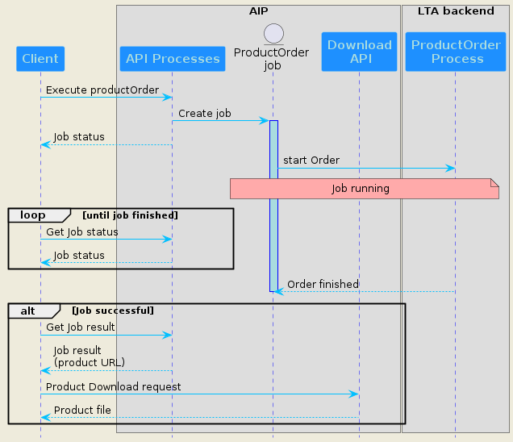
Figure 3: Sequence diagram of the productOrder process

An alternative diagram illustrates the same operation with the callback mechanism in place
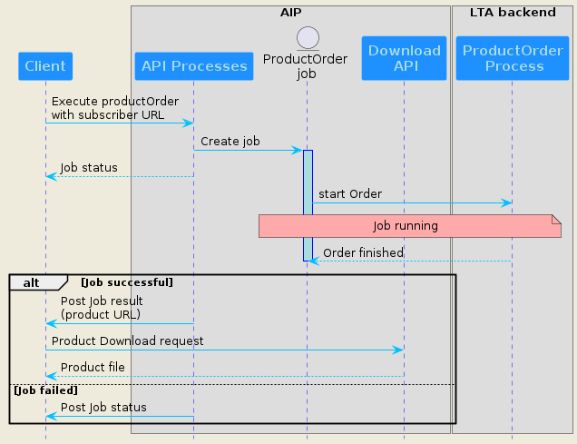
Figure 4: Sequence diagram of the productOrder process with callback

This operation is described through a specific Process implemented in The AIP instance, called productOrder.

Process definition
The following requirements relates to the process description and characteristics, the expected inputs parameters, and the outputs provided in the result in case of successful execution.

OGC-AIP-PRO-REQ-020 – Process Definition
AIP shall define and implement a specific process called “productOrder” to support single product retrieving operation. The productOrder process shall allow execution in asynchronous mode and will return results as value. It also shall be described with the following properties:
- id: value set to “productOrder”.
- title: value set to “LTA product retrieving”
- description: value set to an understandable value

Process inputs/outputs

OGC-AIP-PRO-REQ-030 – Process inputs
The productOrder process shall support the following mandatory inputs:
- productId: string value type which represents an item id in the STAC catalogue
The productOrder process shall support the following optional inputs:
- priority: priority of the order requested by the user, which is an integer value type between 1 and 100 (highest priority).

The following table details the list of inputs.
Input name | Input description | Input type | Occurrences
productId | Product identifier (STAC id attribute) | string | 1
priority | Priority of the order. It is an integer from 1-100, where 100 is the highest priority. There is always a priority associated to an order: if it is not set within the Order Request, then it is automatically set to the default priority assigned to the user. | Integer | 0 to 1

OGC-AIP-PRO-REQ-040 – Process outputs
The productOrder process shall support the following outputs returned as in-line values (outputTransmission set to “value”) in a JSON response document:
- productLink: the URL to the corresponding STAC item
- orderSize: Actual size in bytes of the data retrieved by the Order (restored product). This output has a type “number”.
- evictionDate: Date when the Product related to the order will be removed from the AIP. This output has a type “string” with a date format.
The response JSON document is retrieved through a successful job results query.
Note: on a successful job, as specified in STAC-LTA-ITEM-REQ-0065, the attribute $.properties.expires of the corresponding STAC item is set to the same value as evictionDate

The following table details the list of outputs.
Input name | Input description | Input type | Occurrences
productLink | URL to the corresponding STAC item. In the item definition, assets links can be used for product downloading (asset’s href property) | String | 1
orderSize | Actual size in bytes of the data retrieved by the Order (restored product). This could be the ProductSize unless any transformation is performed by the LTA, e.g. band extraction. | number | 1
evictionDate | Date when the Product related to the order will be removed from the Archive delivery Interface Point. | string | 1

Example of process description
The following illustrates an example of the productOrder process description:
{
"id": "productOrder",
"title": "LTA product retrieving",
"description": "This asynchronous process specifies one product to retrieve from LTA, through its identifier",
"version": "1.0.0",
"jobControlOptions": [
"async-execute"
],
"outputTransmission": [
"value"
],
"inputs": {
"productId": {
"title": "Product identifier",
"description": "Identifier of the product to retrieve",
"minOccurs": 1,
"maxOccurs": 1,
"schema": {
"type": "string"
}
},
"priority": {
"title": "Order priority",
"description": "Priority of the order. It is an integer from 1-100,",
"minOccurs": 0,
"maxOccurs": 1,
"schema": {
"type": "integer",
"minimum": 1,
"maximum": 100
}
}
},
"outputs": {
"productLink": {
"schema": {
"type": "string",
"format": "uri"
}
},
"evictionDate": {
"schema": {
"type": "string",
"format": "date-time"
}
},
"orderSize": {
"schema": {
"type": "number"
}
}
},
"response": "document",
"links": [
{
"href": "https://lta.ordering.copernicus.eu/processes/productOrder/execution",
"rel": "http://www.opengis.net/def/rel/ogc/1.0/execute",
"title": "Execute endpoint"
}
]
}

Process execution

OGC-AIP-PRO-REQ-050 – Process execution
The productOrder process shall trigger retrieving of all the assets defined in the STAC item describing the product, to make them available for download. Once all the assets’ files have been moved to online storage, the following STAC item’s properties shall be modified as follows:
- product:availability shall be set to “online” value.
- expires shall be set to the same value as the evictionDate process’s output parameter

BulkCreate process
The “Bulk Retrieve” operation allows to prepare the delivery of multiple products from the LTA to the AIP, from where they can subsequently be downloaded. The products to retrieve are defined through a search filter used to build to a STAC query. The LTA returns a list of “Batch Orders” with a sub list of products IDs in each one.
This operation is illustrated in the sequence diagram below.
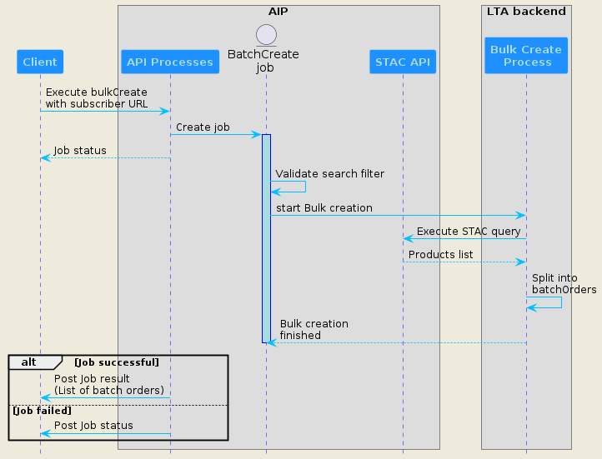
Figure 5: Sequence diagram of the bulkCreate process with client callback

This operation is described through a specific Process implemented in The AIP instance, called bulkCreate.

Process definition
The following requirements relates to the process description and characteristics, the expected inputs parameters, and the outputs provided in the job results in case of successful execution.

OGC-AIP-PRO-REQ-060 – Process Definition
AIP shall define and implement a specific process called “bulkCreate” to support multiple products retrieving operation. The bulkCreate process shall allow execution in asynchronous mode and will return a list of “batch orders”, each one with a unique ID and a list of products IDs. The process shall be defined with the following properties:
- id: value set to “bulkCreate”.
- title: value set to “LTA bulk products retrieving preparation”
- description: value set to an understandable value

Process inputs/outputs

OGC-AIP-PRO-REQ-070 – Process inputs
The bulkCreate process shall support one of the following mandatory inputs:
- Ids: list of products identifiers to be retrieved (exclusive with filterParam)
- filterParam: array of criterion to allow the LTA to build a STAC query based on filter extension. This query shall be used to get a list of products to be split in several batchOrders. Each criterion is defined with a complex object composed by 3 properties:
- key: STAC attribute name on which the criterion applies. An enumeration should be defined to restrict the allowed STAC attributes
- val: STAC attribute value
- op: operand used in the criterion. An enumeration should be defined to restrict the useable operands in conformance with CQL2 language (used in STAC filter extension)
The bulkCreate process shall support the following optional inputs:
- collections: list of collections for which products will be searched
- bbox: Bounding box for which the STAC query shall search products. The spatial operator implemented by default shall be “s_intersects”
- batchsizeProducts: the maximum number of products of each batchOrder making up the Bulk
- batchsizeVolume: the maximum volume of each batchOrder making up the Bulk, in GiB. This value takes precedence of the batchsizeProducts value.

The following table details the list of inputs.
Input name | Input description | Input type | Occurrences
ids | Represents a list of products’ identifiers to be retrieved. Exclusive with filterParam. | array | 0 (if filterParam defined) or 1
filterParam | Represents a list of filter criterion in the STAC query. Combination of criterion is done through an and logical operator | object | 0 if “ids” defined,  or 1 to N
collections | List of valid collections of STAC catalog | array | 0 to 1
bbox | Bounding box for which the STAC query shall search products | bounding box | 0 to 1
batchsizeProducts | The maximum number of products of each batchOrder making up the Bulk. If this number causes the BatchsizeVolume to be exceeded, then the number is limited to that which make up the BatchsizeVolume. | integer | 0 to 1
batchsizeVolume | The maximum volume of each batchOrder making up the Bulk, in GiB. This value takes precedence of the batchsizeProducts value | integer | 0 to 1

OGC-AIP-PRO-REQ-080 – Process outputs
The bulkCreate process shall support the following outputs returned as in-line values (outputTransmission set to “value”) in a response JSON document:
- batchOrderList: an array of bachOrders, with each batchOrder containing an array of products identifiers. Each batchOrder shall have a unique ID. If the STAC query didn’t find any products, the number of batchOrders can be zero.
The JSON response document is retrieved through a successful job results query, or through a HTTP callback if a valid subscriber URI has been passed in the execution request.

The following table details the list of outputs.
Input name | Input description | Output type | Occurrences
batchOrderList | List of batchOrders with a list of products identifiers in each batchOrder | Array of objects | 0 to M batchOrder  with 1 to N products per batchOrder
Note: M and N should be defined as the maximum values supported by the service to retrieve the products with a descent performance.

Example of process description
The following illustrates an example of the bulkCreate process description:
{
"id": "bulkCreate",
"title": "LTA bulk products retrieving preparation",
"description": "This asynchronous process specifies a filter to prepare the retrieving of multiple products from LTA, through several batchOrders",
"version": "1.0.0",
"jobControlOptions": [
"async-execute"
],
"outputTransmission": [
"value"
],
"inputs": {
"oneOf": [
"filterParam": {
"title": "Criteria for query filter",
"description": "Filter for STAC query composed of multiple criterion",
"minOccurs": 1,
"maxOccurs": 5,
"schema": {
"type": "object",
"required": [
"key",
"val",
"op"
],
"properties": {
"key": {
"type": "string",
"enum": [
"published",
"start_datetime",
"end_datetime",
"sat:relative_orbit"
]
},
"val": {
"type": "string"
},
"op": {
"type": "string",
"enum": [
"=",
"<=",
">=",
"<",
">",
"like"
]
}
}
}
},
"ids": {
"title": "Identifiers list",
"description": "List of products identifiers",
"schema": {
"type": "array",
"items": {
"type": "string"
}
}
}],
"batchsizeProducts": {
"title": "Batch order size",
"description": "Number of products in a batchOrder",
"minOccurs": 0,
"maxOccurs": 1,
"schema": {
"type": "integer"
}
},
"batchsizeVolume": {
"title": "Batch order volume",
"description": "Volume of products in a batchOrder, in GiB",
"minOccurs": 0,
"maxOccurs": 1,
"schema": {
"type": "integer"
}
},
"collections": {
"title": "Identifiers list",
"description": "List of products identifiers",
"schema": {
"type": "array",
"items": {
"type": "string"
}
}
},
"bbox": {
"title": "Bounding Box of STAC query",
"description": " Bounding Box for which the query searches products",
"minOccurs": 0,
"maxOccurs": 1,
"schema": {
"allOf": [
{
"format": "ogc-bbox"
},
{
"$ref": https://schemas.opengis.net/ogcapi/processes/part1/1.0/openapi/schemas/bbox.yaml "
}
]
}
}
},
"outputs": {
"batchOrderList": {
"title": "List of batch orders with products lists",
"description": "List of batchOrders. Each batchOrder is defined by a list of products identifiers",
"schema": {
"type": "array",
"minItems": 0,
"maxItems": M,
"items": {
"$ref": "#/$defs/batchOrder"
},
"$defs": {
"batchOrder": {
"type": "object",
"required": [ "batchId" ],
"properties": {
"batchId": {
"type": "string",
"description": "Unique ID of the batch order"
},
"productsIds": {
"type": "array",
"minItems": 1,
"maxItems": N,
"description": "List of products identifiers",
"items": {
"type": "string"
}
}
}
}
}
}
}
},
"response": "document",
"links": [
{
"href": "https://lta.ordering.copernicus.eu/processes/bulkCreate/execution",
"rel": "http://www.opengis.net/def/rel/ogc/1.0/execute",
"title": "Execute endpoint"
}
]
}

BatchOrder process
The “Batch Order” operation allows to trigger the dissemination of a list of products from the LTA to the AIP. This list of products is associated with a Batch order previously created by a bulkCreate process. The result of this operation is a list of products URLs for downloading.
This operation is illustrated in the sequence diagram below.
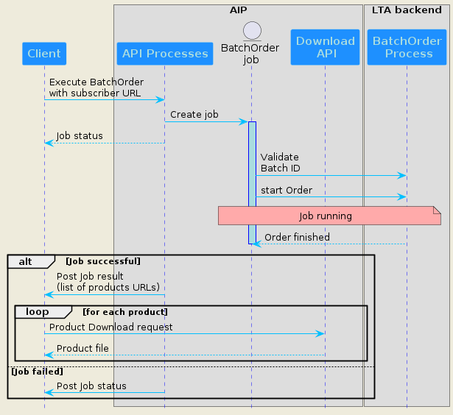
Figure 6: Sequence diagram of the batchOrder process

Process definition
The following requirements relates to the process description and characteristics, the expected inputs parameters, and the outputs provided in the job results in case of successful execution.

OGC-AIP-PRO-REQ-090 – Process Definition
AIP shall define and implement a specific process called “batchOrder” to support multiple products retrieving operation. The batchOrder process shall allow execution in asynchronous mode and will return a list of URLs to download the retrieved products. The process shall be defined with the following properties:
- id: value set to “batchOrder”.
- title: value set to “LTA batch order triggering”
- description: value set to an understandable value

Process inputs/outputs

OGC-AIP-PRO-REQ-100 – Process inputs
The batchOrder process shall support the following mandatory inputs:
- batchOrderId: string value type representing one Batch order Id returned by the bulkCreate job’s results. The process shall verify against the LTA service that the provided Batch order Id is valid, otherwise the job shall fail with an explicit message.
The batchOrder process shall support the following optional inputs:
- priority: priority of the order requested by the user, which is an integer value type between 1 and 100 (highest priority).

The following table details the list of inputs.
Input name | Input description | Input type | Occurrences
batchOrderId | Batch order identifier (created by a previous bulkCreate job execution) | string | 1
priority | Priority of the order. It is an integer from 1-100, where 100 is the highest priority. There is always a priority associated to an order: if it is not set within the Order Request, then it is automatically set to the default priority assigned to the user. | Integer | 0 to 1

OGC-AIP-PRO-REQ-110 – Process outputs
The batchOrder process shall support the following outputs returned as in-line values (outputTransmission set to “value”) in a JSON response document:
- productLinks: an array of URLs to the corresponding STAC items
- orderStatus: an array of results for products’ retrieving
- orderSize: Actual size in bytes of the data retrieved by the Order (total size of restored products). This output has a type “number”.
The response JSON document is retrieved through a successful job results query, or through a HTTP callback if a valid subscriber URI has been passed in the execution request.

The following table details the list of outputs.
Input name | Input description | Input type | Occurrences
productLinks | Ordered list of URLs to the corresponding STAC items. In each item definition, assets links can be used for product downloading (asset’s href property) | Array of uri formatted string | 1 of N
orderStatus | Ordered list of results for each product’s retrieving, either succeeded or failed | Array of string | 1 of N
orderSize | Actual size in bytes of the data retrieved by the Order (restored products). Sum of actual size of the data of all products making up the batchOrder. | number | 1

Example of process description
The following illustrates an example of the batchOrder process description:
{
"id": "batchOrder",
"title": "LTA multiple product retrieving",
"description": "This asynchronous process specifies several products to retrieve from LTA, through a batch order identifier",
"version": "1.0.0",
"jobControlOptions": [
"async-execute"
],
"outputTransmission": [
"value"
],
"inputs": {
"batchOrderId": {
"title": "Batch order identifier",
"description": "Identifier of a pre-defined batch order",
"minOccurs": 1,
"maxOccurs": 1,
"schema": {
"type": "string"
}
},
"priority": {
"title": "Order priority",
"description": "Priority of the order. It is an integer from 1-100,",
"minOccurs": 0,
"maxOccurs": 1,
"schema": {
"type": "integer",
"minimum": 1,
"maximum": 100
}
}
},
"outputs": {
"productLinks": {
"schema": {
"type": "array",
"description": "List of STAC items URLs",
"items": {
"type": "string",
"format": "uri"
}
}
},
"orderStatus": {
"schema": {
"type": "array",
"description": "list of results for each product’s retrieving",
"items": {
"type": "string,
"enum": [
"succeeded",
"failed"
]
}
}
},
"orderSize": {
"schema": {
"type": "number"
}
}
},
"response": "document",
"links": [
{
"href": "https://lta.ordering.copernicus.eu/processes/batchOrder/execution",
"rel": "http://www.opengis.net/def/rel/ogc/1.0/execute",
"title": "Execute endpoint"
}
]
}

Process execution

OGC-AIP-PRO-REQ-120 – Process execution
The batchOrder process shall trigger retrieving of all the assets defined in the STAC items describing the products, to make them available for download. Once all the assets’ files have been successfully moved to online storage, the following item’s properties shall be modified for each product as follows:
- product:availability shall be set to “online” value.
- expires shall be set to the same value as the evictionDate process’s output parameter

Use case examples

ProductOrder example
The following example is a productOrder execute request’s payload:
https://lta.ordering.copernicus.eu/processes/productOrder/execution
{
"inputs": {
"productId": "S02MSIL0__20230216T182840_0001_A123_T000",
"priority": 60
},
"response": "document"
}
And a successful job result:
{
"productLink": "https://stac.dataspace.copernicus.eu/v2/collections/sentinel-2-l0/items/ S02MSIL0__20230216T182840_0001_A123_T000",
"orderSize": 700000000,
"evictionDate": "2025-06-10T15:30:00Z"
}

BulkCreate example
The following example is a bulkCreate execute request’s payload, with a filter based on collection and cloud cover threshold.
https://lta.ordering.copernicus.eu/processes/bulkCreate/execution
{
"inputs": {
"filterParam": [
{
"value": {
"key": "collection",
"val": "sentinel-2-l0",
"op": "="
}
},
{
"value": {
"key": "sat:relative_orbit",
"val": "132",
"op": "="
}
},

],
"bbox": {
"bbox": [ 45, 7, 52, 15 ],
"crs": "http://www.opengis.net/def/crs/OGC/1.3/CRS84"
}
"batchsizeProducts": 30
},
"response": "document"
}
And a successful job result:
{
"batchOrderList": [
{
"batchOrder": {
"batchId": "UUID-1",
"productsIds": [
"S02MSIL0__20230216T182840_0001_A123_T000",
"S02MSIL0__20230221T182840_0001_A123_T000",
…
]
},
"batchOrder": {
"batchId": "UUID-2"
}
}
]
}

BatchOrder example
The following example is a batchOrder execute request’s payload:
https://lta.ordering.copernicus.eu/processes/batchOrder/execution
{
"inputs": {
"batchOrderId": "UUID-1",
"priority": 100
},
"response": "document"
}
And a successful job result:
{
"productLinks": [
" https://stac.dataspace.copernicus.eu/v2/collections/sentinel-2-l0/items/ S02MSIL0__20230216T182840_0001_A123_T000",
" https://stac.dataspace.copernicus.eu/v2/collections/sentinel-2-l0/items/ S02MSIL0__20230221T182840_0001_A123_T000",
…
],
"orderStatus": ["succeeded", "failed", ……],
"orderSize": 5100000000
}

Product Subscription
The Subscription function allows for the notification of future products entering the LTA, or products being deleted from it, according to the set of filter parameters supplied within the subscription request. The request can either trigger the staging of all such products (with download readiness notification) or just provide a product availability notification for each product, which may then be optionally ordered.
Like for “Product retrieval”, the AIP must expose a REST API compliant with OGC Processes – API v1.0. In this respect, it shall define various processes to meet the Subscription functionalities, each process being available for LTA client execution.

OGC-AIP-PRO-REQ-130 – supported Processes for subscription
AIP shall support and define the following processes for subscription management:
- subscriptionCreate to create a new subscription for new and deleted products notifications
- subscriptionCancel to cancel an active subscription

Note: Each process is fully described in next chapters.

The two first paragraphs relate to subscription management, and the third paragraph relates to the sending of notifications to subscribed users.
Note: Generic requirements related to common OGC Processes – API endpoints remain valid for Subscription functionalities (OGC-AIP-API-REQ-020 to OGC-AIP-API-REQ-090).

Subscription creation
The “Subscription Create” operation allows to create a new subscription to receive notifications for new or deleted products from a given collection. This is illustrated in the sequence diagram below.
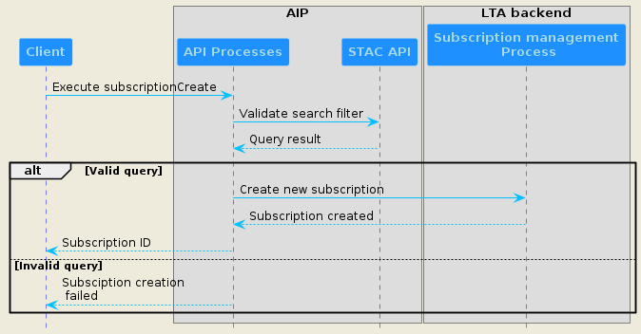
Figure 7: Sequence diagram of “Subscription creation” synchronous process

This operation is described through a specific Process implemented in The AIP instance, called subscriptionCreate.

Process definition
The following requirements relates to the process description and characteristics, the expected inputs parameters, and the outputs provided in the job results in case of successful execution.

OGC-AIP-PRO-REQ-140 – Process Definition
AIP shall define and implement a specific process called “subscriptionCreate” to support the creation of a new subscription in order to be notified on new or deleted products events. The subscriptionCreate process shall allow execution in synchronous mode and will return a unique subscription ID, to which the client can refer in subsequent operations. In case of failure caused by invalid query or any other reason, the response shall have a HTTP error code that corresponds to the reason of the failure. The content of that response shall be based upon the OpenAPI 3.0 schema exception.yaml. The type of the exception shall correspond to the reason of the failure, e.g. InvalidParameterValue for invalid input value.
The process shall be defined with the following properties:
- id: value set to “subscriptionCreate”.
- title: value set to “LTA new subscription creation”
- description: value set to an understandable value

Process inputs/outputs

OGC-AIP-PRO-REQ-150 – Process inputs
The subscriptionCreate process shall support the following mandatory inputs:
- filterParam: array of criterion to allow the LTA building a STAC query based on filter extension. This query shall be used to filter on products for future notifications. Each criterion is defined through a complex object composed by 3 properties:
- key: STAC attribute on which the criterion applies. An enumeration should be defined to restrict the allowed STAC attributes
- val: STAC attribute value
- op: operand used in the criterion. An enumeration should be defined to restrict the useable operands in conformance with CQL2 language (used in STAC filter extension)
- subscriptionEvent: The subscription event to be monitored and for which notification is provided. The possible values are created for new products and deleted for removed products
- collection: The collection for which the event is monitored. shall be a valid STAC collection.
The subscriptionCreate process shall support the following optional inputs:
- stageOrder: if true, automatically orders the staging of products fulfilling the subscription filter parameters (relevant for created event). An order is internally created by the LTA service without going through OGC API Processes (productOrder or batchOrder).
- bbox: Bounding box for which the STAC query shall search products. The spatial operator implemented by default shall be “s_intersects”
- priority: priority of the order created by LTA, which is an integer value type between 1 and 100 (highest priority). This is only relevant if stageOrder is true.

The following table details the list of inputs.
Input name | Input description | Input type | Occurrences
filterParam | Represents a list of filter criterion in the STAC query. Combination of criterion is done through an and logical operator | object | 1 to M
subscriptionEvent | Event to be monitored and for which notification is provided. possible values:  - created  - deleted | string | 1
collection | Collection for which the event is monitored; shall be constrained by an enum corresponding to available STAC collections. | string | 1
stageOrder | True to force a staging of the products listed in the notification. Only relevant for created subscription event. If not provided, its default value is false | boolean | 0 to 1
bbox | Bounding box for which the STAC query shall search products | bounding box | 0 to 1
priority | Priority of the order if stageOrder is true. It is an integer from 1-100, where 100 is the highest priority. | Integer | 0 to 1

OGC-AIP-PRO-REQ-160 – Process outputs
The subscriptionCreate process shall support the following outputs returned as in-line values (outputTransmission set to “value”) in a JSON document response:
- subscriptionId: a unique ID of the created subscription. This ID shall be used by the client to cancel the subscription, and to consume corresponding notification messages.
As the process is synchronous, the response is directly returned by the process execution query.

The following table details the list of outputs.
Input name | Input description | Output type | Occurrences
subscriptionId | Unique ID of the created subscription | string | 1

Example of process description
The following illustrates an example of the subscriptionCreate process description:
{
"id": "subscriptionCreate",
"title": "LTA new subscription creation",
"description": "This synchronous process creates a new subscription to monitor the creation or deletion of products in a collection. A notification will be sent in case of matching with the filterParam specified.",
"version": "1.0.0",
"jobControlOptions": [
"sync-execute"
],
"outputTransmission": [
"value"
],
"inputs": {
"filterParam": {
"title": "Criteria for query filter",
"description": "Filter for STAC query composed of multiple criterion",
"minOccurs": 1,
"maxOccurs": 5,
"schema": {
"type": "object",
"required": [
"key",
"val",
"op"
],
"properties": {
"key": {
"type": "string",
"enum": [
"published",
"sat:relative_orbit"
]
},
"val": {
"type": "string"
},
"op": {
"type": "string",
"enum": [
"=",
"<=",
">=",
"<",
">",
"like"
]
}
}
}
},
"collection": {
"title": "STAC Collection",
"description": "Collection in which to monitor",
"minOccurs": 1,
"maxOccurs": 1,
"schema": {
"type": "string",
"enum": [
"sentinel2-l0",
"sentinel1-l0 ",
"sentinel3-olci-l0",
………
]
}
},
"stageOrder": {
"title": "Flag for product staging",
"description": "If true, automatically order product(s) staging",
"minOccurs": 0,
"maxOccurs": 1,
"schema": {
"type": "boolean"
}
},
"bbox": {
"title": "Bounding Box of STAC query",
"description": " Bounding Box for which the query searches products",
"minOccurs": 0,
"maxOccurs": 1,
"schema": {
"allOf": [
{
"format": "ogc-bbox"
},
{
"$ref": https://schemas.opengis.net/ogcapi/processes/part1/1.0/openapi/schemas/bbox.yaml "
}
]
}
},
"priority": {
"title": "Order priority",
"description": "Priority of the order. It is an integer from 1-100,",
"minOccurs": 0,
"maxOccurs": 1,
"schema": {
"type": "integer",
"minimum": 1,
"maximum": 100
}
}
},
"outputs": {
"subscriptionId": {
"title": "Unique subscription ID",
"description": "Identifier of the created subscription",
"schema": {
"type": "string",
"format": "uuid",
}
}
},
"response": "raw",
"links": [
{
"href": "https://lta.ordering.copernicus.eu/processes/subscriptionCreate/execution",
"rel": "http://www.opengis.net/def/rel/ogc/1.0/execute",
"title": "Execute endpoint"
}
]
}

Subscription cancelation
The “subscription Cancel” operation allows to delete an existing subscription. This is illustrated in the sequence diagram below.
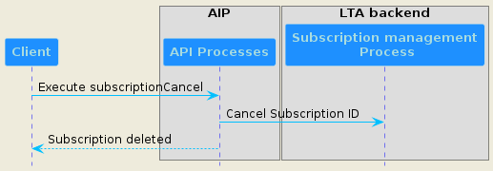
Figure 8: Sequence diagram of Subscription cancel process

This operation is described through a specific Process implemented in The AIP instance, called subscriptionCancel.

Process definition
The following requirements relates to the process description and characteristics, the expected inputs parameters, and the outputs provided in the job results in case of successful execution.

OGC-AIP-PRO-REQ-170 – Process Definition
AIP shall define and implement a specific process called “subscriptionCancel” to support the cancelation of an active subscription. The subscriptionCancel process shall allow execution in synchronous mode and will return the subscription ID of the canceled subscription in case of success. In case of failure caused by invalid query or any other reason, the response shall have a HTTP error code that corresponds to the reason of the failure. The content of that response shall be based upon the OpenAPI 3.0 schema exception.yaml. The type of the exception shall correspond to the reason of the failure, e.g. InvalidParameterValue for invalid subsciptionId.
The process shall be defined with the following properties:
- id: value set to “subscriptionCancel”.
- title: value set to “LTA subscription cancelation”
- description: value set to an understandable value

Process inputs/outputs

OGC-AIP-PRO-REQ-180 – Process inputs
The subscriptionCancel process shall support the following mandatory input:
- subscriptionId: unique identifier of the subscription to cancel

The following table details the list of inputs.
Input name | Input description | Input type | Occurrences
subscriptionId |  | string | 1

OGC-AIP-PRO-REQ-190 – Process outputs
The subscriptionCancel process shall support the following outputs returned as in-line values (outputTransmission set to “value”) in a JSON document response:
- subscriptionId: a unique ID of the created subscription. This ID shall be used by the client to cancel the subscription, and to consume corresponding notification messages.
As the process is synchronous, the response is directly returned by the process execution query.

The following table details the list of outputs.
Input name | Input description | Output type | Occurrences
subscriptionId | Unique ID of the created subscription | string | 1

Notification sending
For each active subscription, the LTA service will monitor if conditions are met (collection, subscription event and product search filter). In case of matching, the following actions shall occur:
- Product or batch order if the subscription has its “stageOrder” parameter to true
- Sending of a notification message. Two operating modes are supported according to the stageOrder value:
- false: the message is published right away with a payload containing a list of matched products identifiers.
- true: the message is published when staging of all matched products are completed. The message contains the list of HTTPS links for products downloading.

The process is illustrated in the sequence diagram below.
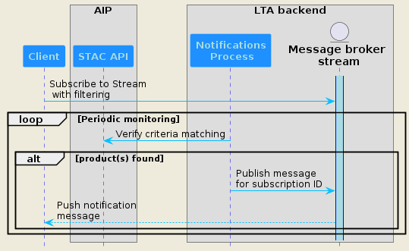
Figure 9: Notification sending sequence diagram

OGC-AIP-PRO-REQ-200 – AMQP streams
The LTA service shall conform to AMQP 1.0 for message publishing. It shall setup a AMQP 1.0 broker and instantiate one dedicated stream per STAC collection.
It shall publish products notification messages related to a collection on the corresponding stream. The client will have to subscribe to each stream related to the collection set in its active subscriptions.
Example: A client creates a subscription for new sentinel2-l1c products (“created” event), and another one for deleted sentinel1-slc products (“deleted” event). Then he subscribes to the AMQP streams “sentinel2-l1c” and “sentinel1-slc” and listens for notification messages. As soon as a new Sentinel2-l1c product is referenced and matches with its subscription’s filter, he receives an AMQP message on the “sentinel2-l1c” stream. On the same way, when a Sentinel1-slc product matching its subscription’s filter is deleted, he receives an AMQP message on the “sentinel1-slc” stream.

OGC-AIP-PRO-REQ-210 – AMQP Stream Filtering
The LTA service shall publish a notification message each time a client’s subscription meets product filtering and selected event.
This message shall be addressed to the right client through the “AMQP Stream Filtering” mechanism: the x-stream-filter-value header shall be set to the “subscription ID” value for which the message shall be delivered.
Then the consumer can perform effective message filtering, thanks to x-stream-filter argument set to a string or an array of strings if he needs consuming messages for several subscription IDs.

OGC-AIP-PRO-REQ-220 – Notification message payload
The LTA service shall publish a notification message with the following JSON formatted payloads according to various subscription’s use cases:
- SubscriptionEvent=created & StageOrder=false
{
“subscriptionEvent”: “created”,
“lastNotificationDate”: “dateTime”,
“productIds”: [
“product-1-ID”,
“product-2-ID”,
….
]
}
- SubscriptionEvent=created & StageOrder=true
{
“subscriptionEvent”: “created”,
“lastNotificationDate”: “dateTime”,
“productIds”: [
“product-1-URL”,
“product-2-URL”,
….
]
}
- SubscriptionEvent=deleted
{
“subscriptionEvent”: “deleted”,
“lastNotificationDate”: “dateTime”,
“productIds”: [
“product-1-ID”,
“product-2-ID”,
….
]
}

Note: the choice is made to not duplicate the subscriptionId information in the message payload

Use case examples
TODO

Catalogue Export
To be specified in next version (Geoparquet standard ?)

Annex A - Conformance test suite
The Conformance Test Suite related to this specification is provided by the following tools:
- The STAC LTA API validator tool, used to validate compliance with this document and which uses the STAC API validator tool to verify the conformance of the STAC API,
- The STAC LTA API data model validation with Postman tool, used to validate the requirements of the data model and the STAC API of a AIP instance as stated by this document with the Postman client,
- The STAC LTA API data model validation with NodeJS tool, also used to validate the requirements of the data model and the STAC API of a AIP instance as stated by this document with NodeJS. It is experimental; the previous tool should be privileged.
Each tool is managed in its own Gitlab Repository and each version of the tool indicates the version of the LTA specification it is related to.
Those tools are managed under LTA CTS Gitlab group of projects.

Annex B - list of schemas for OGC API Processes conformance classes
File name | File content
landingPage.yaml | type: object  required:  - links  properties:  title:  type: string  example: Example processing server  description:  type: string  example: Example server implementing the OGC API - Processes 1.0 Standard  links:  type: array  items:  $ref: "link.yaml"
Link.yaml | type: object  required:  - href  properties:  href:  type: string  rel:  type: string  example: service  type:  type: string  example: application/json  hreflang:  type: string  example: en  title:  type: string
confClasses.yaml | type: object  required:  - conformsTo  properties:  conformsTo:  type: array  items:  type: string  example: "http://www.opengis.net/spec/ogcapi-processes-1/1.0/conf/core"
processList.yaml | type: object  required:  - processes  - links  properties:  processes:  type: array  items:  $ref: "processSummary.yaml"  links:  type: array  items:  $ref: "link.yaml"
processSummary.yaml | allOf:  - $ref: "descriptionType.yaml"  - type: object  required:  - id  - version  properties:  id:  type: string  version:  type: string  jobControlOptions:  type: array  items:  $ref: "jobControlOptions.yaml"  outputTransmission:  type: array  items:  $ref: "transmissionMode.yaml"  links:  type: array  items:  $ref: "link.yaml"
Process.yaml | allOf:  - $ref: "processSummary.yaml"  - type: object  properties:  inputs:  additionalProperties:  $ref: "inputDescription.yaml"  outputs:  additionalProperties:  $ref: "outputDescription.yaml"
inputDescription.yaml | allOf:  - $ref: "descriptionType.yaml"  - type: object  required:  - schema  properties:  minOccurs:  type: integer  default: 1  maxOccurs:  oneOf:  - type: integer  default: 1  - type: string  enum:  - "unbounded"  schema:  $ref: "schema.yaml"
outputDescription.yaml | allOf:  - $ref: "descriptionType.yaml"  - type: object  required:  - schema  properties:  schema:  $ref: "schema.yaml"
Execute.yaml | description: |-  Optional URIs for callbacks for this job.  Support for this parameter is not required and the parameter may be  removed from the API definition, if conformance class **'callback'**  is not listed in the conformance declaration under `/conformance`.  type: object  required:  - successUrl  properties:  successUri:  type: string  format: uri  inProgressUri:  type: string  format: uri  failedUri:  type: string  format: uri
Results.yaml | additionalProperties:  $ref: "inlineOrRefData.yaml"
statusInfo.yaml | type: object  required:  - jobID  - status  - type  properties:  processID:  type: string  type:  type: string  enum:  - process  jobID:  type: string  status:  $ref: "statusCode.yaml"  message:  type: string  created:  type: string  format: date-time  started:  type: string  format: date-time  finished:  type: string  format: date-time  updated:  type: string  format: date-time  progress:  type: integer  minimum: 0  maximum: 100  links:  type: array  items:  $ref: "link.yaml"
Subscriber.yaml | description: |-  Optional URIs for callbacks for this job.  Support for this parameter is not required and the parameter may be  removed from the API definition, if conformance class **'callback'**  is not listed in the conformance declaration under `/conformance`.  type: object  required:  - successUrl  properties:  successUri:  type: string  format: uri  inProgressUri:  type: string  format: uri  failedUri:  type: string  format: uri

A pull request has been made to enrich Product STAC extension (https://github.com/stac-extensions/product/pull/11)
It is the concatenation of the following current OData properties: platformShortName and platformSerialIdentifier
https://github.com/stac-api-extensions/filter
max number of criteria in STAC query

