





ESA EO Framework - Bureau d’Etudes

ICD for PRIP
Reference: CAP-TN-036-BE - Version 1.2
June 2026

Table of Contents
1 Introduction 5
1.1 List of abbreviations 5
1.2 Purpose and Scope 5
1.3 Applicable Documents 6
1.4 Reference Documents and Resources 7
2 Objectives and needs 10
2.1 PRIP Description 10
2.2 STAC Description 10
2.3 OGC API – Processes description 11
2.4 Scope of the document 11
3 PRIP Interface description 13
3.1 Architecture overview 13
3.2 Nominal use scenario description 14
3.3 PRIP Data Model 17
3.4 Search and download product API 30
3.5 On-Demand Processing API 43
3.6 Product Subscription API 57
Annex A - Conformance test suite 65

Table of figures
Figure 1: PRIP Interfaces 13
Figure 2: Sequence diagram for nominal scenario 14
Figure 3: PRIP Catalogue Data Model 17
Figure 4: Sequence diagram of the synchronous workflowQuery process 44
Figure 5: Sequence diagram of the asynchronous productionOrder process. Its execution consumes the AIP endpoint (LTA service) if the input product type is a L0 level one. 49
Figure 6: Sequence diagram of “subscriptionCreate” synchronous process 57
Figure 7: Sequence diagram of Subscription cancel process 61
Figure 8: Notification sending sequence diagram (example for new products in 1 STAC collection) 62

CHANGE LOG
Reason for change | Issue | Date
First Issue | 1.0 | 20/01/2024
Corrections to address comments | 1.1 | 02/06/2025
Integrate Feedbacks from LTA ICD and comments from ESA.  Add OD PRIP section | 1.2 | 17/06/2025
CHANGE RECORD
Reason for change | page(s) | Paragraph(s)
Document creation | All | All
Version 1.1 | 4 | Add list of abbreviations
 | 5 & 7 | Add missing links in tables
 | 20 | Add note in STAC-PRIP-ITEM-REQ-0050
 | 21 | Add column “Queryable” in properties table
 | 25 | Replace “shall” by “should” in STAC-PRIP-ITEM-REQ-0085
 | 26 | Update STAC-PRIP-ITEM-REQ-0101
 | 27 | Add new Req : STAC-PRIP-API-REQ-0203
 | 29 & 31 | Add note in STAC-PRIP-API-REQ-0305 & STAC-PRIP-API-REQ-0410
 | 30 | Remove STAC-PRIP-API-REQ-0340 and add a recommendation instead, and rename STAC-PRIP-API-REQ-0345 into STAC-PRIP-API-REQ-0340
 | 37 | Modify service URL
 | Several | Add .zarr extension in asset URLs
Version 1.2 | 23/24 | Add the following properties into the table:  - created  - mission  - sat:orbit_cycle
 | 26 | STAC-PRIP-ITEM-REQ-0085 to STAC-PRIP-ITEM-REC-0085  New requirement STAC-PRIP-ITEM-REQ-0060
 | 27 | Add 2 asset’s properties: file:size and file:checksum  STAC-PRIP-ITEM-REQ-0101: remove mission from bucket name and add a note about special character
 | 28 | Update version of product, view and sar extensions  Add file info extension into the table
 | 29 | STAC-PRIP-API-REQ-0305 updated (Multipart upload)
 | 31 | Add STAC-PRIP-API-REC-0335
 | 43 | Add requirements for OD PRIP
 | 57 | Add requirements for Subscription and notifications mechanisms
 |  | Fix of several typos
APPROVALS
Role | Name | Signature
Written by: | Bureau d’Etudes Team

Introduction

List of abbreviations
Name | Definition
API | Application Programming Interface
CDSE | Copernicus Data Space Ecosystem
CSC | Copernicus Space Component
EOF | ESA Earth Observations Framework
EOPF | EO Processor Framework. The new EOPF format is based on Zarr standard.
JSON | JavaScript Object Notation
LTA | Long Term Archive
OD Processing | On-Demand Processing
OGC | Open Geospatial Consortium
PRIP | Production Interface delivery Point
Pub/Sub | Publish / Subscribe
STAC | Spatio Temporal Asset Catalog : The STAC specification is a common language to describe geospatial information, so it can more easily be worked with, indexed, and discovered.

Purpose and Scope
The purpose of this document is to specify an https RESTful API through which Sentinel (or Auxiliary) data products may be discovered and downloaded by authorised users from a Production Interface delivery Point (PRIP). PRIPs are intended as the standard pick-up points for systematically produced Sentinel data products generated by the production services within EOF-CSC.
This document extends the specifications contained [STAC_EOF_ICD] and defines a set of requirements to be made applicable in the frame of STAC adoption for the definition and operations of pick-up point of the Production Services [RD-ARC], i.e. the Production service Interface Point (PRIP).
The API defined in this document is meant to be compliant with the STAC specification version 1.1.0.
Compliance to the ICD can be considered as an API contract with a set of STAC API style calls, which have to be supported, that shall follow STAC API query conventions such as URL syntax, filter syntax, content accessing conventions, etc.
However, STAC is not suitable for Processing and Subscription operations. Those endpoints will then be defined through a more suitable standard, “OGC API – Processes v1.0”. For notifications management, the "OGC API Publish-Subscribe" concepts will be supported, despite of the fact that this standard is still a draft version.
This document is structured as follows:
Introduction, this chapter and the list of applicable and reference documents and resources,
Objectives and needs, an explanation of the objectives and how they are achieved,
PRIP Interface description, a detailed description and related requirements of the PRIP interface
Annex A provides explanations and links to the conformance test suite

Applicable Documents
ID | Description
STAC_EOF_ICD | STAC Requirements and Recommendation for EOF Services  CAP-TN-030-BE_STAC Version 1.0
STAC_ITEM_SPEC | STAC Item Specification v1.1.0  https://github.com/radiantearth/stac-spec/tree/v1.1.0/item-spec
STAC_COLLECTION_SPEC | STAC Collection Specification v1.1.0  https://github.com/radiantearth/stac-spec/tree/v1.1.0/collection-spec
STAC_CATALOG_SPEC | STAC Catalog Specification V1.1.0  https://github.com/radiantearth/stac-spec/tree/v1.1.0/catalog-spec
STAC_API_CORE_SPEC | STAC API – Core Specification V1.0.0  https://github.com/radiantearth/stac-api-spec/tree/release/v1.0.0/core
STAC_API_FEATURE_SPEC | STAC API – Collections and Features Specification v1.0.0  https://github.com/radiantearth/stac-api-spec/tree/release/v1.0.0/ogcapi-features#stac-api---features
STAC_API_ITEM_SEARCH_SPEC | STAC API – Item Search v1.0.0  https://github.com/radiantearth/stac-api-spec/tree/release/v1.0.0/item-search
STAC_API_FILTER_EXTENSION | STAC API – Filter Extension Specification  https://github.com/stac-api-extensions/filter
STAC_API_SORT_EXTENSION | STAC API – Sort Extension Specification  https://github.com/stac-api-extensions/sort
STAC_API_FIELDS_EXTENSION | STAC API – Fields Extension Specification  https://github.com/stac-api-extensions/fields
GEOJSON_SPEC | The GeoJSON Format – RFC7946  https://datatracker.ietf.org/doc/html/rfc7946
GEOFOOTPRINT_RECOM | Recommendations for GeoJSON Footprints  Ref: CAP-TN-027-ESA-BE  Version 1.0
JSON_SCHEMA | JSON Schema Specification  JSON Schema - Specification [#section] (json-schema.org)
AUTHENTICATION_SERVICE_ICD | Central Authentication Service ICD  TBD

Reference Documents and Resources
ID |  | Description
RD-ARC |  | ESA EO Operations Framework (EOF) - CSC - Ground Segment Architecture  Ref: ESA-EOPG-EOPGC-TN-7  Version 1.5
EOPF_SPECIFICATION |  | Earth Observation Product Format  https://eopf.copernicus.eu/eopf-products-and-adfs/eopf-adf-format-def-product-tutorials/
CEOS_STAC_RECOM |  | CEOS EO collection and granule discovery best practices with STAC  https://github.com/ceos-org/stac-collection-and-granule-discovery-best-practices
STAC_BEST_PRACTICES |  | STAC Best Practices  https://github.com/radiantearth/stac-spec/blob/master/best-practices.md
STAC_EXTENSIONS |  | STAC extensions  https://stac-extensions.github.io/
STAC_API_EXTENSIONS |  | STAC API Extensions  https://stac-api-extensions.github.io/
STAC_ALTERNATE_ASSET_EXTENSION |  | Alternate Assets Extension Specification  https://github.com/stac-extensions/alternate-assets
STAC_TIMESTAMP_EXTENSION |  | Timestamps Extension Specification  https://github.com/stac-extensions/timestamps
STAC_EOPF_EXTENSION |  | EOPF STAC Extension  https://github.com/CS-SI/eopf-stac-extension
STAC_STORAGE_EXTENSION | Storage Extension Specification  https://github.com/stac-extensions/storage
STAC_PRODUCT_EXTENSION | Product Extension Specification  https://github.com/stac-extensions/product
STAC_PROCESSING_EXTENSION | Processing Extension Specification  https://github.com/stac-extensions/processing
STAC_FILE_INFO_EXTENSION | File Info Extension Specification  https://github.com/stac-extensions/file
STAC_AUTHENTICATION_EXTENSION | Authentication Extension Specification  https://github.com/stac-extensions/authentication
STAC_EO_EXTENSION | Electro Optical Extension Specification  https://github.com/stac-extensions/eo
STAC_SATELLITE_EXTENSION | Satellite Extension Specification  https://github.com/stac-extensions/sat
STAC_SCIENTIFIC_EXTENSION | Scientific Extension Specification  https://github.com/stac-extensions/scientific
STAC_GRID_EXTENSION | Grid Extension Specification  https://github.com/stac-extensions/grid
STAC_SAR_EXTENSION | SAR Extension Specification  https://github.com/stac-extensions/sar
STAC_VIEW_EXTENSION | View Geometry Specification  https://github.com/stac-extensions/view
S3_API | S3 API Reference  https://docs.aws.amazon.com/AmazonS3/latest/API/Type_API_Reference.html
OPENID_CONNECT_SPEC | OpenID Connect Core 1.0 incorporating errata set 2  https://openid.net/specs/openid-connect-core-1_0.html
CQL2_SPEC | Common Query Language (CQL2)  https://docs.ogc.org/is/21-065r2/21-065r2.html#cql2-json
FILTER_CLASS | Filter Conformance Class URI  https://portal.ogc.org/files/96288#_requirements_class_filter
FEATURE_FILTER_CLASS | Feature Filter Conformance Class URI  https://portal.ogc.org/files/96288#_requirements_class_features_filter
BASIC_CQL2_CLASS | Simple CQL Conformance Class URI  http://www.opengis.net/spec/cql2/1.0/conf/basic-cql2
ITEM_SEARCH_FILTER_CLASS | Item Search Filter Conformance Class URI  https://api.stacspec.org/v1.0.0-rc.3/item-search#filter
CQL2_JSON_CLASS | CQL2 JSON Conformance Class URI  http://www.opengis.net/spec/cql2/1.0/conf/cql2-json
DATA_FLOW_CONFIG | Copernicus Ground Segment - Sentinels Data Flow Configuration  Ref: ESA-EOPG-EOPGC-TN-58  Version 1.2
DATA_PORTFOLIO | ESA EO Operations Framework (EOF) – CSC – Copernicus Sentinel Data Portfolio  Ref: ESA-EOPG-EOPGC-TN-12  Version 1.4
OGC_API_PROCESSES_STANDARD | OGC API - Processes - Part 1: Core  Ref: 18-062r2  Version: 1.0.0  https://docs.ogc.org/is/18-062r2/18-062r2.html
OGC-API_Publish Subscribe_STANDARD | OGC API Publish-Subscribe Workflow - Part 1: Core  https://docs.ogc.org/DRAFTS/25-030.html
PRIP_ODATA_ICD | Production Interface Delivery Point Specification  Ref: ESA-EOPG-EOPGC-IF-3  version 2.0
LTA_ICD | Long Term Archive AIP Specification  Ref: CAP-TN-037-BE  Version 1.0-rc3

Objectives and needs

PRIP Description
PRIPs are pick-up points for newly published Sentinel data products, located inside the CSC Ground Segment, which allow clients to straightforwardly discover and retrieve available products through standard interfaces, in this case a STAC RESTful API. Clients of the PRIPs are intended to be bulk downloaders whose principal use case requires systematic (or at least regular) retrieval of newly published Sentinel data products. Examples of PRIP clients include the Copernicus Data Space Ecosystem (which in turn makes the products available to end users), Long Term Archives (LTAs), and possibly clients requiring data for Instrument and Product Performance investigations.
PRIPs are the first point of retrieval for newly published Sentinel data products and, as such, they are co-located with the production service. PRIPs make new products available in the agreed packaged unit, with any compression as described in each product unit definition and metadata; the products are only being published once the product package is fully available. The published products are maintained in a rolling archive covering a time span of e.g. 3 to 5 days, thereby allowing the recovery of data in case of delays, connectivity issues, etc.
In the typical use scenario, the API allows authorised users to discover, through a simple set of filters, the list of products matching specified criteria (e.g. since the last check) and to download those products.

STAC Description
STAC is an open specification that defines a common structure and an API for describing and cataloguing
spatio-temporal assets.
The following figure highlights the main concepts of the STAC specification:

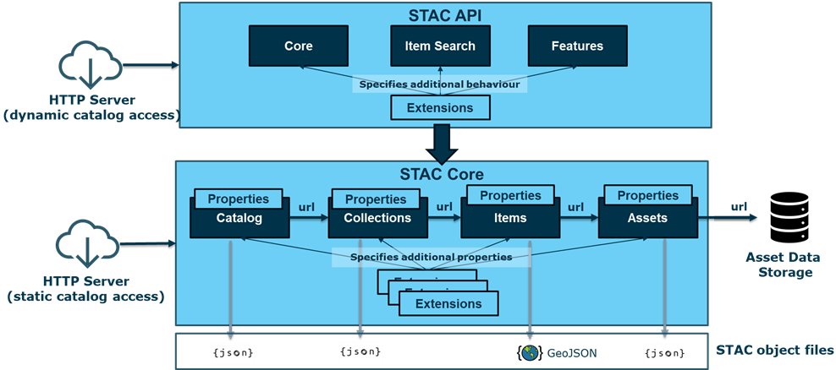

The STAC specification is composed of two main sub-parts:
- The STAC Core, that specifies the STAC Objects that constitute the STAC Data Model, and
- The STAC API, that specifies the set of operations that can be performed on the STAC Objects leveraging an HTTP API.
This document establishes requirements and recommendations for the implementation of STAC in EOF PRIP instances, independently of the specific Sentinel Mission served by each PRIP. Mission-specific requirements and tailoring are defined in an independent document, named "tailored ICD" in the following.
Therefore, it is expected that any PRIP instance involved in the applicable Sentinel missions complies with:
- The requirements and recommendations defined in [STAC_EOF_ICD],
- The requirements and recommendations contained in the present document

OGC API – Processes description
Reference to [LTA_ICD], chapter 2.3

Scope of the document
This document is applicable to the following functions that are provided by PRIP instances:
- Query PRIP Product Catalogue
- Download PRIP Products
- On-Demand Processing
- Subscription and Notification
- Export PRIP Catalogue (in a next version)

Compared to the legacy PRIP ICD based on OData [PRIP_ICD], the current document does not address the following PRIP functions:
- Production Metrics
- Retrieve PRIP Production Report (for end-to-end monitoring purposes)
This specification is assumed to be applicable in conjunction with the adoption of the new Sentinel product format, EOPF.

Each statement is formulated according to the following example:
<ID> – <Title>
Text of the statement.

The first line includes the following fields:
- For Query functionalities: <ID> Id of the requirement or recommendation in the form STAC-PRIP-<CAT>-REQ-<XXXX> (for a requirement) or STAC-PRIP-<CAT>-REC-<XXXX> (for a recommendation)
- <CAT> is the related STAC category:
- CORE: General requirement related to STAC Core
- API: PRIP API
- CAT: Catalog
- COL: Collection
- ITEM: Item
- ASSET: Asset
- <XXXX> is the four-digit ID of the statement.
- For OD processing functionalities: <ID> Id of the requirement or recommendation in the form OD-PRIP-PRO-REQ-<XXXX> (for a requirement) or OD-PRIP-PRO-REC-<XXXX> (for a recommendation)
- <Title> The title of the statement.
The following lines are the body (text) of the requirement or recommendation. For a requirement, we use the modal “shall” whereas a “recommendation” is expressed with the modal “should”.

PRIP Interface description

Architecture overview
The following diagram describes the high-level architecture that underpins the PRIP interface.

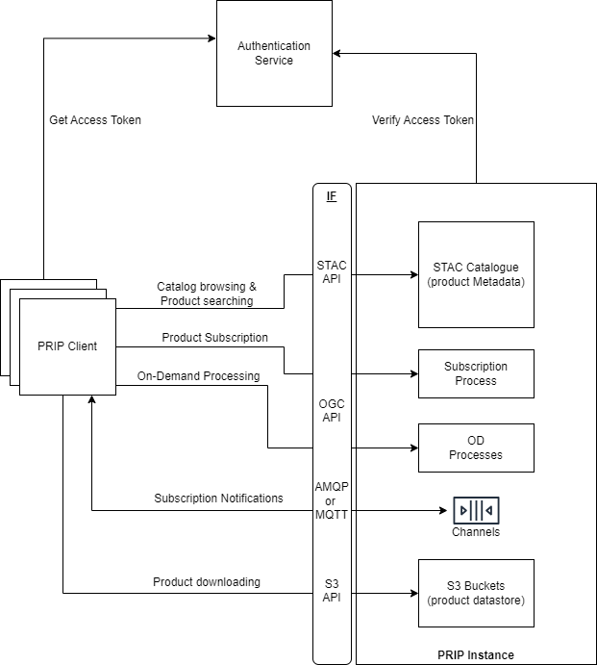
Figure 1: PRIP Interfaces

This architecture highlights the following components:
- The PRIP Instance, which embeds:
The STAC Catalogue, that exposes a standard STAC API for browsing and searching the collections and products managed by the instance and for retrieving their metadata.
OGC API - Processes for OD processing and Subscription
Pub/Sub channels for Notification sending
A set of S3 Buckets, that store the managed products and expose the S3 API to allow the downloading of those products.
The PRIP Clients, that use the various APIs (STAC Catalogue API, S3 API, OGC API) for searching, ordering and downloading products that match their area of interest.
The Authentication Service that supports the centralized authentication service by providing an OIDC interface so that:
PRIP Clients retrieve an access token that shall be included in any request sent to the STAC Catalog API and OGC API
PRIP Instance validate the access tokens found in the incoming requests to ensure they are valid.

Nominal use scenario description
The nominal use scenario for discovery and download of products from a PRIP is shown in the figure below:

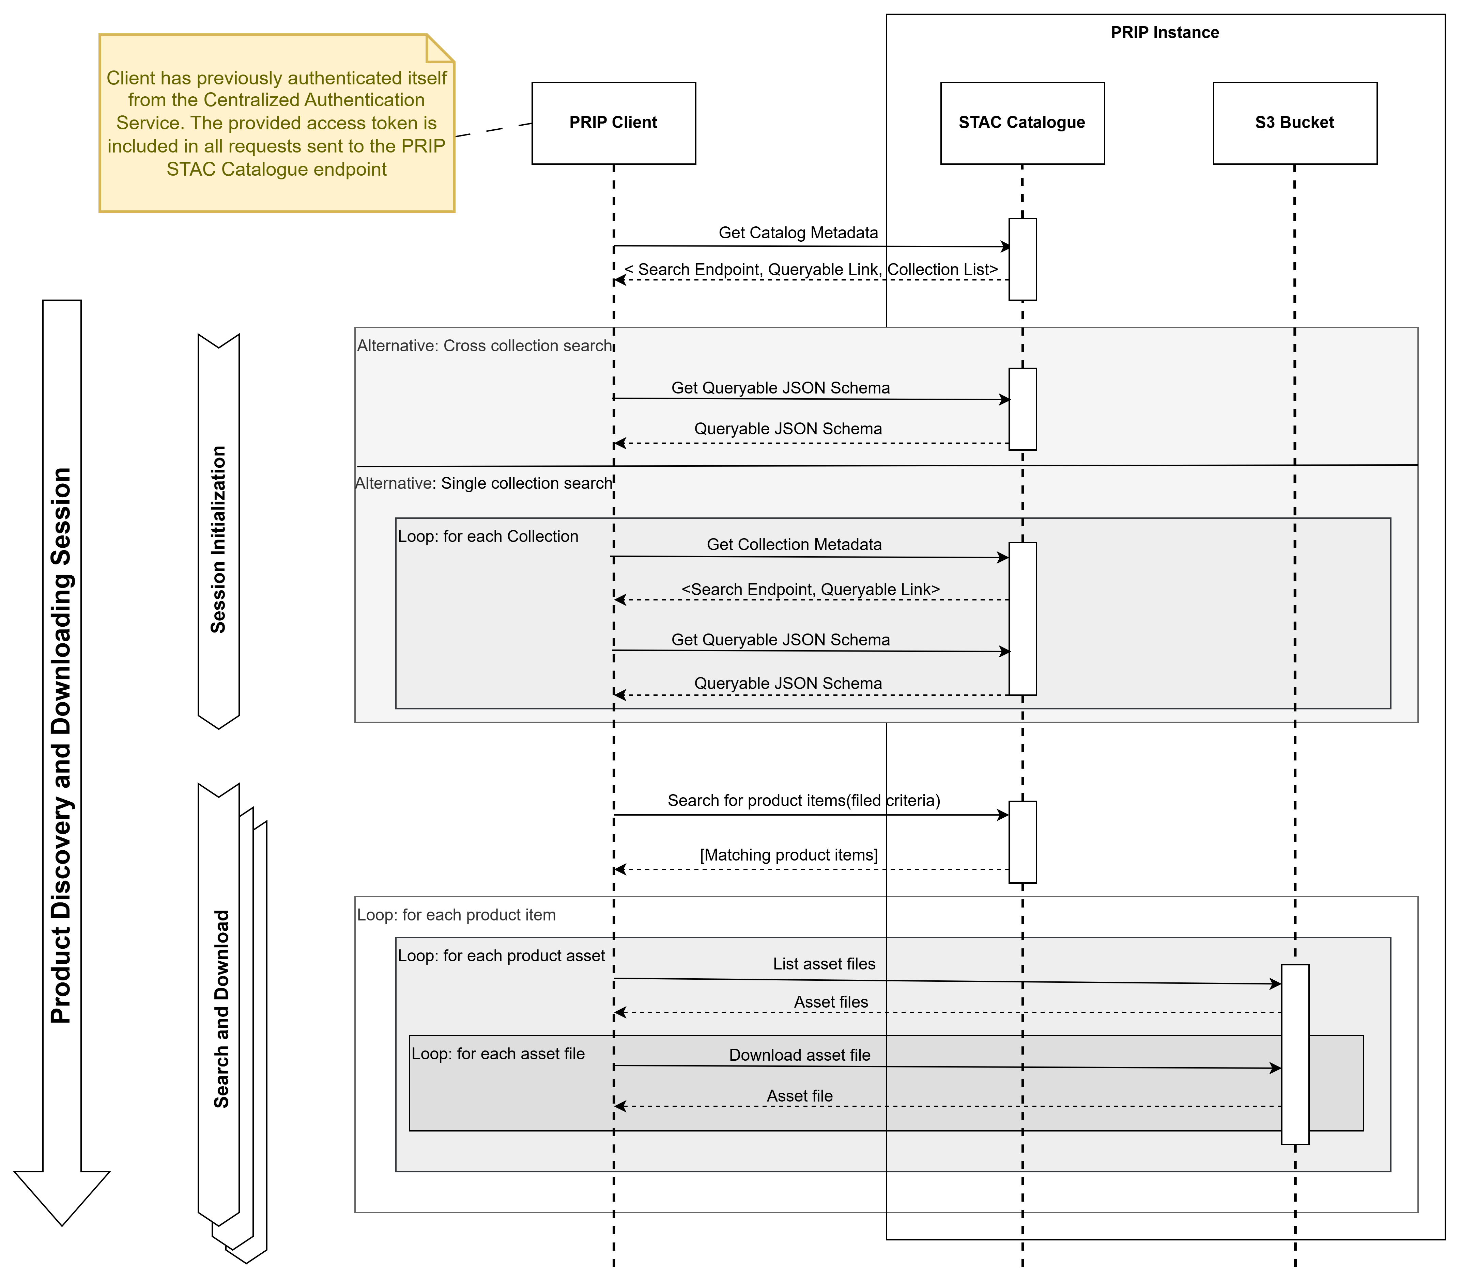
Figure 2: Sequence diagram for nominal scenario

It is mandatory that the PRIP Client retrieves from the Centralized Authentication Service an Access Token. This Access Token shall be included in all requests sent to the STAC Catalogue endpoint. The latter is responsible for validating this token and ensuring the client is authorized to access the requested information. For the sake of clarity and concision, these interactions are not shown in the diagram above.
First, during the session initialization, the PRIP Client shall retrieve from the STAC Catalogue root page the Catalogue metadata, which provide in particular:
- The HTTP endpoint to perform cross collection searching.
- The link to the Queryable JSON Schema that specifies the product metadata fields that can be provided as query parameters for future search requests.
- The list of links to the managed product collections.
From this point, the PRIP Client is able to perform two kinds of queries for searching products:
Cross collection search queries.
Single collection search queries.
For cross collection search queries, the PRIP Client shall retrieve the Queryable JSON Schema provided in the STAC Catalogue root page.
For single collection search queries, the PRIP Client shall first retrieve the related collection metadata. From those metadata, it shall extract the corresponding Queryable JSON schema and the search endpoint. This shall be performed for any collection that will be requested in the next steps.
Once the PRIP Client has retrieved the relevant Queryable JSON schema and search endpoint, it can perform product search queries, ensuring that provided metadata field criteria comply with the Queryable JSON Schema.
As a result of a search query, the PRIP Client retrieves a set of STAC Items. Each of them includes properties backed by STAC Core specification or STAC extensions and a list of STAC Assets. Each asset provides a link to the corresponding files stored in S3 buckets. From those STAC Assets, the PRIP Client is able to download the related files by querying S3 buckets. As with STAC Catalog access, all requests sent to the S3 bucket must be authenticated by leveraging the authentication mechanism provided by the object storage provider (not shown in the diagram above).
Note that the PRIP Client may repeat those searches and download requests as many times as needed for the ongoing session.
As part of the EOPF specification, each Product is formatted as a Zarr file structure. Here is a sample of such a structure:

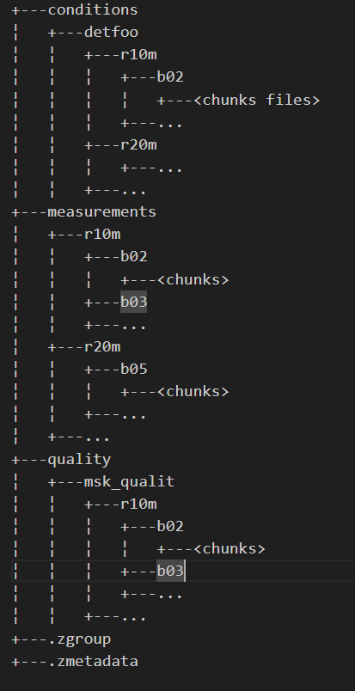

At the root of the file structure, .zmetadata file identifies this folder as a Zarr content. Under the measurements folder, the various band data for each resolution can be found.
The Zarr format allows a client to download and exploit:
- Either the entire Zarr content,
- Or an individual group of measures, for example the data of a given band.

Thus, for the purpose of this ICD, Product Items returned in response to a Catalogue query include a STAC Asset for the downloading of the entire Zarr content and an Asset for each individual band or resolution. The detailed list of exposed assets is mission specific and shall be defined in the relevant EOPF product specification.
This implies that the Zarr file structure is stored as is in a S3 bucket, that is each file of the Zarr content is copied as a S3 object, keeping the relative path from the root folder as a S3 prefix. From the PRIP client point of view, retrieving an asset requires to:
- list all S3 objects sharing the prefix provided by the asset link, leveraging the ListObjectsV2 S3 operation
- download each object whose reference has been returned by the previous operation, leveraging the S3 GetObject operation. The PRIP client shall ensure to keep the file structure defined by the full Object key when storing an object on the local file system.

PRIP Data Model
The main feature implemented by PRIP is to allow remote EOF Services, such as LTA or CDSE, to query the PRIP Product Catalogue and download products referenced in the responses of those queries.
For this purpose, PRIP leverages a Data Model represented by the following figure:
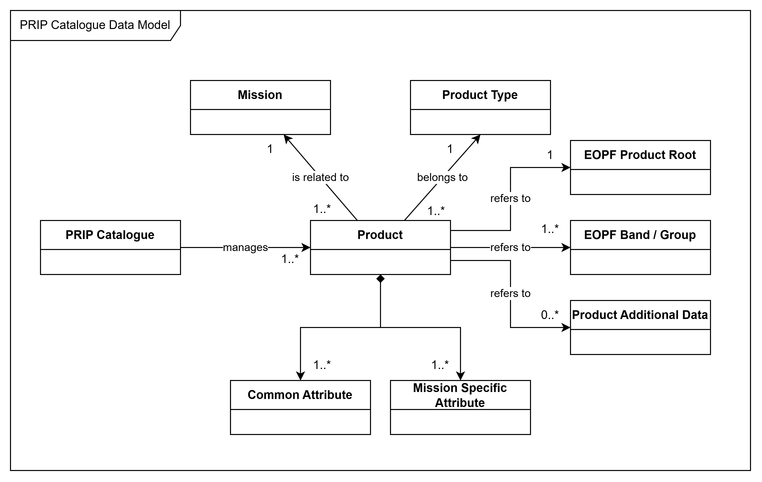
Figure 3: PRIP Catalogue Data Model
Each PRIP Catalogue instance manages a set of Products related to a given mission. Each Product belongs to a Product Type and is described by a set of common attributes and mission specific attributes. Each Product maintains:
- a reference to the full EOPF Product Zarr structure,
- a set of references to the EOPF product assets
- a set of references to production additional data.
Those references allow a PRIP client to download the related content.
Based on this high-level data model, the following table provides the relationship between each entity of the PRIP data Model and the STAC metamodel:

PRIP Data Model entities | Related STAC Metamodel element
PRIP Catalogue Instance | STAC Catalogue
Product Type | STAC Collection
Product | STAC Item
Product attributes | STAC Item properties
Reference to Product Files | STAC Asset

The following sections state the requirements applicable to any PRIP instance to properly map the PRIP Data Model to the STAC Core metamodel.

STAC Catalogue requirements
STAC-PRIP-CAT-REQ-0010 – Mapping PRIP Catalogue instance to STAC Catalogue
The PRIP instance shall implement and expose a STAC Catalogue for the purpose of querying the products managed by the PRIP.

The STAC Catalogue for Production Services will typically manage the production of a single satellite unit.
STAC-PRIP-CAT-REQ-0011 – Compliance with high level STAC Core requirements
The PRIP STAC Catalogue shall comply with the STAC Core requirements stated in [STAC_EOF_ICD].

Here is a sample of the returned JSON response when retrieving the Catalogue landing page.

{
"type": "Catalog",
"id": "s2a-prip",
"title": "Sentinel 2A PRIP Catalogue",
"description": "PRIP Catalogue for Sentinel 2A",
"stac_version": "1.1.0",
"conformsTo": [
"http://www.opengis.net/spec/cql2/1.0/conf/cql2-json",
"http://www.opengis.net/spec/cql2/1.0/conf/cql2-text",
"https://api.stacspec.org/v1.0.0/item-search",
"https://api.stacspec.org/v1.0.0/ogcapi-features",
"http://www.opengis.net/spec/ogcapi-features-3/1.0/conf/features-filter",
"https://api.stacspec.org/v1.0.0-rc.3/ogcapi-features/extensions/transaction",
"https://api.stacspec.org/v1.0.0/item-search#sort",
"https://api.stacspec.org/v1.0.0/collections",
"https://api.stacspec.org/v1.0.0/item-search#fields",
"https://api.stacspec.org/v1.0.0/item-search#query",
"http://www.opengis.net/spec/ogcapi-features-3/1.0/conf/filter",
"http://www.opengis.net/spec/cql2/1.0/conf/basic-cql2",
"http://www.opengis.net/spec/ogcapi-features-1/1.0/conf/oas30",
"https://api.stacspec.org/v1.0.0-rc.2/item-search#filter",
"https://api.stacspec.org/v1.0.0-rc.2/item-search#context",
"http://www.opengis.net/spec/ogcapi-features-1/1.0/conf/core",
"https://api.stacspec.org/v1.0.0/core",
"http://www.opengis.net/spec/ogcapi-features-1/1.0/conf/geojson"
],
"links": [
{
"rel": "self",
"type": "application/json",
"href": "https://s2a-prip.copernicus.esa.int/"
},
{
"rel": "root",
"type": "application/json",
"href": "https://s2a-prip.copernicus.esa.int/"
},
{
"rel": "data",
"type": "application/json",
"href": "https://s2a-prip.copernicus.esa.int/collections"
},
{
"rel": "conformance",
"type": "application/json",
"title": "STAC/OGC conformance classes implemented by this server",
"href": "https://s2a-prip.copernicus.esa.int/conformance"
},
{
"rel": "search",
"type": "application/geo+json",
"title": "STAC search",
"href": "https://s2a-prip.copernicus.esa.int/search",
"method": "GET"
},
{
"rel": "search",
"type": "application/geo+json",
"title": "STAC search",
"href": "https://s2a-prip.copernicus.esa.int/search",
"method": "POST"
},
{
"rel": "http://www.opengis.net/def/rel/ogc/1.0/queryables",
"type": "application/schema+json",
"title": "Queryables",
"href": "https://s2a-prip.copernicus.esa.int/queryables",
"method": "GET"
},
{
"rel": "child",
"type": "application/json",
"title": "Sentinel-2 Level-1C",
"href": "https://https://s2a-prip.copernicus.esa.int/collections/sentinel-2-level-1C"
},
{
"rel": "child",
"type": "application/json",
"title": "Sentinel-2 Level-2A",
"href": "https://https://s2a-prip.copernicus.esa.int/collections/sentinel-2-level-2A"
},
{
"rel": "service-desc",
"type": "application/vnd.oai.openapi+json;version=3.0",
"title": "OpenAPI service description",
"href": "https://s2a-prip.copernicus.esa.int/api"
},
{
"rel": "service-doc",
"type": "text/html",
"title": "OpenAPI service documentation",
"href": "https://s2a-prip.copernicus.esa.int/api.html"
}
],
"stac_extensions": []
}

STAC Collection requirements

STAC-PRIP-COL-REQ-0020 – Mapping PRIP Sentinel Missions to STAC Collections
The PRIP instance shall implement and expose a STAC Collection for each Product Type it manages.

STAC-PRIP-COL-REQ-0030 – PRIP STAC Collection mandatory properties
The PRIP instance shall ensure that the following STAC Collection properties are set as specified:
- "id": product type identifier
- "title": display name of the collection
- "description": short description of the collection
- "links": links to related STAC entities; it shall include at least the following relations:
"root": the link to the root page, that is the root URL to reach the PRIP Catalogue instance
"parent": same as root
"self": the link to retrieve the current Collection definition
- "items": the link to access to the STAC Items belonging to the Collection
- "queryables": the link to the JSON Schema that defines all the criteria that are supported by the query function. This schema shall be defined by the mission specific configuration.
- "item_assets": the list of common assets for each STAC Item belonging to this collection, and their description
- "stac_version": the STAC Core specification version; shall be set to 1.1.0
- "stac_extensions": the list of STAC Core extensions used to define the current Collection.

Here is an example of the expected JSON response when retrieving a STAC Collection managed by the PRIP instance:
{
"id": "sentinel-2-l1c",
"type": "Collection",
"links": [
{
"rel": "items",
"type": "application/geo+json",
"href": "https://s2a-prip.copernicus.esa.int/collections/sentinel-2-l1c/items"
},
{
"rel": "parent",
"type": "application/json",
"href": "https://s2a-prip.copernicus.esa.int/"
},
{
"rel": "root",
"type": "application/json",
"href": "https://s2a-prip.copernicus.esa.int/"
},
{
"rel": "self",
"type": "application/json",
"href": "https://s2a-prip.copernicus.esa.int/collections/sentinel-2-l1c"
},
{
"rel": "http://www.opengis.net/def/rel/ogc/1.0/queryables",
"href": "https://s2a-prip.copernicus.esa.int/collections/sentinel-2-l1c/queryables",
"type": "application/schema+json",
"title": "Queryables"
}
],
"title": "Sentinel-2 Level-1C",
"description": "The Level-1C product is composed of 110x110 km2 tiles (ortho-images in UTM/WGS84 projection). Earth is subdivided on a predefined set of tiles, defined in UTM/WGS84 projection and using a 100 km step. However, each tile has a surface of 110x110 km² in order to provide large overlap with the neighbouring. The Level-1C product results from using a Digital Elevation Model (DEM) to project the image in cartographic geometry. Per-pixel radiometric measurements are provided in Top Of Atmosphere (TOA) reflectances along with the parameters to transform them into radiances.",
"item_assets": {
"product": {
"gsd": 10,
"type": "application/vnd+zarr",
"roles": [
"data",
"reflectance"
],
"title": "Full EOPF Product",
"auth:refs": [
"s3"
]
},
"b02": {
"gsd": 10,
"name": "Band 2",
"type": "application/vnd+zarr",
"roles": [
"data",
"reflectance"
],
"title": "Blue (band 2) - 10m",
"auth:refs": [
"s3"
]
}
// ... other asset descriptions
},
"auth:schemes": {
"s3": {
"type": "s3"
},
"oidc": {
"type": "openIdConnect",
"openIdConnectUrl": "https://identity.copernicus.eu/auth/realms/EOF/.well-known/openid-configuration"
}
},
"stac_version": "1.1.0",
"stac_extensions": [
"https://stac-extensions.github.io/item-assets/v1.0.0/schema.json",
"https://stac-extensions.github.io/authentication/v1.1.0/schema.json",
"https://stac-extensions.github.io/projection/v1.1.0/schema.json",
"https://stac-extensions.github.io/product/v0.1.0/schema.json",
]
}

STAC Item and Asset requirements
The following requirements are applicable to any PRIP instance, whatever the related Sentinel mission.

STAC-PRIP-ITEM-REQ-0040 – STAC Items available in each collection
For each STAC collection (corresponding to a product type) it exposes, the PRIP instance shall publish and make available each product belonging to this collection. Each product shall be described as a distinct STAC Item.

STAC-PRIP-ITEM-REQ-0050 – STAC Items common properties
Any Items delivered by the PRIP instance shall at least include the properties listed in following table.
Note : all the properties related to time information shall have a microsecond precision.

Meaning of the table's columns:
- Field Name: Full name of the field
- JSON path in Item: JSON path expression of the field in the STAC Item
- STAC Core or Extension: Set to STAC Core when the field is defined by STAC Core specification or the Full Name of the STAC Extension that defines the related field
- Provider: 'EOPF' if the value is retrieved from the EOPF product metadata; 'PRIP' when the value is directly provided by the PRIP instance.

Field Name | JSON path in Item | STAC Core or Extension | Provider | Expected value |  | Queryable
Id | $.id | STAC Core | EOPF | Name of the corresponding product without the file extension (generally the name of the EOPF product). | yes
Item Type | $.type | STAC Core | EOPF | Shall be set to "Feature"
Geo Footprint | $.geometry | STAC Core | EOPF | GeoJSON geometry that represents the product geo footprint. The inner "type" and "coordinates" attributes shall be set accordingly. | yes
Bounding Box | $.bbox | STAC Core | EOPF | The bounding box coordinates of the product.
Origin Datetime | $.properties.eopf:origin_datetime | EOPF | PRIP | Timestamp of the availability of all CADU data on the CADIP/XBIP.
Creation Date | $.properties.created | STAC Core | PRIP | Creation date and time of the corresponding STAC item into the PRIP instance Catalogue.
Publication Date | $.properties.published | Timestamps | PRIP | Timestamp of the availability of the current Item in the PRIP instance Catalogue. | yes
Update Date | $.properties.updated | STAC Core | PRIP | If STAC Item properties have been updated, timestamp of the last update.
Expiration Date | $.properties.expires | Timestamps | PRIP | Timestamp when the Item will no longer be available in the PRIP instance Catalog
Datetime | $.properties.datetime | STAC Core | EOPF | Timestamp of the satellite observation related to the product. In case of a time range acquisition, it shall be set to the middle of the start and end time of the acquisition, as per STAC-CORE-ITEM-REQ-0170. | yes
Start Datetime | $.properties.start_datetime | STAC Core | EOPF | Start datetime of the satellite observation related to the product. In case of a single time acquisition, it shall be set to the Datetime field, as per STAC-CORE-ITEM-REQ-0170. | yes
End Datetime | $.properties.end_datetime | STAC Core | EOPF | End datetime of the satellite observation related to the product. In case of a single time acquisition, it shall be set to the Datetime field, as per STAC-CORE-ITEM-REQ-0170. | yes
Product Type | $.properties.product:type | Product | EOPF | See allowed product types in [Erreur ! Source du renvoi introuvable.] | yes
Product Timeliness | $.properties.product:timeliness | Product | EOPF | Timeliness of the product.
Product Timeliness Category | $.properties.product:timeliness_category | Product | EOPF | Timeliness category of the product.
Production Type | $.properties.processing:lineage | Processing | EOPF | Information on the production type.
Mission | $.properties.mission | Stac Core | EOPF | Name of the space program to which the constellation belongs (ex: copernicus)
Constellation | $.properties.constellation | Stac Core | EOPF | Name of the constellation, e.g.: sentinel-1 or sentinel-2.
Platform | $.properties.platform | STAC Core | EOPF | Platform involved in the data acquisition of the product. It shall be set according to STAC-CORE-GEN-REC-0020. It is mission specific and shall be defined in tailored ICDs.  e.g: sentinel-1a | yes
Instruments | $.properties.instruments | Core | EOPF | List of instrument names, e.g.:  "instruments": [  "olci"  ]
Orbit cycle | $.properties.sat:orbit_cycle | Satellite | EOPF | The number of repeat cycle done by the satellite at the time of the acquisition
Absolute Orbit Number | $.properties.sat:absolute_orbit | Satellite | EOPF | Satellite absolute orbit number at the time of observation | yes
Relative Orbit Number | $.properties.sat:relative_orbit | Satellite | EOPF | Satellite relative orbit number at the time of observation | yes
Orbit State | $.properties.sat:orbit_state | Satellite | EOPF | Satellite orbit state at the time observation, may be "ascending" or "descending" | yes
Processing Level | $.properties.processing:level | Processing | EOPF | Depending on the Sentinel missions, possible values are:  - "L1"  - "L1B"  - "L1C"  - "L2"  - "L2A"
Processing Version | $.properties.processing:version | Processing | EOPF | Processing algorithm version, e.g:  "05.10" | yes
Processing Date | $.properties.processing:datetime | Processing | EOPF | Processing date and time of the corresponding product.
Processing Facility | $.properties.processing:facility | Processing | EOPF | The name of the PRIP instance that produced the product.
Processing Software | $.properties.processing:software | Processing | EOPF | A dictionary with name/version for key/value describing one or more applications or libraries that were involved during the production of the data for provenance purposes.
STAC Version | $.stac_version | Core | PRIP | Shall be set to "1.1.0"
STAC Extensions | $.stac_extensions | Core | PRIP | Shall include the list of all the STAC extension schema URL used to describe the Item (see STAC-PRIP-CORE-REQ-300).
Links | $.links | Core | PRIP | The links related to the current Item. See STAC-CORE-ITEM-REQ-0150 from [STAC_EOF_ICD]
Collection | $.collection | Core | PRIP | Name of the parent collection (shall be identical to the Product Type attribute). | yes

STAC-PRIP-ITEM-REQ-0060 – STAC Items $.id field’s uniqueness
The $.id field of an item shall be unique across all collections in the STAC catalog hosted by The PRIP instance, and implementations must prevent the creation of STAC items with the same ID in multiple collections.

STAC-PRIP-ITEM-REQ-0070 – Expected STAC Assets
Any items delivered by the PRIP instance shall include at least the following Assets:
- Asset related to the full EOPF Product
- Asset related to the individual or group of bands of the Product

STAC-PRIP-ITEM-REQ-0080 – Name of the STAC Asset related to the EOPF product
The name (JSON key) of the STAC Asset related to the full EOPF product package shall be "product".

STAC-PRIP-ITEM-REC-0085 – Thumbnail asset
Each STAC item exposed by the PRIP instance should include an asset representing a thumbnail of the full EOPF product. The PRIP instance should ensure the download of the thumbnail file from the corresponding URL.

Note: This thumbnail is useful when browsing the PRIP instance STAC catalog through the STAC Browser.
Note 2: See STAC-CORE-ASSET-REQ-0300 for proper implementation of this recommendation.

STAC-PRIP-ITEM-REQ-0087 – Exposed assets related to sub-elements of the EOPF product
Each STAC Item exposed by the PRIP instance shall include and allow the download of all the assets identified in the [Erreur ! Source du renvoi introuvable.] for the corresponding STAC collection (a.k.a. product type).

STAC-PRIP-ITEM-REQ-0090 – STAC Asset properties
The STAC Assets included in Items published by PRIP Instance shall include the properties listed in the following table:

Field Name | JSON path in Item | STAC Core or Extension | Expected value
Download URL | $.assets.<asset_name>.href | STAC Core | S3 URL of the corresponding ZARR folder in the following form:  s3://<bucket>/<path>  The <path> is an S3 prefix allowing to list all the S3 objects matching this prefix.
Title | $.assets. <asset_name>.title | STAC Core | The title of the asset
Type | $.assets. <asset_name>.type | STAC Core | The media type be set to "application/vnd+zarr"
Roles | $.assets. <asset_name>.roles | STAC Core | The role list shall include following items:  - "data"  - "metadata"
Local Folder  Name | $.assets. <asset_name>.file:local_path | File Info | Name of the full folder path, for example : "<product_id>.zarr/measurements/r10m/b02/"
File size | $.assets.<asset_name>.file:  size | File Info | Size of the file: only relevant for asset targeting the full zarr product
File checksum | $.assets.<asset_name>.file:  checksum | File Info | File checksum: only relevant for asset targeting the full zarr product
Authentication scheme | $.assets.<asset_name>.auth:refs | Authentication | Reference to the authentication scheme defined in the auth:schemes of the item properties

STAC-PRIP-ITEM-REQ-0100 – STAC Asset href
The STAC Asset href property is a S3 compliant URL. It shall have the following form: s3://<bucket_name>/<product_path>
The <product_path> shall have one of the following forms:
- <product_id>.zarr/ to point to the Full EOPF Product content identified by <product_id>
- <product_id>.zarr/<folder>/<subfolder>/ to point to the ZARR sub-folder with the relative path <folder>/<subfolder> (the number of levels of the subfolder hierarchy is not limited)

STAC-PRIP-ITEM-REQ-0101 – Bucket naming convention
The STAC Asset shall be stored within a bucket whose name matches the following form:
prip-<provider>-<productType>
with provider = the name of Service provider
Note about spacial character : when the name of a product type contains one or several '_' characters (forbidden in bucket names), they shall be replaced with '-' characters, or removed if it's a trailing character.

Example for a Zarr product with ID S02MSIL2A_20230629T120347_0000_A064_TC64.zarr, stored in bucket “prip-<provider>-sentinel-2-l2a” (note that “<provider>” must be replaced by the service provider name):

Asset Type | S3 url
Full EOPF Product | s3://prip-<provider>-sentinel-2-l2a/ S02MSIL2A_20230629T120347_0000_A064_TC64.zarr/
Band 02 | s3://prip-<provider>-sentinel-2-l2a/ S02MSIL2A_20230629T120347_0000_A064_TC64.zarr/measurements/reflectance/r10m/b02/

STAC Extensions
STAC-PRIP-CORE-REQ-0102 – STAC Extensions
The PRIP instance shall implement the following STAC extensions and the related minimal version

Extension Name | Minimal version | Reference
Satellite | 1.1.0 | [STAC_SATELLITE_EXTENSION]
Product | 1.0.0 | [STAC_PRODUCT_EXTENSION]
Processing | 1.2.0 | [STAC_PROCESSING_EXTENSIONSTAC_PRODUCT_EXTENSION]
Scientific Citation | 1.0.0 | [STAC_SCIENTIFIC_EXTENSION]
Electro Optical | 2.0.0 | [STAC_EO_EXTENSION]
Grid | 1.1.0 | [STAC_GRID_EXTENSION]
View Geometry | 1.1.0 | [STAC_VIEW_EXTENSION]
SAR | 1.3.0 | [STAC_SAR_EXTENSION]
EOPF | 1.2.0 | [STAC_EOPF_EXTENSION]
Timestamps | 1.1.0 | [STAC_TIMESTAMP_EXTENSION]
Authentication | 1.1.0 | [STAC_AUTHENTICATION_EXTENSION]
File Info | 2.1.0 | [STAC_FILE_INFO_EXTENSION]

Search and download product API
This section formalizes the requirements applicable to PRIP Instances and PRIP Clients to implement PRIP Search and download products based on the principles described in §3.2.

PRIP instance requirements
This section defines the requirements applicable to any PRIP instance for allowing PRIP Clients to search and download products leveraging:
- OpenID Connect and JWT standards for authentication and authorization
- STAC API specification for searching capabilities
- AWS S3 API for downloading products

Search capability requirements
STAC-PRIP-API-REQ-0200 – STAC API requirements
The PRIP instance shall be compliant with all the requirements specified in section §4 of document [STAC_EOF_ICD]. This includes:
- General Requirements
- Simple search capabilities
- Advanced search capabilities

STAC-PRIP-API-REQ-0203 – STAC API limit parameter
The PRIP instance shall allow to configure the maximum number of objects (collections or items) returned by a STAC query. This limit shall not be less than 100.

STAC-PRIP-API-REQ-0205 – STAC API Extensions
The PRIP instance shall implement the following STAC API extensions and the related minimal version

Extension Name | Minimal version | Reference
Filter | 1.0.0-rc4 | [STAC_API_FILTER_EXTENSION]
Sort | 1.0.0 | [STAC_API_SORT_EXTENSION]
Field | 1.0.0 | [STAC_API_FIELDS_EXTENSION]

STAC-PRIP-API-REQ-0207 – Queryable fields
The PRIP instance shall allow clients to create filters based on the following fields:
- The common properties that are listed in STAC-PRIP-ITEM-REQ-0050 and marked as “queryable”
- Mission specific properties that are defined in the [Erreur ! Source du renvoi introuvable.] for the corresponding product type

Note: It implies that the queryable schemas managed by PRIP instance shall be set accordingly.

Authentication and authorization requirements
STAC-PRIP-API-REQ-0208 – Compliance to Central Authentication Service
The PRIP instance shall comply with [AUTHENTICATION_SERVICE_ICD] to ensure the authentication of the client.

STAC-PRIP-API-REQ-0210 – Access control to the STAC Catalogue
The PRIP instance shall implement an authorization mechanism that allows to grant (or deny) individual clients at different levels:
- global access to the PRIP Catalogue;
- access to each individual PRIP Collection.

STAC-PRIP-API-REQ-0220 – Global access control semantics
Global access control shall be applied priorly to collection access control.
Global access is required to:
- retrieve the metadata of the Catalogue object
- retrieve the metadata of the underlying Collections, the metadata of the included Items, and to download the related asset files.
If global access is denied for a Client, any STAC API requests it sends shall result in a 403 HTTP Status code response and the corresponding error message. In this case, access to the underlying collections shall be denied too.

STAC-PRIP-API-REQ-0230 – Collection access control semantics
Collection access is required to:
- retrieve the metadata of the Collection object;
- retrieve the metadata of the Items included in this Collection and download the related asset files.

STAC-PRIP-API-REQ-0240 – Role based access control
The authorization mechanism shall rely on the “Client roles” specified through the corresponding JWT claims. The JWT is provided as a Bearer token in the incoming request.

STAC-PRIP-API-REQ-0250 – Configurable access control
The authorization mechanism implemented by the PRIP instance shall be configurable.

STAC-PRIP-API-REQ-0260 – Zero downtime access control configuration change
It shall be possible to update the access control configuration with no downtime.

Download capability requirements

STAC-PRIP-API-REQ-0300 – S3 data storage
The PRIP instance shall store products it manages in S3 buckets.

STAC-PRIP-API-REQ-0305 – S3 object checksum
The PRIP instance shall use the checksum feature of the underlying S3 infrastructure to associate a checksum with each object stored in S3 buckets. In case the Multipart upload method is used, it shall:
- choose the “full object checksum” type,
- specify a suitable algorithm for checksum calculation (CRC64NVME, CRC32 or CRC32C)
Note: This checksum is used by the PRIP client to check the file integrity of the downloaded objects.

STAC-PRIP-API-REQ-0310 – Keeping the Zarr file Structure
The PRIP instance shall preserve the Zarr file structure when storing a product in a S3 bucket. This implies that:
- Each individual file of the Zarr product is stored as a S3 object;
- The file relative path from the root folder of the Zarr product is the prefix of the corresponding S3 object;
- "/" is the delimiter for any listing operations.

STAC-PRIP-API-REQ-0320 – S3 API endpoint for downloading products
The PRIP instance shall expose a S3 API endpoint to allow PRIP clients to download the products it manages.

STAC-PRIP-API-REQ-0330 – S3 API endpoint authentication and authorization
The PRIP instance shall authenticate any requests to the S3 API endpoint it manages. It shall authorize download requests consistently with respect to STAC-PRIP-API-REQ-210.

Note: as per STAC-PRIP-ITEM-REQ-0101, each asset file is backed by an S3 bucket related to the collection/product type.

STAC-PRIP-API-REC-0335 – download quotas exceeded
The PRIP instance should implement a quota management on downloaded assets by each individual client
In case an LTA client has consumed its allowed quotas, an HTTP status code 429 (“Too Many Requests) is sent in the response with the necessary information, including the datetime when the quotas will be reset.
Note: For each client, it should be possible to configure the size of data per unit of time to download (for example, n Tbytes per month). Quota adjustment should be managed at operations level.

PRIP Client requirements

STAC-PRIP-API-REQ-0340 – STAC compliance
PRIP Clients shall compls with STAC Core 1.1.0 and STAC API 1.0.

STAC-PRIP-API-REQ-0350 – PRIP Catalogue search
When searching for products managed by a PRIP instance, the PRIP Client shall apply:
- [STAC_API_FILTER_EXTENSION] for cross-collection search
- [STAC_API_FEATURE_SPEC] for single collection search
- The compliance classes provided in the STAC Catalogue root page in the conformsTo property.

STAC-PRIP-API-REQ-0360 – PRIP Catalogue search
When searching for products managed by a PRIP instance, the PRIP Client shall apply:
- [STAC_API_FILTER_EXTENSION] for expressing criteria on the resulting product Items
- [STAC_API_FIELDS_EXTENSION] for defining the fields that shall be included in or excluded from the resulting STAC items
- [STAC_API_SORT_EXTENSION] for defining the sorting logic on the resulting STAC items

STAC-PRIP-API-REQ-0365 – Compliance to Queryables schemas
When searching for products managed by a PRIP instance, the PRIP Client shall verify that the fields provided as search criteria comply with:
- the Queryable JSON schema provided in the STAC Catalogue root page when performing cross-collection search;
- the Queryable JSON schema provided in a Collection page when performing a search within that collection.

STAC-PRIP-API-REQ-0370 – PRIP Client authentication for STAC browsing
When searching for products managed by a PRIP instance, the PRIP Client shall include in any HTTP request it sends to the PRIP instance an access token previously gathered from the centralized Authentication Service. This token shall be provided in the request an Authorization Bearer token HTTP Header, of the following form:
- Authorization: Bearer <token>

STAC-PRIP-API-REQ-0380 – Keeping an access token up to date
The PRIP Client is responsible for keeping its access token up to date implementing the refresh token OIDC flow.

STAC-PRIP-API-REQ-0390 – S3 Compliance
The PRIP Client shall comply with [S3_API] when downloading products from a PRIP instance S3 API endpoint.

STAC-PRIP-API-REQ-0391 – PRIP Client authentication for S3 accesses
The PRIP Client shall implement the authentication mechanism related to the PRIP instance S3 API endpoint.
Note: This mechanism is specific to each PRIP instance, as it relies on the S3 implementation provided by the Cloud provider hosting the PRIP instance. Therefore, it shall be specified in tailored ICDs.

STAC-PRIP-API-REQ-0400 – Asset download
The PRIP Client shall use the S3 URL provided in any PRIP Asset as a prefix . In order to retrieve the content from this prefix, the PRIP Client shall:
- List all the objects matching this prefix, using the ListObjectsV2 operation.
- Download all the objects from the previous list operation, using the GetObject operation
- Store locally each object as a file, preserving the folder structure reflected in the object key and the "/" delimiter

STAC-PRIP-API-REQ-0410 – object checksum verification
The PRIP client shall use the checksum feature of the S3 API to verify the integrity of each downloaded object.

Use case examples
This section provides some examples of interactions between a PRIP Client and a PRIP Instance. For the examples, the following CLI executables are used:
- curl to interact with the STAC Catalogue endpoint
- AWS CLI to interact with the S3 endpoint

In the following examples, it is assumed that:
- The PRIP Client has already retrieved from the Centralized Authentication Service an access token whose content is <TOKEN>
- The STAC Catalogue endpoint is https://s2a-prip.copernicus.esa.int/
- aws-cli is configured with the proper S3 endpoint URL, access key and secret key to access the PRIP S3 endpoint.

Retrieving the STAC Catalogue root page
The following command allows to retrieve the Catalogue metadata, needed for the next operations:
curl -H "Authorization: Bearer <TOKEN>" -H "Accept: application/json" https://s2a-prip.copernicus.esa.int/

The response has the following form:
{
"type": "Catalog",
"id": "s2a-prip",
"title": "Sentinel 2A PRIP Catalogue",
"description": "PRIP Catalogue for Sentinel 2A",
"stac_version": "1.1.0",
"conformsTo": [
"http://www.opengis.net/spec/cql2/1.0/conf/cql2-json",
"http://www.opengis.net/spec/cql2/1.0/conf/cql2-text",
"https://api.stacspec.org/v1.0.0/item-search",
"https://api.stacspec.org/v1.0.0/ogcapi-features",
"http://www.opengis.net/spec/ogcapi-features-3/1.0/conf/features-filter",
"https://api.stacspec.org/v1.0.0-rc.3/ogcapi-features/extensions/transaction",
"https://api.stacspec.org/v1.0.0/item-search#sort",
"https://api.stacspec.org/v1.0.0/collections",
"https://api.stacspec.org/v1.0.0/item-search#fields",
"https://api.stacspec.org/v1.0.0/item-search#query",
"http://www.opengis.net/spec/ogcapi-features-3/1.0/conf/filter",
"http://www.opengis.net/spec/cql2/1.0/conf/basic-cql2",
"http://www.opengis.net/spec/ogcapi-features-1/1.0/conf/oas30",
"https://api.stacspec.org/v1.0.0-rc.2/item-search#filter",
"https://api.stacspec.org/v1.0.0-rc.2/item-search#context",
"http://www.opengis.net/spec/ogcapi-features-1/1.0/conf/core",
"https://api.stacspec.org/v1.0.0/core",
"http://www.opengis.net/spec/ogcapi-features-1/1.0/conf/geojson"
],
"links": [
{
"rel": "self",
"type": "application/json",
"href": "https://s2a-prip.copernicus.esa.int/"
},
{
"rel": "root",
"type": "application/json",
"href": "https://s2a-prip.copernicus.esa.int/"
},
{
"rel": "data",
"type": "application/json",
"href": "https://s2a-prip.copernicus.esa.int/collections"
},
{
"rel": "conformance",
"type": "application/json",
"title": "STAC/OGC conformance classes implemented by this server",
"href": "https://s2a-prip.copernicus.esa.int/conformance"
},
{
"rel": "search",
"type": "application/geo+json",
"title": "STAC search",
"href": "https://s2a-prip.copernicus.esa.int/search",
"method": "GET"
},
{
"rel": "search",
"type": "application/geo+json",
"title": "STAC search",
"href": "https://s2a-prip.copernicus.esa.int/search",
"method": "POST"
},
{
"rel": "http://www.opengis.net/def/rel/ogc/1.0/queryables",
"type": "application/schema+json",
"title": "Queryables",
"href": "https://s2a-prip.copernicus.esa.int/queryables",
"method": "GET"
},
{
"rel": "child",
"type": "application/json",
"title": "Sentinel-2 Level-1C",
"href": "https://https://s2a-prip.copernicus.esa.int/collections/sentinel-2-level-1C"
},
{
"rel": "child",
"type": "application/json",
"title": "Sentinel-2 Level-2A",
"href": "https://https://s2a-prip.copernicus.esa.int/collections/sentinel-2-level-2A"
},
{
"rel": "service-desc",
"type": "application/vnd.oai.openapi+json;version=3.0",
"title": "OpenAPI service description",
"href": "https://s2a-prip.copernicus.esa.int/api"
},
{
"rel": "service-doc",
"type": "text/html",
"title": "OpenAPI service documentation",
"href": "https://s2a-prip.copernicus.esa.int/api.html"
}
],
"stac_extensions": []
}

From this response, the PRIP Client can extract:
- The conformance classes found in the "conformsTo" property
- The cross-collection search endpoint URL defined by the "rel": "search" link, that is https://s2a-prip.copernicus.esa.int/search
- The cross-collection Queryable JSON schema URL defined by the "rel": "http://www.opengis.net/def/rel/ogc/1.0/queryables" link, that is https://s2a-prip.copernicus.esa.int/queryables
- The collection endpoint URL defined by the "rel": "data" link, to retrieve the list of collections managed by the PRIP Instance, that is https://s2a-prip.copernicus.esa.int/collections

Retrieving the Collections list
The following command retrieves the list of collections managed by the PRIP Instance and the related metadata needed for the next operations:
curl -H "Authorization: Bearer <TOKEN>" -H "Accept: application/json" https://s2a-prip.copernicus.esa.int/collections

The response has the following form:
{
"collections": [
{
"id": "sentinel-2-l1c",
"type": "Collection",
"links": [
{
"rel": "items",
"type": "application/geo+json",
"href": "https://s2a-prip.copernicus.esa.int/collections/sentinel-2-l1c/items"
},
{
"rel": "parent",
"type": "application/json",
"href": "https://s2a-prip.copernicus.esa.int/"
},
{
"rel": "root",
"type": "application/json",
"href": "https://s2a-prip.copernicus.esa.int/"
},
{
"rel": "self",
"type": "application/json",
"href": "https://s2a-prip.copernicus.esa.int/collections/sentinel-2-l1c"
},
{
"rel": "http://www.opengis.net/def/rel/ogc/1.0/queryables",
"href": "https://s2a-prip.copernicus.esa.int/collections/sentinel-2-l1c/queryables",
"type": "application/schema+json",
"title": "Queryables"
}
],
"title": "Sentinel-2 Level-1C",
"description": "The Level-1C product is composed of 110x110 km2 tiles (ortho-images in UTM/WGS84 projection). Earth is subdivided on a predefined set of tiles, defined in UTM/WGS84 projection and using a 100 km step. However, each tile has a surface of 110x110 km² in order to provide large overlap with the neighbouring. The Level-1C product results from using a Digital Elevation Model (DEM) to project the image in cartographic geometry. Per-pixel radiometric measurements are provided in Top Of Atmosphere (TOA) reflectances along with the parameters to transform them into radiances.",
"item_assets": {
…… // list of assets
},
"auth:schemes": {
"s3": {
"type": "s3"
},
"oidc": {
"type": "openIdConnect",
"openIdConnectUrl": "https://identity.copernicus.eu/auth/realms/EOF/.well-known/openid-configuration"
}
},
"stac_version": "1.1.0",
"stac_extensions": [
"https://stac-extensions.github.io/item-assets/v1.0.0/schema.json",
"https://stac-extensions.github.io/authentication/v1.1.0/schema.json",
"https://stac-extensions.github.io/projection/v1.1.0/schema.json",
"https://stac-extensions.github.io/product/v0.1.0/schema.json",
]
},
{
"id": "sentinel-2-l2a",
"type": "Collection",
// ... other collection properties
}
]
}

From the collection list, the PRIP Client shall extract for each collection:
- The collection search endpoint URL defined by the "rel": "items" link, that is https://s2a-prip.copernicus.esa.int/collections/sentinel-2-l1c/items for the first collection
- The cross-collection Queryable JSON schema URL defined by the "rel": "http://www.opengis.net/def/rel/ogc/1.0/queryables" link, that is https://s2a-prip.copernicus.esa.int/sentinel-2-l1c/queryables for the first collection

Searching for Items within all the collections
The following command allows to search for all items whose publication date is after 1st January 2024 and request that the results be sorted according to their publication date. The results are returned according to a page size of 100 items (limit query parameter).
curl -X POST -d @query.json -H "Authorization: Bearer <TOKEN>" -H "Content-Type: application/json" -H "Accept: application/geo+json" https://s2a-prip.copernicus.esa.int /search?limit=100

The query.json file has the following content:
{
"filter-lang": "cql2-json",
"filter": {
"op": "and",
"args": [
{
"op" : ">=",
"args": [ { "property": "published" }, "2024-01-01:T00:00:00Z" ]
},
{
"op" : "=",
"args": [ { "property": "collection" }, "sentinel-2-l1c" ]
}
]
},
"sortby": [
{
"field": "published",
"direction": "asc"
}
]
}

The response has the following form:
{
"type": "FeatureCollection",
"numberMatched": 12734,
"numberReturned": 100,
"features": [
{
"id": "S2B_MSIL1C_20240604T101559_N0510_R065_T44XNR_20240604T111607",
"bbox": [
80.99872,
80.920299,
87.993274,
81.956919
],
"geometry": {
"type": "Polygon",
"coordinates": [
[
[
80.9987196457332,
81.9569194040658
],
[
87.9932736707368,
81.8974237140705
],
[
87.2429668849209,
80.920298611386
],
[
80.9988581739129,
80.9732636725462
],
[
80.9987196457332,
81.9569194040658
]
]
]
},
"type": "Feature",
"links": [
// links
],
"auth:schemes": {
"s3": {
"type": "s3"
}
},
"assets": {
Product:, // description of asset 1
B01:…, // description of asset 2
….,
},
"properties": {
// item properties
},
"stac_extensions": [
"https://stac-extensions.github.io/eo/v1.1.0/schema.json",
"https://stac-extensions.github.io/raster/v1.1.0/schema.json",
"https://stac-extensions.github.io/view/v1.0.0/schema.json",
"https://stac-extensions.github.io/file/v2.1.0/schema.json",
"https://stac-extensions.github.io/processing/v1.2.0/schema.json",
"https://stac-extensions.github.io/product/v0.1.0/schema.json",
"https://stac-extensions.github.io/storage/v1.0.0/schema.json",
"https://stac-extensions.github.io/timestamps/v1.1.0/schema.json",
"https://stac-extensions.github.io/authentication/v1.1.0/schema.json"
],
"stac_version": "1.1.0"
},
// other item
]
}

From this response, the PRIP Client can identify from the asset list of each Item, the assets matching the content it wants to download. Each asset associated with an item is defined with a specific key. For example, the asset representing the full Zarr product is defined with the “Product:” key and its download’s URL targets a .zarr file:
s3://s2b_products/S2B_MSIL1C_20240604T101559_N0510_R065_T44XNR_20240604T111607.zarr
As another example, the asset corresponding to the product’s band2 is defined with the “B02:” key and its URL is:
s3://s2b_products/S2B_MSIL1C_20240604T101559_N0510_R065_T44XNR_20240604T111607.zarr/measuremens/r10m/b02/
From the previous result, the PRIP Client can read the total number of items that match its query from the "numberMatched" property. It may retrieve the results of any given page by specifying the page number as a query parameter. The following example demonstrates how to retrieve page number 5 considering 100 items per page:
curl -X POST -d @query.json -H "Authorization: Bearer <TOKEN>" -H "Content-Type: application/json" -H "Accept: application/geo+json" https://pgstac.demo.cloudferro.com/search?limit=100&page=5

Downloading Zarr content
The following command allows to download the ZARR content of an asset whose href property is s3://s2b_products/S2B_MSIL1C_20240604T101559_N0510_R065_T44XNR_20240604T111607.zarr

aws s3 cp --recursive s3://s2b_products/S2B_MSIL1C_20240604T101559_N0510_R065_T44XNR_20240604T111607.zarr/ .

Note: It is assumed that the AWS CLI is configured with the expected S3 API endpoint and authentication credentials.
The corresponding ZARR file structure is stored in the current working directory.

On-Demand Processing API
The On-Demand Processing API allows a client to request the on-the-fly processing of a parent (input) product into a higher level (output) product. More specifically, this is achieved by creating a ProductionOrder entity which specifies the product to be used as input, the workflow to apply, and the options if any for customising the workflow. In the context of the On-Demand Processing, a workflow corresponds to a specific version of a product processor.
There are two basic scenarios in which OD processing may be applied. The first is that a product that has been previously produced and catalogued has been evicted from the data access service and has to be recreated. The second is that a higher level processing may be applied to a product available in the catalogue.
The nominal scenario can be described in the following steps:
- Step 1 - Workflow Query: allows to get the relevant Workflows to apply on a given input product. This step is described in §3.5.2.
- Step 2 - ProductionOrder submission: allows to create a ProductionOrder towards the OD PRIP Service. This step is described in §3.5.3.
- Step 3 - ProductionOrder Processing: following receipt of a ProductionOrder, the OD PRIP Service generates a request for a product Order to retrieve the input product and sends to the LTA Service. The interfaces between the OD PRIP and LTA are fully covered in the LTA ICD [LTA_ICD] and hence are not described in detail in this document.
- Step 4 - Output Product Retrieval: once the ProductionOrder is completed, the output product can be identified and can be downloaded, either through a notification sent by the OD PRIP to the client, or through poll requests from the client. This mechanism is described in §3.5.3.

Conformance with OGC API Processes
The OD PRIP API shall be compliant with OGC API Processes v1.0 standard. The requirements described in [LTA_ICD] (chapter 2.3) are related to general requirements for conformance with this OGC API standard and describe common operations to list available processes, describe a process, execute a process, get a job status and gather a job result. They are valid for OD PRIP too.
The OD PRIP service shall define various processes to implement OD processing functionalities.

OD-PRIP-PRO-REQ-010 – supported Processes
The OD PRIP service shall support and define the following OGC processes:
- workflowQuery to get available Workflows
- productionOrder to request the execution of a Workflow for output product generation
Note: Each process is fully described in a dedicated section further in the document.

WorkflowQuery Process
Following the initial identification of the input product to which on-demand processing is to be applied, the PRIP Client may query the OD PRIP Service for relevant Workflows to apply, if this is not already known. The query response provides information on the identified Workflows, including the unique identifier, name, textual description and input and output products types.
This operation is illustrated in the sequence diagram below.
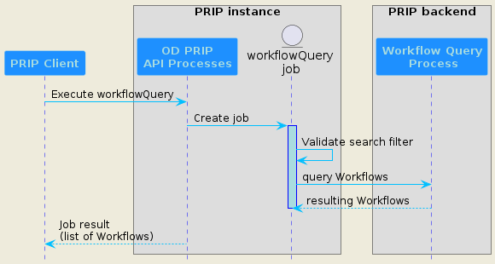
Figure 4: Sequence diagram of the synchronous workflowQuery process

The following requirements relates to the process description and characteristics, the expected inputs parameters, and the outputs provided in the result in case of a successful execution.

Process definition
OD-PRIP-PRO-REQ-020 – workflowQuery Process Definition
The OD PRIP service shall define and implement a specific process called “workflowQuery” to retrieve the list of available Workflows with optional search filtering. The workflowQuery process shall allow execution in synchronous mode and will return results as value. It shall be described with the following properties:
- id: value set to “workflowQuery”.
- title: value set to “list all processing Workflows available to the user”
- description: value set to an understandable description of what the process performs

Process inputs/outputs
OD-PRIP-PRO-REQ-030 – workflowQuery Process inputs
The workflowQuery process shall support the following optional inputs:
- filter: Search filter on Workflow attributes (e.g. name, inputProductType, ..)
- workflowOptions: flag to include workflows options in the response

The following table details the list of inputs.
Input name | Input description | Input type | Occurrences
filter | Search filter on one Workflow attribute among the following ones: name or inputProductType. The filter shall be conform to the CQL2 JSON standard. | object | 0 to 1
workflowOptions | If true, the Workflows options will be included in the response.  Default value : false | boolean | 0 to 1

OD-PRIP-PRO-REQ-040 – workflowQuery Process outputs
When successful, the workflowQuery process shall return a list of available Workflows, returned as in-line values (outputTransmission set to “value”) in a JSON response document. Each Workflow object has the following attributes (mandatory attributes in bold):
- id: Local unique identifier for the Workflow instance within the OD PRIP service (UUID format)
- name: Short name of the workflow
- description: Textual description of the workflow, including details of the processor version and configuration applicable
- inputProductType: Type of the Input Product
- outputProductType: Type of the Output Product
- workflowVersion: Version number applicable to the workflow
- workflowOptions: client-selectable WorkflowOptions. For each option, the following attributes are specified:
- name: The name of the option
- description: Textual description of the option.
- type: The type of the option
- default: The default value of the option, if there is one
- value: Array representing all possible values for the option.
The response JSON document is retrieved through a job results query once it has reached a successful status (reference to [LTA_ICD] / OGC-LTA-API-REQ-070).

The following table summarizes the list of outputs.
Ouput name | Input description | Input type | Occurrences
workflowList | List of available Workflows corresponding to the optional search criteria defined in the "filter" input parameter. Each workflow is an object with various attributes (listed in OD-PRIP-PRO-REQ-040) | object | 0 to N

Example of process definition
The following illustrates a definition of the workflowQuery process:
{
"id": "workflowQuery",
"title": "OD PRIP Workflows retrieval",
"description": "This synchronous process sends back a list of supported Workflows for input product types",
"version": "1.0.0",
"jobControlOptions": [
"sync-execute"
],
"outputTransmission": [
"value"
],
"inputs": {
"filter": {
"title": "Filter to search Workflows",
"description": "Filter in CQL2 JSON standard, to search on Worflows attributes",
"minOccurs": 0,
"maxOccurs": 1,
"schema": {
"$ref": "https://github.com/opengeospatial/ogcapi-features/blob/master/cql2/standard/schema/cql2.json"
}
},
"workflowOptions": {
"title": "Flag for WorkflowOptions display",
"description": "Used to return WorkflowOptions",
"minOccurs": 0,
"maxOccurs": 1,
"schema": {
"type": "boolean"
}
}
},
"outputs": {
"workflowList": {
"title": "List of available Workflows",
"description": "List of Workflows meeting search filter (if defined)",
"schema": {
"type": "array",
"minItems": 0,
"maxItems": N,
"items": {
"$ref": "#/$defs/workflow"
},
"$defs": {
"workflow": {
"type": "object",
"required": [ "id","name","description","InputProductType","OutputProductType","workflowVersion" ],
"properties": {
"id": {
"type": "string",
"format": "uuid",
"description": "Unique ID of the Workflow"
},
"name": {
"type": "string",
"description": "Workflow short name"
},
"description": {
"type": "string",
"description": "Workflow description"
},
"inputProductType": {
"type": "string",
"description": "Main product type"
},
"outputProductType": {
"type": "string",
"description": "Output product type"
},
"workflowVersion": {
"type": "string",
"description": "Workflow version"
},
"workflowOptions": {
"type": "array",
"minItems": 0,
"maxItems": M,
"description": "List of Workflow options",
"items": {
"$ref": "#/$defs/options"
},
"$defs": {
"options": {
"type": "object",
"required": [ "name","description","type","value" ],
"properties": {
"name": {
"type": "string",
"description": "Option name"
},
"type": {
"type": "string",
"description": "Option type"
},
"description": {
"type": "string",
"description": "Option description"
},
"default": {
"type": "string",
"description": "The default value of the option"
},
"value": {
"type": "array",
"minItems": 1,
"maxItems": K,
"description": "all possible values of the option",
"items": {
"type": "string"
}
}
}
}
}
}
}
}
}
}
}
},
"response": "document",
"links": [
{
"href": "https://s2a-prip.copernicus.esa.int/odp/workflowQuery/execution",
"rel": "http://www.opengis.net/def/rel/ogc/1.0/execute",
"title": "Execute endpoint"
}
]
}

Process execution
OD-PRIP-PRO-REQ-050 – workflowQuery Process execution
The workflowQuery process shall complete with a "successful " status if the "filter" input parameter is valid, even if none Workflows are returned back (empty list of Workflows). Otherwise, the process shall return with a "failed " status with an explicit error message.
As the process is synchronous, the results are directly sent back to the user in case of a successful execution.

ProductionOrder Process
Having selected the input product and the Workflow to be triggered plus applicable options, the Client submits a request to create a ProductionOrder towards the OD PRIP Service.
This operation is illustrated in the sequence diagram below.
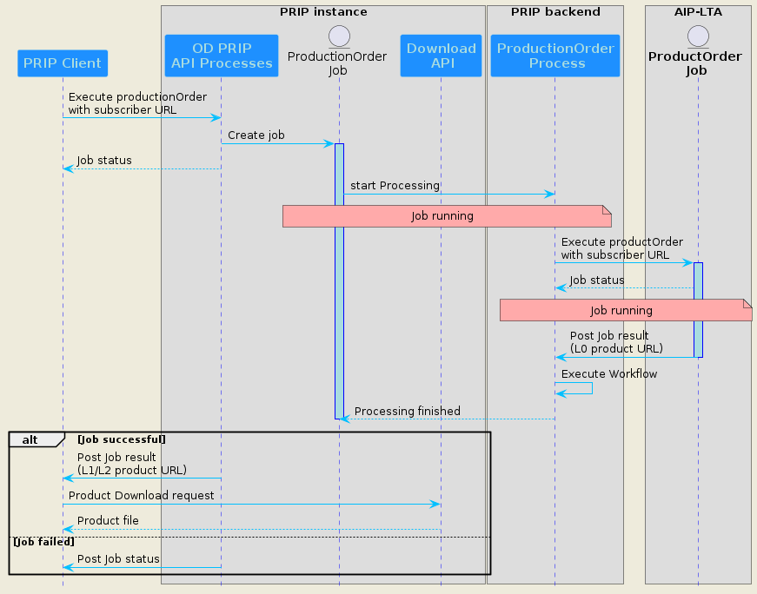
Figure 5: Sequence diagram of the asynchronous productionOrder process. Its execution consumes the AIP endpoint (LTA service) if the input product type is a L0 level one.

The following requirements relates to the process description and characteristics, the expected inputs parameters, and the outputs provided in the result in case of successful execution.

Process definition
OD-PRIP-PRO-REQ-060 – productionOrder Process Definition
The OD PRIP service shall define and implement a specific process called “productionOrder” to trigger a specific Workflow to execute to generate an output product from a given input product. The productionOrder process shall allow execution in asynchronous mode and will return results as value. It also shall be described with the following properties:
- id: value set to “productionOrder”.
- title: value set to "Trigger a processing workflow to generate an output product from a given input product”
- description: value set to an understandable description of what the process performs

Process inputs/outputs

OD-PRIP-PRO-REQ-070 – productionOrder Process inputs
The productionOrder process shall support the following mandatory inputs:
- inputProductReference: Complex type used to unambiguously identify the input product
- workflowId: local unique identifier for the Workflow instance within the OD PRIP which is applicable to the productionOrder
- workflowName: Short name of the workflow
The productionOrder process shall support the following optional inputs:
- priority: Priority of the ProductionOrder. It is an integer from 1-100, where 100 is the highest priority.
- WorkflowOptions: Selection of applicable options from the Workflow (in the form "name:value")

The following table details the list of inputs.
Input name | Input description | Input type | Occurrences
inputProductReference | Either the product identifier ("id" STAC field) or the sensing range period (dates interval). | string  or  array of string | 1
workflowId | Local unique identifier of the Workflow instance | string  format uuid | 1
workflowName | Short name of the workflow | string | 1
priority | Priority of the ProductionOrder (value between 1 and 100) | integer | 0 to 1
workflowOptions | Selection of applicable options from the Workflow | array of string | 0 to 1

OD-PRIP-PRO-REQ-080 – productionOrder Process outputs
Once the associated job is successful, the workflowQuery process shall return a list of available Workflows as in-line values (outputTransmission set to “value”) in a JSON response document. Each Workflow object has the following attributes (mandatory attributes in bold):
- productId: Unique identifier of the output product generated by the Workflow (UUID).
- productName: name of the output product.
- productionOrderId: Local unique identifier for the ProductionOrder instance within the OD PRIP.
- evictionDate: Date when the Product related to the order will be removed from the OD PRIP.
- orderOutputSize: Actual size in bytes (B) of the output Product composing the Order.
The response JSON document is retrieved through a successful job "results query" (reference to [LTA_ICD] / OGC-LTA-API-REQ-070), or through a HTTP callback if a valid subscriber URI has been passed in the execution request.

Note 1: the "productionOrderId" attribute is a duplicate of the "jobID" generated by the OD PRIP service (related to OGC API - Processes standard).
Note 2: other fields specified in previous version of this ICD, like "status", "statusMessage", "submissionDate" and "CompletedDate" are not specified here because they are directly managed by
OGC API - Processes standard. Their equivalent names are respectively "status", "message", "created" and "finished".

The following table summarizes the list of outputs.
Ouput name | Input description | Input type | Occurrences
productId | Identifier of the output product generated by the Workflow processor | string  format uuid | 1
productName | name of the output product | string | 1
productionOrderId | Identical to Job ID generated by OD PRIP service | string  format uuid | 1
evictionDate | Date when the Product related to the order will be removed from the OD PRIP | string  format date | 0 to 1
orderOutputSize | Actual size in bytes (B) of the output Product | number | 0 to 1

Example of process definition
The following illustrates a definition of the productionOrder process:
{
"id": "productionOrder",
"title": "Product generation with a given Workflow",
"description": "This asynchronous process executes the required Workflow and generates a higher level product from an input parent product",
"version": "1.0.0",
"jobControlOptions": [
"async-execute"
],
"outputTransmission": [
"value"
],
"inputs": {
"inputProductReference": {
"oneOf": [
{
"title": "Product identifier",
"description": "Input Product identifier",
"minOccurs": 1,
"maxOccurs": 1,
"schema": {
"type": "string"
}
},
{
"title": "Sensing range period",
"description": "Interval of dates with start date and and date",
"minOccurs": 1,
"maxOccurs": 1,
"schema": {
"type": "array",
"minItems": 2,
"maxItems": 2,
"items": {
"type": "string",
"format": "date-time"
}
}
}
]
},
"workflowId": {
"title": "Workflow identifier",
"description": "Local unique identifier for the Workflow instance to execute",
"minOccurs": 1,
"maxOccurs": 1,
"schema": {
"type": "string",
"format": "uuid"
}
},
"workflowName": {
"title": "Workflow name",
"description": "Short name of the workflow to execute",
"minOccurs": 1,
"maxOccurs": 1,
"schema": {
"type": "string"
}
},
"priority": {
"title": "Order priority",
"description": "Priority of the ProductionOrder",
"minOccurs": 0,
"maxOccurs": 1,
"schema": {
"type": "integer",
"minimum": 1,
"maximum": 100
}
},
"workflowOptions": {
"title": "Workflow options",
"description": "Selection of applicable options from the Workflow",
"schema": {
"type": "array",
"items": {
"$ref": "#/$defs/options"
},
"$defs": {
"options": {
"type": "object",
"required": [ "name","value" ],
"properties": {
"name": {
"type": "string",
"description": "Option name"
},
"type": {
"type": "string",
"description": "Option value"
}
}
}
}
}
}
},
"outputs": {
"productId": {
"schema": {
"type": "string",
"format": "uuid"
}
},
"productName": {
"schema": {
"type": "string"
}
},
"productionOrderId": {
"schema": {
"type": "string",
"format": "uuid"
}
},
"evictionDate": {
"schema": {
"type": "string",
"format": "date-time"
}
},
"orderOutputSize": {
"schema": {
"type": "number"
}
}
},
"response": "document",
"links": [
{
"href": "https://s2a-prip.copernicus.esa.int/odp/productionOrder/execution",
"rel": "http://www.opengis.net/def/rel/ogc/1.0/execute",
"title": "Execute endpoint"
}
]
}

Process execution
OD-PRIP-PRO-REQ-090 – productionOrder Process execution
After the submission of a new productionOrder, a new job is created ("accepted " status). Before the workflow can be executed, several conditions shall be checked:
- The workflowId input parameter corresponds to a valid Workflow.
- The workflowId input parameter is consistant with the InputProductReference input parameter
- User quotas are not exceeded (number of concurrent orders and maximum number of authorized orders in a defined period)
If all those conditions are met, the job shall launch the requested Workflow, and switches to a "successful" status as soon as the output product has been generated.
Otherwise, the job terminates with a "failed" status. The content of that response shall be based upon the OpenAPI 3.0 schema exception.yaml. The type of the exception shall correspond to the reason of the failure, e.g. InvalidParameterValue for invalid input value.

Use case examples

WorkflowQuery example
The following example is a workflowQuery execute request’s payload, with a CQL2 filter's criteria based on inputProductType field.
https://s2a-prip.copernicus.esa.int/odp/workflowQuery/execution
{
"inputs": {
"filterParam": {
"filter-lang": "cql2-json",
"filter": {
"op": "like",
"args": [
{ "property": "inputProductType" },
"%S2MSI0%"
]
}
}
"workflowOptions": true
},
"response": "document"
}
And a successful job result:
{
"workflowList": [
{
"id": "UUID-1",
"name": "Sentinel-2-L0-S2MSI1C",
"description": "Product processing from Sentinel-2 L0 to L1C. Processor V2.3.6",
"inputProductType": "S2MSI0",
"outputProductType": "S2MSI1C",
"workflowVersion": "2.1",
"workflowOptions": [
{
"name": "ProductFormat",
"type": "String",
"description": "Product Format option for the production output",
"value": [
"SAFE",
"ZARR"
]
}
]
},
{
"id": "UUID-2",
"name": "Sentinel-2-L0-S2MSI2A",
"description": "Product processing from Sentinel-2 L0 to L2A. Processor V2.4.6",
"inputProductType": "S2MSI0",
"outputProductType": "S2MSI2A",
"workflowVersion": "2.2",
"workflowOptions": [
{
"name": "ProductFormat",
"type": "String",
"description": "Product Format option for the production output",
"value": [
"SAFE",
"ZARR"
]
}
]
}
]
}

ProductionOrder example
The following example is a productionOrder execute request’s payload, with a specified Workflow option and a URL for notification purpose.
https://s2a-prip.copernicus.esa.int/odp/productionOrder/execution
{
"inputs": {
"inputProductReference": "S02MSIL0__20251111T182840_0001_A123_T000",
"workflowId": "UUID-1",
"workflowName": "Sentinel-2-L0-S2MSI1C",
"priority": 50,
"workflowOptions": [
{
"name": "ProductFormat",
"value": "zarr"
}
]
},
"response": "document",
"subscriber": {
"successUri": "https://prip_client_url"
}
}

And a successful job result:
{
"productId": "UUID-1",
"productName": "S2A_MSIL1C_20240604T101559_N0510_R065_T44XNR_20240604T111607",
"productionOrderId": "JOB-UUID",
"evictionDate": "2026-07-01:T00:00:00Z",
"orderOuputSize": 734003200
}

Product Subscription API
The Subscription function allows the request for automated notifications of future products published into the PRIP STAC Catalogue, according to a set of filter parameters supplied within the subscription request. Once a notification has been received about a new product availability, the client can request the download of the product.
Like for OD Processing, the PRIP service shall expose a REST API compliant with OGC Processes – API v1.0.
In this respect, it shall define various processes to meet the Subscription functionalities, each process being available for PRIP client execution.
OGC-PRIP-PRO-REQ-100 – supported Processes for subscription
The PRIP instance shall support and define the following processes for subscription management:
- subscriptionCreate to create a new subscription for new products notifications
- subscriptionCancel to cancel an active subscription

Note: Each process is fully described in the next chapters.

The first paragraph relates to subscription management, and the second one relates to the sending of notifications to users with active subscrition(s).
Note: Generic requirements related to common OGC Processes – API endpoints remain valid for Subscription functionalities (see reference document [LTA_ICD] and requirements OGC-LTA-API-REQ-020 to OGC-LTA-API-REQ-090).

Subscription creation
The “Subscription Create” operation allows to create a new subscription to receive notifications for new products from a given collection. This is illustrated in the sequence diagram below.
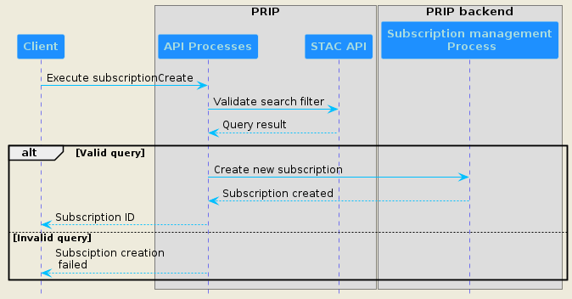
Figure 6: Sequence diagram of “subscriptionCreate” synchronous process

This operation is described through a specific Process implemented in the PRIP instance, called subscriptionCreate.

Process definition
The following requirements relates to the process description and characteristics, the expected inputs parameters, and the outputs provided in the job results in case of successful execution.
OGC-PRIP-PRO-REQ-110 – subscriptionCreate Process Definition
The PRIP instance shall define and implement a specific process called “subscriptionCreate” to support the creation of a new subscription in order to be notified on new products events. The subscriptionCreate process shall allow execution in synchronous mode and will return a unique subscription ID, to which the client can refer in subsequent operations. In case of failure caused by invalid query or any other reason, the response shall have a HTTP error code that corresponds to the reason of the failure. The content of that response shall be based upon the OpenAPI 3.0 schema exception.yaml. The type of the exception shall correspond to the reason of the failure, e.g. InvalidParameterValue for invalid input value.
The process shall be defined with the following properties:
- id: value set to “subscriptionCreate”.
- title: value set to “PRIP new subscription creation”
- description: value set to an understandable description of what the process performs

Process inputs/outputs
OGC-PRIP-PRO-REQ-120 – subscriptionCreate Process inputs
The subscriptionCreate process shall support the following mandatory inputs:
- filterParam: filter expressed in CQL2 JSON to allow the PRIP instance to run a STAC query with filter extension. This query shall be used to filter on products for future notifications.
- collection: The collection for which the event is monitored. shall be a valid STAC collection.
The subscriptionCreate process shall support the following optional inputs:
- bbox: Bounding box for which the STAC query shall search products. The spatial operator implemented by default shall be “s_intersects”. If a spatial operator is present in "filterParam", the bbox input parameter is ignored.

The following table details the list of inputs.
Input name | Input description | Input type | Occurrences
filterParam | Represents filter expressed in a CQL2 JSON language | object | 1
collection | Collection for which the event is monitored; shall be constrained by an enum corresponding to supported STAC collections. | string | 1
bbox | Bounding box for which the STAC query shall search products. Ignored if filterParam already contains a spatial operator. | bounding box | 0 to 1

OGC-PRIP-PRO-REQ-130 – subscriptionCreate Process outputs
The subscriptionCreate process shall support the following outputs returned as in-line values (outputTransmission set to “value”) in a JSON document response:
- subscriptionId: a unique ID of the created subscription. This ID shall be used by the client to cancel the subscription, and to consume corresponding notification messages.
As the process is synchronous, the response is directly returned after the execution query.

The following table details the list of outputs parameters.
Output name | Input description | Output type | Occurrences
subscriptionId | Unique ID of the created subscription | string  format uuid | 1

Example of process definition
The following JSON content illustrates a definition of the subscriptionCreate process.
{
"id": "subscriptionCreate",
"title": "PRIP new subscription creation",
"description": "This synchronous process creates a new subscription to monitor the publication of products into a STAC collection. A notification is sent in case of matching with the filterParam specified.",
"version": "1.0.0",
"jobControlOptions": [
"sync-execute"
],
"outputTransmission": [
"value"
],
"inputs": {
"filterParam": {
"title": "cql2-json filter",
"description": "Filter for STAC query in CQL2 JSON",
"minOccurs": 1,
"maxOccurs": 1,
"schema": {
"$ref": "https://github.com/opengeospatial/ogcapi-features/blob/master/cql2/standard/schema/cql2.json"
}
},
"collection": {
"title": "STAC Collection",
"description": "Collection in which to monitor",
"minOccurs": 1,
"maxOccurs": 1,
"schema": {
"type": "string",
"enum": [
"sentinel2-l1c",
"sentinel2-l2a"
]
}
},
"bbox": {
"title": "Bounding Box of STAC query",
"description": " Bounding Box for which the query searches products",
"minOccurs": 0,
"maxOccurs": 1,
"schema": {
"allOf": [
{
"format": "ogc-bbox"
},
{
"$ref": https://schemas.opengis.net/ogcapi/processes/part1/1.0/openapi/schemas/bbox.yaml"
}
]
}
}
},
"outputs": {
"subscriptionId": {
"title": "Unique subscription ID",
"description": "Identifier of the created subscription",
"schema": {
"type": "string",
"format": "uuid"
}
}
},
"response": "raw",
"links": [
{
"href": "https://s2a-prip.copernicus.esa.int/processes/subscriptionCreate/execution",
"rel": "http://www.opengis.net/def/rel/ogc/1.0/execute",
"title": "Execute endpoint"
}
]
}

Subscription cancelation
The “subscription Cancel” operation allows to delete an existing subscription. This is illustrated in the sequence diagram below.
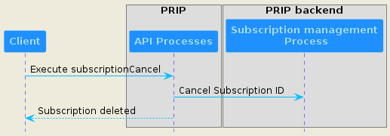
Figure 7: Sequence diagram of Subscription cancel process

This operation is described through a specific Process implemented in The AIP instance, called subscriptionCancel.

Process definition
The following requirements relates to the process description and characteristics, the expected inputs parameters, and the outputs provided in the job results in case of successful execution.
OGC-PRIP-PRO-REQ-140 – subscriptionCancel Process Definition
The PRIP instance shall define and implement a specific process called “subscriptionCancel” to support the cancelation of an active subscription. The subscriptionCancel process shall allow execution in synchronous mode and will return the subscription ID of the canceled subscription in case of success. In case of failure caused by invalid query, the response shall have a HTTP error code that corresponds to the reason of the failure. The content of that response shall be based upon the OpenAPI 3.0 schema exception.yaml. The type of the exception shall correspond to the reason of the failure, e.g. InvalidParameterValue for invalid subscriptionId.
The process shall be defined with the following properties:
- id: value set to “subscriptionCancel”.
- title: value set to “PRIP subscription cancelation”
- description: value set to an understandable description of what the process performs

Process inputs/outputs
OGC-PRIP-PRO-REQ-150 – subscriptionCancel Process inputs
The subscriptionCancel process shall support the following mandatory input:
- subscriptionId: unique identifier of the subscription to cancel
The following table details the list of inputs.
Input name | Input description | Input type | Occurrences
subscriptionId | Unique identifier of the active subscription to cancel | string | 1

OGC-PRIP-PRO-REQ-160 – subscriptionCancel Process outputs
The subscriptionCancel process shall support the following outputs returned as in-line values (outputTransmission set to “value”) in a JSON document response:
- subscriptionId: a unique ID of the active subscription. This ID shall be used by the client to cancel the subscription, and to consume corresponding notification messages.
As the process is synchronous, the response is directly returned after the execution query.

Notification sending
For each active subscription, the PRIP instance will monitor if conditions are met (collection and product search filter). In case of matching, a notification message is sent for each new product published into the STAC Catalogue. The process is illustrated in the sequence diagram below.
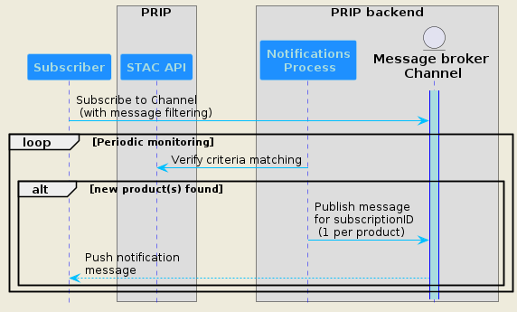
Figure 8: Notification sending sequence diagram (example for new products in 1 STAC collection)

OGC-PRIP-PRO-REQ-170 – Pub/Sub broker and notification channels
The PRIP instance shall conform to "OGC API Publish-Subscribe Workflow - Part 1: Core", which relies on Pub/Sub protocol for notification message publishing. The supported protocol shall be either AMQP 1.0 or MQTT 5.0. The PRIP instance shall setup a broker and instantiate one dedicated channel per STAC collection which supports subscription mechanism. It shall also provide the following information :
- host: the server hostname and port
- protocol: Pub/Sub protocol supported by the server (mqtt or amqp)
- protocolVersion: version of the Pub/Sub protocol supported by the server
- description: string describing the host
- security: reference to supported authentication types
It shall also declare all the channels to which a consumer can subscribe.

OGC-PRIP-PRO-REQ-180 – Notification messages publishing
The PRIP instance shall publish a notification message to the Pub/Sub broker each time a client’s subscription meets product filtering. It shall publish this notification on the channel corresponding to the collection the product belongs to. The client must subscribe to each channel related to the collection set in its active subscriptions.
Example: A client creates a subscription for new sentinel2-l1c products. Then he subscribes to the AMQP channel “sentinel2-l1c” and listens for notification messages. As soon as a new Sentinel2-l1c product is published and matches with its subscription’s filter, he receives a notification message on the “sentinel2-l1c” channel.

OGC-PRIP-PRO-REQ-190 – AMQP Stream Filtering
The PRIP instance shall publish a notification message on the Pub/Sub broker for each product corresponding to a client’s subscription.
Optionally, if the broker is AMQP compliant, this message could be addressed to the right consumer through the “AMQP Stream Filtering” mechanism: the x-stream-filter-value header is set to the “subscriptionID” value for which the notification must be delivered.
Then the consumer can perform effective message filtering, thanks to x-stream-filter argument set to a string or an array of strings if he needs consuming messages for several subscription IDs.

OGC-PRIP-PRO-REQ-200 – Notification message payload for new STAC items
The Pub/Sub broker shall publish a notification message with the following CloudEvents (JSON) formatted payload for a new product published into a STAC collection.
{
"id": "UUID", # unique message ID
"specversion": "1.0",
"type": "org.ogc.api.collection.item.create",
"subscriptionid": "SubscriptionID", # allows a consumer to filter messages based on it's subscription ID
"source": " https://s2a-prip.copernicus.esa.int/collections/collection",
"subject":"https://s2a-prip.copernicus.esa.int/collections/collection_id/items/item_id",
"time": "2025-08-27T12:36:33Z",
"datacontenttype": "application/json",
"data": {
"type": "application/geo+json",
"rel": "collection.item",
"href": "https://s2a-prip.copernicus.esa.int/collections/collection_id/items/item_id"
}
}

Annex A - Conformance test suite
The Conformance Test Suite related to this specification is provided by the following tools:
- The STAC PRIP API validator tool, used to validate compliance with this document and which uses the STAC API validator tool to verify the conformance of the STAC API,
- The STAC PRIP API data model validation with Postman tool, used to validate the requirements of the data model and the STAC API of a PRIP instance as stated by this document with the Postman client,
- The STAC PRIP API data model validation with NodeJS tool, also used to validate the requirements of the data model and the STAC API of a PRIP instance as stated by this document with NodeJS. It is experimental; the previous tool should be privileged.
Each tool is managed in its own Gitlab Repository and each version of the tool indicates the version of the PRIP specification it is related to.
Those tools are managed under PRIP CTS Gitlab group of projects.

It is the concatenation of the following current OData properties: platformShortName and platformSerialIdentifier
This standard is still draft (https://docs.ogc.org/DRAFTS/25-030.html)
This field is added for LTA service needs and is not in line with to "OGC API Publish-Subscribe" standard. It's useful if AMQP Stream Filtering cannot be implemented (see OGC-LTA-PRO-RECO-220)

